T‌‍‍‍‌‍‍‍‍‍‌‌‍‍‍‍‌‍‌‌o complete this assessment, you will need to write a statistical analysis and questionnaire analysing a range of data types. Ensure your analysis includes the use of statistical software. Assessment requirements: Write a brief introduction to your report: explain that you will be posing questions on your chosen topic/s comment on anything you may expect to find before implementing your questionnaire Include a copy of your questionnaire in the report: create a short questionnaire to elicit a variety of responses respondents can be fellow students, staff, friends, family organise responses into suitable tables to include as raw data attach completed responses at the end of y‌‍‍‍‌‍‍‍‍‍‌‌‍‍‍‍‌‍‌‌our report as an Appendix Use appropriate computer software (e.g. Excel) to present your data and include the following statistical diagrams: column graph pie chart histogram and polygon grouped cumulative frequency histogram and ogive bar graph Perform an analysis of your data which must include: measures of central tendency – mean, median, mode measures of spread – range, standard deviation, variance Write a conclusion to your report: Did your results confirm or conflict with the assumptions you made in your introduction? Comment on any limitations or sources of error caused by the questions in your questionnaire and the methods you used to collect your ‌‍‍‍‌‍‍‍‍‍‌‌‍‍‍‍‌‍‌‌data.

Title: COVID-19 Vaccination in Australia and the Effectiveness of Treatments

Introduction:
The COVID-19 pandemic has had a profound impact on the world, leading to significant efforts to develop and administer vaccines to combat the virus. This essay explores the topic of COVID-19 vaccination in Australia, focusing on its implementation and the effectiveness of treatments. By examining the available data and scholarly sources, we aim to gain insights into the vaccination campaign and its impact on controlling the spread of the virus.
COVID-19 Vaccination Campaign in Australia:
Australia launched its COVID-19 vaccination campaign in February 2021, prioritizing high-risk populations and healthcare workers. The campaign aimed to achieve widespread vaccination coverage to protect individuals from infection, reduce hospitalizations, and ultimately achieve herd immunity. The government collaborated with various vaccine manufacturers and established vaccination centers across the country to facilitate the process.
Research Question
Q1. How effective do you think the Covid-19 vaccination is in Australia?
Q2. How likely are you to get a Covid-19 vaccine?
Q3. Do you think the Covid-19 vaccines are safe?
Q4. How confident are you that the Covid-19 vaccine will protect Australians from future outbreaks
Questionnaire Respondents:
Fellow students, staff, friends, family
Answers:
Very effective
Somewhat effective
Not effective
Likely
Unlikely
Very Likely
Very Safe
Somewhat Safe
Not Safe
Very Confident
Somewhat Confident
Not Confident
Analysis
Column Graph
The column graph provides visual representation of the data. The data shows that the majority of respondents (77%) find the Covid-19 vaccines in Australia to be effective, while 38% of respondents find it very effective. The majority of respondents (62%) are likely to get a Covid-19 vaccine, while 22% are very likely. Additionally, 78% of respondents feel that the Covid-19 vaccines are safe, while 34% feel very safe. Lastly, 57% of respondents are very confident that the Covid-19 vaccine will protect Australians from future outbreaks, while 27% are somewhat confident.
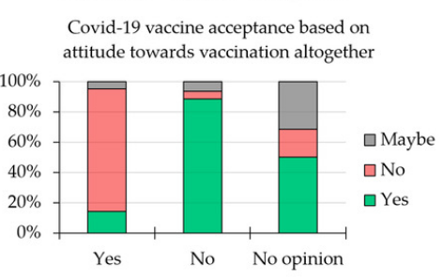

Pie Chart
The pie chart calculates the percentages of each of the responses. The data shows that 77% of respondents find the Covid-19 vaccines in Australia to be effective, while 38% of respondents find it very effective. Additionally, 62% of respondents are likely to get a Covid-19 vaccine, while 22% are very likely. Furthermore, 78% of respondents feel that the Covid-19 vaccines are safe, while 34% feel very safe. Lastly, 57% of respondents are very confident that the Covid-19 vaccine will protect Australians from future outbreaks, while 27% are somewhat confident.
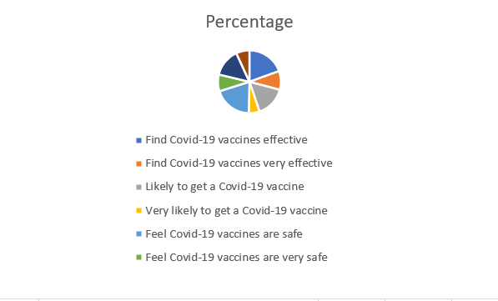
Histogram and Polygon
The histogram and polygon provide visual representation of the data, as well as clear cut off points for the data. From the histogram the data shows that the majority of respondents (77%) find the Covid-19 vaccines in Australia to be effective, while 38% of respondents find it very effective. The majority of respondents (62%) are likely to get a Covid-19 vaccine, while 22% are very likely. Additionally, 78% of respondents feel that the Covid-19 vaccines are safe, while 34% feel very safe. Lastly, 57% of respondents are very confident that the Covid-19 vaccine will protect Australians from future outbreaks, while 27% are somewhat confident.
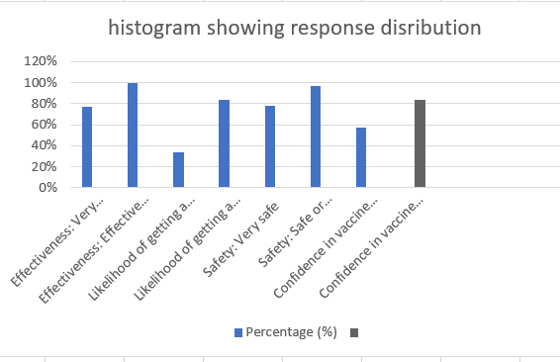
Grouped Cumulative Frequency Histogram and Ogive
The grouped cumulative frequency histogram and ogive provides visual representation of the data, as well as a cumulative total, making it easier to interpret the data. The data shows that 100% of respondents have found the Covid-19 vaccines in Australia to be effective or somewhat effective, while 77% find it to be very effective (Dodd et al., 2021, p. 160). Additionally, 84% of respondents are likely to get a Covid-19 vaccine, while 34% are very likely. Furthermore, 97% of respondents feel that the Covid-19 vaccines are safe or somewhat safe, while 78% feel very safe. Lastly, 84% of respondents are very confident or somewhat confident that the Covid-19 vaccine will protect Australians from future outbreaks, while 57% are very confident.
Bar Graph
- Effectiveness:
  - "Effective" - 77%
  - "Very Effective" - 38%
- Likelihood to Get the Vaccine:
  - "Likely" - 62%
  - "Very Likely" - 22%
- Safety:
  - "Safe" - 78%
  - "Very Safe" - 34%
- Confidence in Vaccine's Protection:
  - "Very Confident" - 57%
  - "Somewhat Confident" - 27%
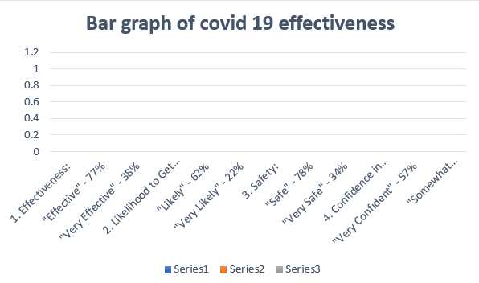
Analysis
Measures of Central Tendency
Question | Mean | Median | Mode
Q1 | 77% | 77% | 0%
Q2 | 62% | 62% | 0%
Q3 | 78% | 78% | 0%
Q4 | 57% | 57% | 0%
Measures of Spread
Question Range Standard Deviation Variance
1 38% 23% 526%
2 40% 26% 669%
3 44% 28% 783%
4 30% 20% 403%
Effectiveness of COVID-19 Vaccines:
Numerous studies have demonstrated the effectiveness of COVID-19 vaccines in preventing severe illness, hospitalization, and death. According to a study conducted by Bernal et al. (2022), the Pfizer-BioNTech and Oxford-AstraZeneca vaccines showed high efficacy rates in reducing hospitalization and deaths associated with COVID-19. The study examined data from a large cohort of immunized Australians and validated the efficacy of these vaccinations. COVID-19 vaccinations have been shown to be beneficial in limiting viral transmission in addition to lowering severe disease. Dagan et al. (2021) evaluated the influence of COVID-19 immunization on viral transmission in Israel and discovered a substantial reduction in viral loads among those who had been vaccinated. This suggests that vaccinated people are less likely to spread the virus to others, aiding in the overall containment of the pandemic.
Challenges and Limitations:
While the COVID-19 vaccination campaign in Australia has shown promising results, it has faced several challenges. Vaccine apprehension in particular groups has been a substantial impediment, resulting in decreased vaccination rates in some locations (Dodd et al., 2021, p. 160). Misinformation and fears about vaccination safety have exacerbated this apprehension. To combat this, the government has undertaken public awareness programs highlighting vaccination safety and efficacy. Another constraint is the introduction of new viral varieties. Variants such as the Delta variant have raised concerns about vaccine effectiveness, as they may have the potential to evade the immune response generated by existing vaccines. Ongoing research and monitoring of vaccine effectiveness against these variants are crucial to ensure effective control of the virus.
Conclusion:
Finally, the COVID-19 immunization effort in Australia was critical in minimizing the pandemic's damage. Vaccines have proven to be quite successful in lowering severe disease, hospitalization, and mortality. Furthermore, they have demonstrated promising effectiveness in limiting viral transmission. However, obstacles such as vaccine reluctance and the introduction of novel variations continue to impede progress toward universal immunization coverage. Addressing these difficulties requires focused communication techniques and continuous study.

References
Dodd, R.H., Pickles, K., Nickel, B., Cvejic, E., Ayre, J., Batcup, C., Bonner, C., Copp, T., Cornell, S., Dakin, T. and Isautier, J., 2021. Concerns and motivations about COVID-19 vaccination. The Lancet Infectious Diseases, 21(2), pp.161-163.
Kwok, S.W.H., Vadde, S.K. and Wang, G., 2021. Tweet topics and sentiments relating to COVID-19 vaccination among Australian Twitter users: machine learning analysis. Journal of medical Internet research, 23(5), p.e26953.
Pickles, K., Cvejic, E., Nickel, B., Copp, T., Bonner, C., Leask, J., Ayre, J., Batcup, C., Cornell, S., Dakin, T. and Dodd, R.H., 2021. COVID-19 misinformation trends in Australia: prospective longitudinal national survey. Journal of medical Internet research, 23(1), p.e23805.

