What are the relative relations of globalization and labor standards? Are there possible positive and negative effects of globalization on labour standards? Can labour standards improve or develop under globalization? What are the factual techniques and strategies laid to improve labour standards through globalization? Can multinational firms develop labor standards? Are worker's rights and global value chains addressed? All these queries are systematically addressed in this article.
With globalization being increased acceleration of trends and trades-off of goods and services, capital and technologies across the world, it has developed several concepts that influence the existence and running of other disciplines involved.

Globalization and Labor Standards- Various Types of Globalization in Labor Standards
Economic Globalization - Is the growth of commerce structure within multinational actors and non-governmental or private sector organizations.
Financial Globalization - Entails the rise of global financial structure with multinational financial and monetary trade-offs.
Cultural Globalization - Involves the adopted principles, beliefs, customs and cultural practices involved in all activities of running the individual firm.
Political Globalization - The intervention of WHO and UN in multinational firms declares government actions takes place at international levels.
Geographic Globalization - The physical structures of multinational firms repetitively change over time due to internal and external reasons within the firm.
Ecological Globalization - With the basic understanding of we live in an evolving plane with physical tangible surroundings that exist with the help of human naturing them.

Globalization and Labor Standards-Relative Relations of Globalization to Labor Standards and Labor Markets
With the help of globalization, states and regions are able to communicate and interact within themselves and create an environment where casual, skilled and unskilled laborers compete for better paying jobs that best meet their needs whereas employers evaluate individual employees according to levels of intelligence and experience to hire them to deliver in their respective firms across the globe.
For instance, in a certain region labor markets works on the principal of demand and supply of labor where labour demand in a firm is demand for a laborers supply of labor.
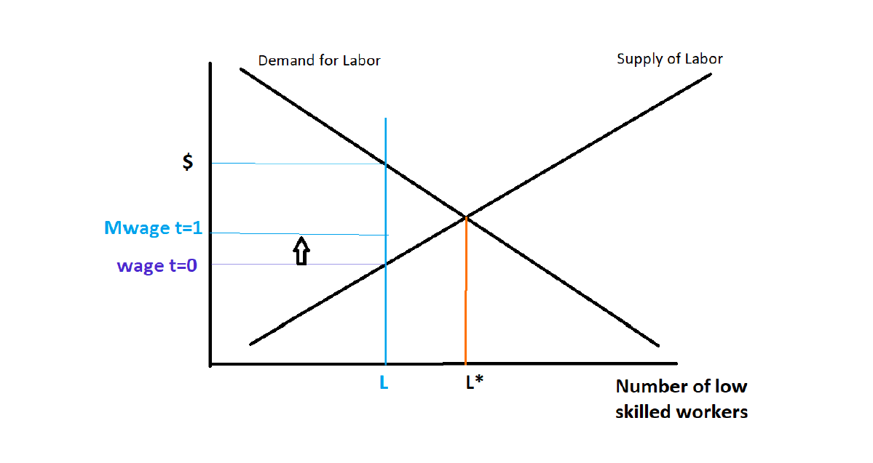
Labor standards are however established and improved in the the way they conduct themselves in these firms to help laborers work effectively in good working environments and work together with the aim of high productivity cumulative results. This is essential because it covers areas like forced labor/child labor, minimum wages, working hours, safety and healthy conditions, right to trade unions and legal democratic strikes.

Positive Effects of Globalization
- Growth of technology and innovations - Technological advances are made are spred across various regions as well as growth of new inventions and discoveries.
- Enhances better living standards - With good wages and gross salaries amongst casual laborers, they are able to satisfy their needs and make individual economic growths and labor standards improved.
- Access to new markets. - Firms can diverse and reach out extensively to more customers in various regions.
- Access to new cultures and beliefs - Both customers, firm boards and workers adopt new cultural practices like foods, music arts and religion.
- Leads to better lower prices of products and services - With healthy competitions amongst multinational firms within regions, goods and services are offered at affordable prices in order not to incur loses arising from unsold goods.
- Enhances growth and development of talents and abilities - Workers with tech talents enable firms perform highly in the marketing fields.

Globalization and Labor Standards- Negative Effects of Globalization.
- Employee Immigration - Workers from different races leave their native lands and join at one similar environment but are only joined together by job opportunities and nothing else.
- Difficulties in International expansions - For expansions to be a success in other countries, changes occur arising from taxes and expenses involved to set up a fim in another country.
- Cultural Identity loss - Workers lose their diversity by indulging in new practices and beliefs.

Globalization and Labor Standards - Workers Rights and Global Value Chains
Through strategies laid to cater for the well being of workers in a firm, labor standards have been improved and brought about firmness in establishment of the law that protects casual workers. Workers demand for genuine and transparency in their working fields.
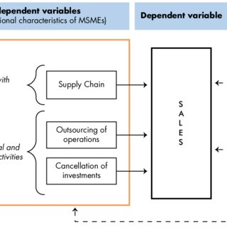
Workers also call for increased safety and better working environments that are human habitable. Casual workers also call for better minimum wages and gross salaries in supply chains forn individuals econimic growth that leads to labor standard development.

