With the Diabetes disparities gap not narrowing uncontrollably over a long period, in various regions across the globe, general health disparity is being handled by conducting health promotions and disease prevention campaigns. Health disparity being the variety of curable health differences closely associated with diseases, social, economic and environmental drawbacks.
Diabetes itself is proven to affect any group of people, be it native Americans, African Americans, the elderly and lower disadvantaged socioeconomic classes of both men and women.

How Diabetes Disparities affects African Americans population
Black people increasingly face difficulty to accessing properly utilized healthcare services. With the current discrimination against black people by white people, several health-related challenges come along the way. With the higher risk of diabetes in black people, African Americans are most likely to face more complications from diabetes. For instance, the rate of diabetic retinopathy is 46 percent higher than Hispanic white people.
According to research, non hispanic African members are 60 percent more likely to be diagnosed with diabetes than non hispanic white Americans. There are two types of diabetes. Diabetes disparities have increased due to non white people being affected.
Type 1 Diabetes; involves an autoimmune condition that most develops in childhood. Body attacks the beta cells of the pancreas limiting their ability to produce insulin. With limited insulin, the body cannot absorb glucose which causes high blood sugar levels.
Type 2 Diabetes; is a chronic condition that often starts at childhood too where the body finds it hard to recognise insulin commonly known as insulin resistance thus blood sugar level rise rapidly. This type is also caused by sensitivity of body tissues to insulin.
African Americans are highly affected by type two due to a couple of factors which include genetic and environmental factors.
Diabetes disparities in black people was highly triggered by periods of exposure to famine and drought where they were experiencing efficiently stored fats and increased to body weights. People lose their jobs, limited social amenities, infrastructure and lives, and suffered other diseases due to lack of efficient medical services. Extensively, high prevalences of G6PD deficiency also contributes to increased spread of diabetes.

Approaches to optimize health for the Diabetes African Americans
In areas affected by diabetes disparities, equity treatment to all races involved is one way to optimize population in the affected areas. Improving a countries general health conditions leads to economic growth prosperity. Health disparities are costly and hence, results to costly medical services, productivity lost and high economic situations due to early deaths.
WHO and UN foundations have however laid strategies to cater for diabetes patients across the globe. This has led to reduction of deaths experienced annually after patients undergo the right medical clinics and check ups.
Campaigns against racism and discrimination are being conducted to enable equity treatment through globalization in multinational firms that hold workers from various regions in the world.

Proposal for Health Education Promotion
To curb the spread of diabetes disparities and manage health conditions of those already affected, strategic plans are put into place for conducive facilitation. Assessment conduct of public awareness mostly in targets ports through technological ways all over the world.

This is also achieved through public sensitization through community education on importance and advantages of adopting and implementing preventive mechanisms.
Diabetes disparities is also reduced through identification of vulnerable areas with extensively high risks of conducting diabetes through famine and malnutrition cases.
Provision of essential life saving health services in conjunction with respective medical check up routines to stabilize other diseases that come along diabetes.

Health Related Organization for diabetes disparities for black Americans
One major health related organization for patients with diabetes in America or across the world in general is the African American Diabetes Association (AADA). This is a non profitable organization that deals with campaigns and promotions that educate all individuals about diabetes and other related diseases.
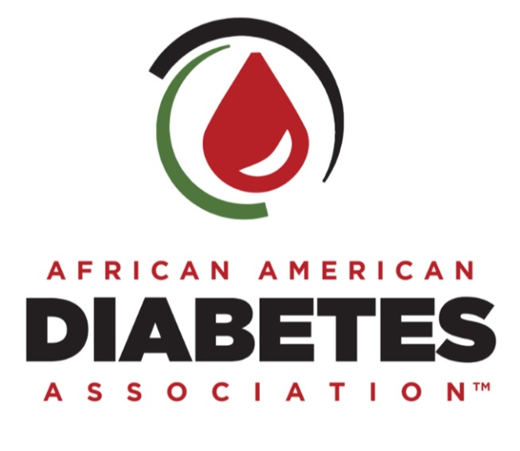

The National Association of Diabetes Centres (NADC) is a collective body that unites other sub bodies that involve themselves with diabetes care. This body explores strategies and more advanced mechanisms to improve the general living standards of diabetes victims across the world.

Interdisciplinary Health Professionals in Health Promotions
These are both public and private individuals or organizations that are responsible for improving patients well being and medical and psychological conditions. These bodies work together with the aim of providing support to the needs of a patient diagnosed with diabetes.
Diabetes disparities are however controlled equally and improved. These educators are either registered nurses, pharmacists and others skilled and well equipped medical specialists. Some of these include Endocrinologists, Registered Dietitians, Optometrists and Diabetes Care and Education Specialists.

Roles of Interdisciplinary Health Professionals in Health Promotions
These are offering professional training to provide medical assistance to patients, create public awareness on necessary measures to prevent contacting diabetes. They are also responsible for proper medicinal recommendations for treatments of patients with diabetes and other related diseases.

