Rebels in Petticoats: Women Who Defied Conventions and Transformed Society (Susan B. Anthony, Prudence Crandall, and Elizabeth Blackwell)
In this paper, three extraordinary women who, in their day, broke social conventions—Susan B. Anthony, Prudence Crandall, and Elizabeth Blackwell—will be profiled for their achievements. These "rebels in petticoats" greatly impacted society by defying conventional wisdom and paved the way for future generations with their bold deeds and unyielding resolve. George Santayana, a philosopher, famously said: "Those who do not learn history are doomed to repeat it." This wise saying emphasizes how crucial it is to research the past to prevent repeating the same mistakes.

Susan Anthony:
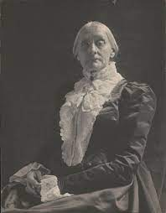
A Pioneer in the Fight for Women's Rights, Anthony was an influential suffragist and abolitionist who dedicated her life to advocating for gender equality and women's right to vote. Born in 1820, Anthony played a pivotal role in organizing the women's suffrage movement in the United States during the late 19th and early 20th centuries. She tirelessly campaigned for legal and political rights for women, believing that equality was a fundamental human right.
Anthony's impact on society was far-reaching. She co-founded the National Woman Suffrage Association and was vital in drafting the Nineteenth Amendment to the United States Constitution, which granted women the right to vote in 1920. Through her speeches, writings, and tireless activism, Anthony inspired countless women to join the fight for gender equality and challenged her time's deeply ingrained patriarchal structures.
Sources:
Hayward, N. (2018). Susan B. Anthony. [online] National Women’s History Museum. Available at: https://www.womenshistory.org/education-resources/biographies/susan-b-anthony.
Susanb.org. (2019). Catherine E. Beecher and the Cult of Domesticity. [online] Available at: https://susanb.org/.
Crandall:
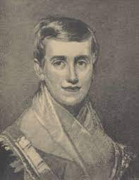
Education as a Weapon for Social Change Prudence Crandall was a courageous educator and abolitionist who fought against racial discrimination in education during the early 19th century. In 1831, she opened a school for African American girls in Canterbury, Connecticut, which was met with fierce opposition from the community.
Crandall's determination to provide equal educational opportunities for African American girls profoundly impacted society. Despite facing violent protests, legal challenges, and the closure of her school, she remained resolute in her mission. Her efforts brought attention to the racial inequalities in education and helped spark a national conversation about the importance of equal access to education for all.
Sources:
CT Women’s Hall of Fame. (n.d.). Prudence Crandall. [online] Available at: https://www.cwhf.org/inductees/prudence-crandall.
Prudence Crandall | American educator | Britannica. (2020). In: Encyclopædia Britannica. [online] Available at: https://www.britannica.com/biography/Prudence-Crandall.

Blackwell:
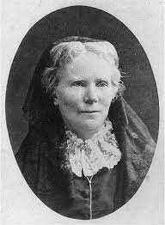
Pioneering Female Physician and Advocate for Women's Health, Blackwell shattered gender barriers in the medical field as the first woman to earn a medical degree in the United States. Blackwell was born in 1821 and faced significant prejudice and discrimination while pursuing her medical education. Despite the challenges, she advocated for women's health and reproductive rights.
Blackwell's impact on society was multifaceted. She challenged societal expectations by proving that women could excel in medicine and paved the way for other women to enter the field. She also played a crucial role in advancing women's healthcare, addressing issues related to reproductive health, and advocating for improved healthcare access for women.
Sources:
Michals, D. (2015). Elizabeth Blackwell. [online] National Women’s History Museum. Available at: https://www.womenshistory.org/education-resources/biographies/elizabeth-blackwell.
Nih.gov. (2015). Changing the Face of Medicine | Karin J. Blakemore. [online] Available at: https://cfmedicine.nlm.nih.gov/physicians/biography_37.html
In conclusion, The lives and accomplishments of Susan Anthony, Crandall, and Blackwell serve as powerful examples of individuals who defied societal conventions and created lasting change. These women challenged the status quo through unwavering determination and fought for equality, justice, and empowerment. Their contributions have shaped our society and continue to inspire future generations. As Santayana wisely stated, by learning from the stories of these remarkable women and the lessons of history, we can strive to create a more equitable and just society for all.
Bibliography:
- Baumann, S. (2018). Hollywood Highbrow From Entertainment to Art. Princeton University Press.
- Gordon, A. (2012). The Selected Papers of Elizabeth Cady Stanton and Susan B. Anthony An Awful Hush, 1895 to 1906. Rutgers Univ Pr.
- Harper, I.H. (2020). The Life and Work of Susan B. Anthony Volume III.
- NA, N. (2016). Writers Directory. Springer.
- Ogilvie, M.B. and Meek, K.L. (2018). Women and Science. Routledge.

