Definitions:
Race is a social construct categorizing people into distinct groups based on physical characteristics such as skin color, hair texture, and facial features. These categories often differentiate populations and can include designations such as Black, White, Asian, Indigenous, and more. However, it is essential to note that race is a social concept and does not have a biological basis. The understanding and significance of race vary across different societies and historical contexts, and it is essential to recognize that there is more genetic diversity within racial groups than between them.
Ethnicity: Ethnicity refers to a shared cultural heritage, including customs, traditions, language, and often a common geographic origin, that distinguishes one group of people from another. Ethnicity is usually based on nationality, language, ancestry, and history. Examples of ethnicities include Irish, Chinese, Maasai, and Kurdish. Unlike race, ethnicity is primarily a cultural and social identity, and individuals can have multiple ethnic affiliations.
Religion: Religion encompasses a set of beliefs, practices, rituals, and values through which individuals and communities seek to understand and relate to the divine or transcendent. It often involves organized systems of faith and worship and can provide moral guidance and a framework for understanding the world. Examples of religions include Christianity, Islam, Hinduism, Buddhism, and Judaism. Religion plays a significant role in shaping individuals' identities, cultural practices, and social structures.
Language: Language is a complex communication system humans use to express thoughts, ideas, and emotions. It involves a structured set of symbols, such as vocal sounds or written characters that convey meaning within a particular community. Languages can be spoken, written, or signed, varying significantly across regions and cultures. Language is a fundamental aspect of human culture and identity, facilitating social interaction, knowledge transmission, and the preservation of cultural heritage. Thousands of languages are spoken worldwide, including English, Spanish, Mandarin Chinese, Arabic, French, Swahili, and many more.

Online race discrimination activism:
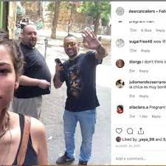
In the picture, three passionate individuals are engaged in online activism, channeling their efforts toward combating discrimination. Their shared goal of creating positive change is evident in their determined expressions and focused demeanor.
The composition of the image highlights the individuals' unity and collaboration. They are positioned side by side, symbolizing their commitment and solidarity in combating discrimination. Their posture exudes confidence and determination, indicating their unwavering belief in the importance of their cause.

Freedom of worship for all religions:
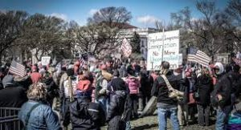
In the picture, a diverse group gathers together, passionately advocating for freedom of worship. Their unity and determination to protect this fundamental human right are vividly depicted.
The participants hold signs and banners adorned with powerful slogans, symbols, and messages advocating for protecting and preserving religious freedom. These visual expressions serve as a collective voice, demanding the right to practice their respective religions without fear of persecution or discrimination.

Opportunities regardless of ethnicity:
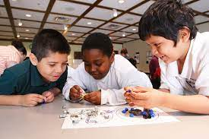
In the picture, three boys of different races are captured studying together, wearing the same uniform, to eliminate educational disparities. The image reflects the power of diversity and inclusivity while acknowledging the existence of ethnic diversity within America.
The boys wearing the same uniform symbolize equality, demonstrating that every child deserves an equal chance to succeed academically, irrespective of race or ethnicity. This visual representation emphasizes the importance of a level playing field for all students, regardless of their cultural or ethnic background.

Language barrier :
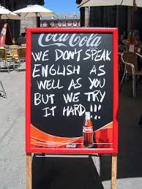
In the picture, there is a board prominently displayed, conveying a powerful message about language barriers in America. The board is filled with handwritten text stating, "Some people in America struggle to communicate in English, but they make genuine efforts to do so." The words are written with care and compassion, reflecting the artist's intention to shed light on a reality that often goes unnoticed.
The image's composition captures the essence of diversity and multiculturalism, showcasing the tapestry of America's population. It features individuals engaging in everyday activities, such as conversing, reading, or writing, while displaying their sincere attempts to communicate in English. The artist has depicted a range of expressions on their faces, conveying determination, perseverance, and a sense of belonging.

Protesting of the black race:
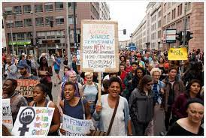
The picture's powerful scene unfolds, capturing a demonstration centered around Black people's lives in America. The image is filled with a palpable energy and a shared sense of purpose. The diverse group of individuals, united by their common cause, stands together, voicing their demands for equality, justice, and an end to systemic racism.
People of various ages, genders, and backgrounds influence the picture's foreground, all engaging in peaceful protest. Many hold up signs and banners adorned with bold slogans, calling for ending racial discrimination and police brutality. The messages on the signs are heartfelt and impactful, amplifying the collective voice of the movement.

References:
Race:
- American Anthropological Association: www.americananthro.org
Ethnicity:
- National Association for the Advancement of Colored People (NAACP): www.naacp.org
Religion:
- Pew Research Center: www.pewresearch.org
Language:
- International Association of Applied Linguistics: www.aila.info

