Operating System EvaluationAn operating system ( OS ) is system software that acts as an interface between the computer and the user, manages computer hardware and software resources, and provides necessary services to computer programs efficiently for a specific user.
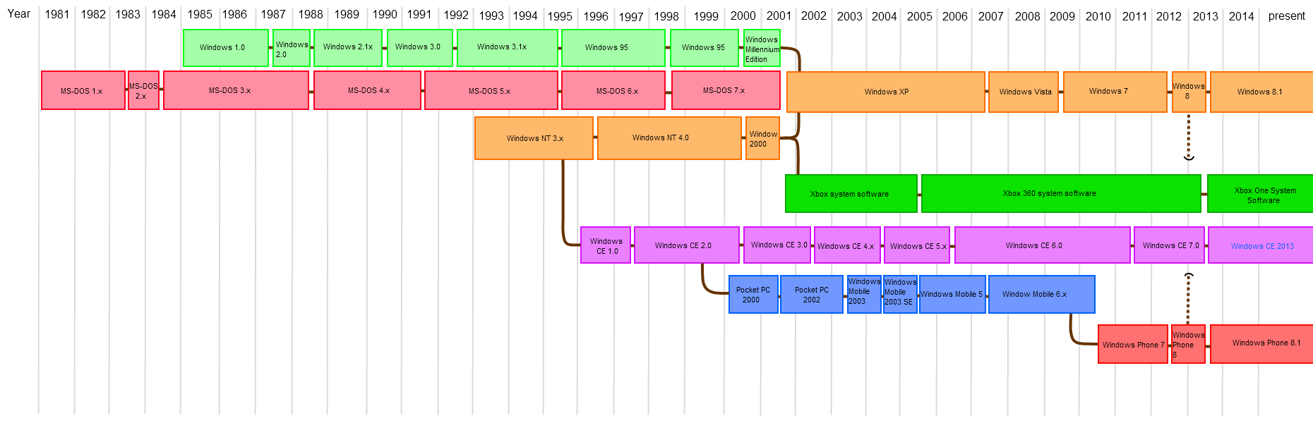
For hardware functions such as input and output, and memory allocation the OS acts as an intermediary between programs and the specific computer hardware, though at some point according to individuals user specifications, the application code is usually executed directed by the hardware and repetitively makes necessary calls to an OS function.

Operating System Evaluation; organizational Needs For An Operating System
The OS has a couple of tasks that it best performs in an organization for the utmost satisfaction of a specific user in an organizational profile performance.
Inventory keeping needs an operating system for systematically arranging and formulating table content. Proper record keeping concerning a company property needs more detailed data keeping for tracking their usage, new stock arrival, and the exact quantity and quality maintenance.
An organization's most discrete data and information such as formulas and procedures used to make certain products call for a more advanced operating system to store information in.
Data concerning the organizational profile, competition techniques handling strategies, and future proposed plans are kept in a more secretive system for the benefit of an organization to thrive and achieve desired goals.
An organization's technicalities, and procedures involved in running the company are more safe and well organized through modern technology in a more advanced operating system that enhances the proper smooth running of an organization.

Operating System Evaluation; Layered Architecture for an Operating System.
Is a systematic program that distinguishes software components into different layers in which the hardware is at the bottommost part, where each layer is responsible for certain functional tasks performance. These layers are designed in a certain way where layers below a layer provide certain services and the layers above are those that consume the service provided.
[caption id="" align="alignnone" width="1280"]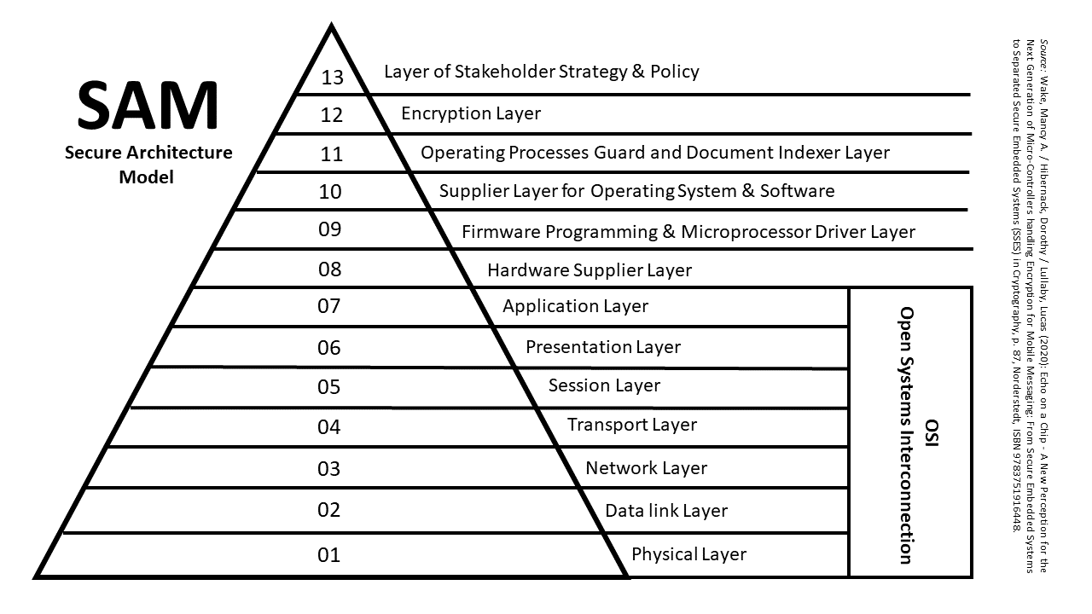 Operating System Evaluation- wiki[/caption]
This exercise is used in software engineering to create applications that are modular, scalable, and easy to maintain.
The layers sandwiched between the first and the last layer are responsible for system services and management such as CPU scheduling, memory management, process management, and I/O management.
Some terms and technicalities are put at hand where;
- the outermost layer needs where the user is able to interact with the operating system or interface.
- the lowermost layer is the hardware which consists of all the components of the device working in integration with the software.
- a certain layer is allowed to access all the layers below it but not those above it.

Operating System Evaluation; Multiprocessor Operating System
Is a program used in OS to boost the performance of multiple CPUs within a single computer system of an individual user. In this case, several CPUs are linked together such that a certain user's job can be divided and executed much more quickly and efficiently.
[caption id="" align="alignnone" width="994"] File:SMP - Symmetric Multiprocessor System.svg - Wikimedia Commons;[/caption]
Types of Multiprocessors;
Symmetrical; each processor in a symmetrical multiprocessing system runs the same copy of the OS, makes its own decision, and collaborates with other processes to keep the system smoothly running.
Asymmetrical; the processors in an asymmetrical system have a master-slave relationship where one processor serves as a master or supervisor processor and the rest receive commands and act correspondingly and fulfill the needs of a user.

Operating System Evaluation; Technical Evaluation of an Operating System
Your computer's operating system evaluation practice should include analysis and assessment of the hardware software interface, necessary techniques used in implementation processes and threads, the file systems supported by the operating system, the respective I/O system, and the OS security features.
Memory Management
Is the full functionality of the operating system which handles and manages the primary memory and moves processes back and forth between the main memory of a computer and the disk duration execution.
It keeps track of each and every memory-specific allocation detail regardless of being responsible for certain tasks or not.

