[Dee Dee’s Pawn Star Shop]
E-Commerce Website Development

[A proposal for the creation of an e-commerce website.]
2021
[]
PM 3000
11/21/2021

Executive Summary
Budget: $10000.00
Project Summary: Using the agile method, create a highly engaging e-commerce website. This will be developed within a set budget. Web design, hosting, and e-commerce solutions are all included in the budget. A "bargain of the day" area will be one of the specific items to be established. She'll utilize it to highlight specific sale products. A page for specific products she wants to buy from potential clients will be included in the project.
Term: 60 Days
Project Resources: Project coordinator, database architect, web site developer, business property, business applications, company equipment, virtual servers and hosting, Encryption and copyright through host, and URL are just a few of the job titles available.
Table of Contents

Executive Summary 1
Version Control 3
Project Charter 4
Stakeholder Register 5
Work Breakdown Structure (WBS) 7
Budget 9
Communications Matrix 10
Risk Matrix 11
Project Schedule 13
References 14
Appendices 15

Version Control

Version Number | Assignment Number | Date
1.0

Project Charter
[OVERVIEW OF PROJECT CHARTER:
C
harters establish the project within the organization and recognize the project manager as the person in charge of resources (Human Resources, Money, Procurement, et cetera) and the ability to utilize those resources. It defines what is known at the beginning of the project such as the Title, Timeframe, Starting Budget, Project Manager, Approach, and roles and responsibilities of the team members. Many projects experience “progressive elaboration,” or in other words, more is known about the project as it moves along.]
Project Title: Dee Dee’s Pawns Star Total E-Commerce & Website Solution

Project Start Date: 11/21/2021 Project Finish Date: 12/17/2021

Budget: $10,000.00

Project Manager: [Ricardo Charles]

Project Objectives:
- Show the timeframe when the project was finished.
- Create a list of services to use.
- Create a page for deals of the day
- Create a website to inquire what collectibles someone is looking to acquire
- Properly teach staff and the owner on how to use the program maintain Proper provincial statutes for sales tax
- Develop project data and user guides
- Provide one year of services

Approach:
- Set up proposal hosting
- Payment processing for e-commerce
- Create an e-commerce website and use search engine optimization to drive visitors to it.
- All users should be educated.
- At the end of the project, a one-year maintenance agreement will begin.

Stakeholder Register

Stakeholder Identification

Name | Role | Position | Contact Information
Jean Pierre | Sponsor | Business Owner | (516) 345-0987
Marie Saint Pierre | Project Manager | PM | (718)543-6523
Jean Mac Sylvain | Project Development | E-Commerce & Coaching | (631)223-1223
Jennifer Jean Baptiste | Project Development | Web Designer | (854) 900-6543
Stakeholder Assessment
Requirements | Communication Needs | Frequency of Communication | Expectations | Influence on the Project | Interest and Power
Project  Sponsor | Regular | everyday | Authorizations | High | High
Project  Manager | Regular | everyday | supervising the project | High | High
Project  Developer | Moderate | every week | E-commerce and coaching products and services | Low | Low
Web  Developer | Regular | everyday | Creating a website | Medium | Medium

Jean Pierre has attempted to gain his sales capabilities by going global online for a long time. Her justification for the program's necessity to his company.
- Market sales have increased.
- Improved customer service
- During the Covid-19 epidemic, he will be able to better support consumers remotely.
- During the Covid-19 epidemic, increase sales. Inventory should be promoted overstock for promotional resale.
- On a worldwide scale, locate missing parts from his collections.

Work Breakdown Structure (WBS)
[OVERVIEW OF WORK BREAKDOWN STRUCTURE
A
Work Breakdown Structure (WBS) is included in the Scope Statement Documentation. Usually, there are TWO views.
The first view is a hierarchical one that is usually worked upon by the project manager and team to discover exactly what tasks need to be done and in what order. (You will have to show more detail or levels than these examples.)
WBS Hierarchy Example (Created in Microsoft Visio, saved as a .jpeg picture, and inserted into this Word document)]
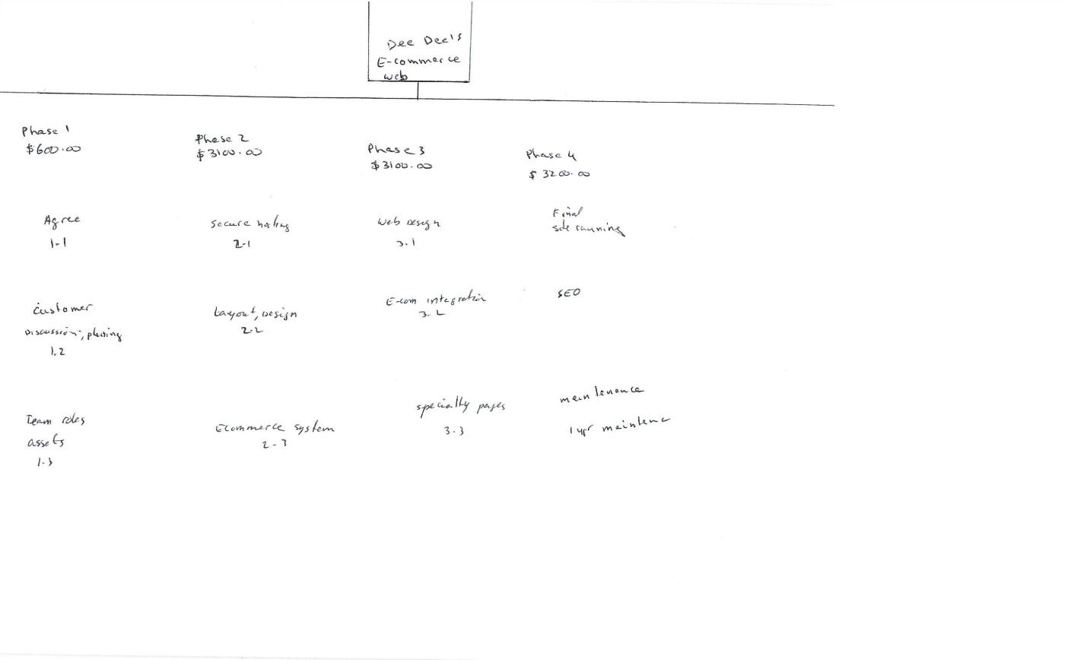
The second view is a list view or outline of the WBS.
Project: Building a Garage
- Initiate
  - Accept the Project's Terms
  - Find out what your customers want.
- Plan
  - Operating on a Secure Server
  - Start with the first design and layout.
- Execute
  - Design for the Web
  - E-commerce Platform Incorporation
- Monitor & Control
  - The website is now live on the webservers after its final upload.
  - SEO services (search engine optimization.)
- Close
  - Maintenance.
  - It is a one-year maintenance agreement.

Budget

Communications Matrix
Information | Provider | Recipient(s) | Frequency | Medium | Location
Status Report | PM | Sponsor | Bi-weekly | Email | SharePoint
Weekly Project Group Meeting | PM | PM, E-com, Web Dev | Every day | ZOOM | Remote
Daily  Updates | Web Dev, E-com | PM | everyday | Microsoft Note | Remote

Glossary
- PM = Project Manager
- E-com= E-Commerce
- Web Dev= Web Developer

Risk Matrix

Risk | Probability (L,M,H) | Severity (L,M,H) | Mitigation Approach
Team skillsets not up to par | M | H | Train team members on new technology.
Website issues | M | L | Make sure every software is updated
Remote team | M | H | Make sure all communications are clear and data on time
Time | H | M | Complete all the tasks on time
Disappointed clients | L | L | Examine every detail to ensure it is properly installed and is safe.

Reference
2020 ProjectManager.com, Inc. Recovered (2020)
https://www.projectmanager.com/blog/create-project-management-schedule
How Much Does a Website Cost in 2021? (Full Breakdown) (websitebuilderexpert.com)
Order PSD to HTML conversion, front-end development. – PSD2HTML®

