4.2 - What is leadership, and who is a leader?

Let’s look back to the exercise where you had to choose one of those four leaders.
We all have different ideas about who is and isn’t a leader. Whether you agree or disagree with what other people think, this isn’t as important as what your choice of role models reveals about you.
Leadership is a complicated concept. Indeed, whether someone is considered to be a leader or not is highly contentious. While we often hear the words ‘leader’ and ‘leadership’ used, there’s still a lot of debate about what these words actually mean. Even if we agree on who is a leader, the reasons we give to explain why are often very different.

As such you can learn more about the person describing their leadership role model than their chosen leader. For example, if we consider political elections, even if someone is voted in there are still vocal contingents of people rejecting them as a legitimate leader. If you were to speak to an anti-Monarchist in Britain or Australia, they may say the Queen isn’t a true leader.
There are three conclusions to be drawn from this:
- We have different views on who we regard as a leader and who we don’t.
- Even when we agree on who we think is a leader, we express different reasons for explaining why.
- There is no-one who is universally accepted as a model leader.
This is important to understand. Leadership is in the eye of the follower. You will be perceived as a leader if people feel the desire to follow you. And what compels us to follow people will always be different; some of us will agree but we will never all agree. It is also why we would like to focus more on ‘what is leadership’ as opposed to just ‘who is a leader?’ Leadership is something you can practice, it is a process. It is less about who you are and more about what you do.
In this section, your learning will be guided by the following questions:
- How is leadership defined?
- What makes leadership and management different?
- Is there such a thing as a born leader?

Overview

What is leadership?
Video: 4.2 - MBA706_-_Defining_Leadership

From an exploration of leadership definitions we can conclude four things:
1. The definition of leadership has evolved over time.
2. There are competing definitions, but the majority have three things in common:
  - followers
  - influence
  - goals.
3. How we define leadership is important as it distinguishes it from management. Not everything is about leadership.
4. Contemporary approaches see leadership as a process as opposed to being held by a single ‘leader.’

Leader or Manager?
Video: 4.2 - MBA706_-_Are_you_a_leader_or_a_manager_

As you can see from the table below, management is not a bad thing. You need to have management as well as leadership in organisations. To harness your leadership potential you need to be able to diagnose when would be a good time for management, and when is the time for leadership.
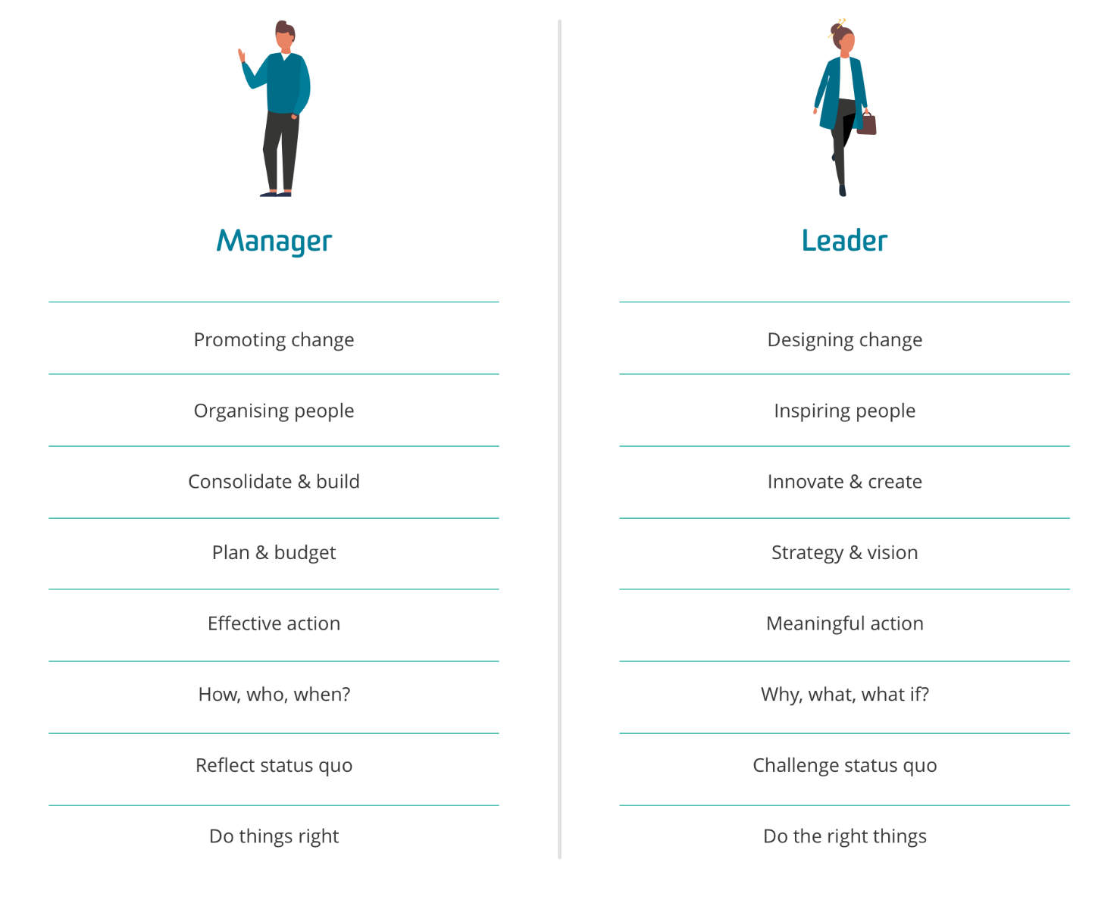
(Bennis 1994)
Leader or manager? text version

Your power and influence
As leadership is an act of influence, if you don’t have power then you can’t influence. If you can’t influence then you can’t be a leader.
Power has been defined as the ability to get someone to do something they would not otherwise have done (Morgan 1997). In other words, power is about the capacity to influence others, while influence is concerned with producing desired behavioural or psychological effects in another person.
A person’s power is determined by two factors: personal attributes and position characteristics. Personal power is your source for influencing and leading. Positional power is related to your role and is your power for managing.

Personal power
Several personal attributes foster power:
- Expertise: Are you considered to be an expert in your chosen field?
- Personal attraction: Do people like being around you?
- Extra effort: Do you ‘go the extra mile’ at work?
- Legitimacy: Is your expertise, attraction and effort seen to be relevant and important to your organisation?
Each of these attributes are within your direct and personal control. So even if you don’t have ‘positional power’, that is, are not very senior in your workplace, you still have the capacity to exert influence by harnessing your personal power. This is why ‘pure’ forms of leadership are more often seen at lower levels of organisations rather than in more senior roles.

Positional power
On the other hand, if your position has power (eg the CEO), then people will be following you because of your position, not necessarily because of who you are as a person. Whether you have ‘positional power’ depends on where you sit in your organisation. It’s called ‘positional power’ because the power does not belong to you; it belongs to the role. If you were to leave the role, you wouldn’t take the power with you, it would be left there for the next person to take up.
The sources of positional power are:
- Centrality: this is the relative position in a communication network. Central positions have greater power. Therefore to increase power, you would need to take a central role in communication networks.
- Criticality: this refers to the uniqueness of a task assignment. Critical tasks are often assigned to one position. In other words, taking on tasks that are critical to the work performed by others increases power.
- Flexibility: the amount of discretion vested in a position. Flexible positions foster power because they do not involve close supervision and a requirement to do everything by the book. This allows scope for innovation and personal achievement.
- Visibility: the degree to which influential leaders in an organisation are aware of a person’s task performance. If you are not visible, then you need to find ways to become visible to the people who matter.
- Relevance: the relationship between the tasks performed by individuals and organisational priorities. The more your role is directly aligned with the strategic outcomes of the organisation, the more power you will have, which is why some areas of an organisation are treated better than others. For example, they may be more profitable or have greater industry prestige and, as such, are considered to hold more relevance.

To exert influence and lead, you must have a clear understanding of which sources of power are available to you. And for the process of leadership to develop, you can now start thinking about which sources of power you already have and which sources you would like to cultivate.

Born to lead?
From what we can see in the previous section, power is something you acquire. It isn’t necessarily something you are born with. Yet a person's innate characteristics, and whether that predisposes them to greatness, often preoccupies us. It’s not a silly question given that ‘personal attraction’, one of the elements of personal power is often described with a more familiar term: charisma. This is often regarded as an innate quality, which leads people to believe that some people are just ‘born with it.’
This was one of the first questions that sparked leadership research, that is, what are the traits associated with effective leadership?
The trait approach to leadership was one of the first attempts to study leadership-in-action. This approach sought to determine whether inherent characteristics are shared by effective leaders. Traits have been defined as ‘stable or consistent patterns of behaviour that are relatively immune to situational contingencies’ (Allport 1966), and more recently, as ‘personal characteristics that foster a consistent pattern of leadership performance across a variety of group and organisational situations’ (Zaccaro et al 2004).
Early researchers sought to determine if any of the following were common across the fields of leader emergence and leader effectiveness:
- Physiological (appearance, height and weight)
- Demographic (age, education and socioeconomic background)
- Personality (self-confidence and aggressiveness)
- Intellective (intelligence, decisiveness, judgment and knowledge)
- Task-related (achievement drive, initiative and persistence)
- Social characteristics (sociability and cooperativeness)
In terms of trait theory('Trait Theory of Leadership' (Management Study Guide ), these researchers determined that successful leaders definitely have interests, abilities, and personality traits that are different from those of the less effective leaders.
This line of research stymied when it was determined that having the traits didn’t consistently predict leadership effectiveness. It was also difficult to assess whether someone’s attributes were actually innate or skills, abilities and behaviours they had acquired over time.
This is what sparked the ‘skills and behaviours’ approach to leadership that started in the 1950s (and continues to this day in many respects) gave attention to two key questions :
- Is it possible to isolate the necessary skills and behaviours of effective leaders? If so, what might some of those be?
- Can those skills and behaviours be taught so people could either acquire or emulate them and thus become leaders?
The most popular approach from this wave of research is the Blake Mouton Managerial Grid. It shows that you can adapt your approach according to either:
- a concern for people
- a concern for results
Impoverished
The Impoverished or "indifferent" manager is mostly ineffective and is completely disengaged from followers, having little interest in creating a motivated and successful team.
Produce-or-Perish
Also known as "authoritarian" or "authority-compliance" leadership, people in this category believe that their team members are simply a means to an end. The team's needs are always secondary to its productivity, with very strict work rules and an emphasis on reward and punishment to motivate.
Middle-of-the-Road
A Middle-of-the-Road or "status quo" leadership tries to balance results and people, but this strategy is not as effective as it may sound, as followers are not inspired with their needs largely unmet.

Country Club
The Country Club or "accommodating" style is most concerned about followers’ needs and feelings. While the team may be relaxed and fun productivity may suffer as a result.
Team leader
This is seen to be the most effective leadership style. It reflects a leader who is passionate about his work and who does the best they can for the people they work with, showing commitment to the organisation and their team, inspiring and empowering their followers.Even back in the 1960s when this research came to the fore, we started to realise that leadership is less about who you are and more about what you do.
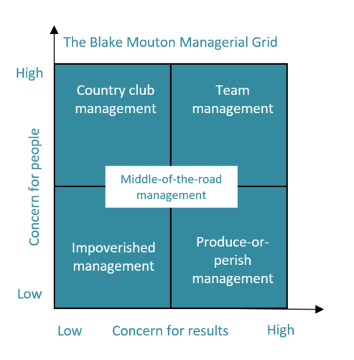
(Adapted from Blake & Adams McCanse 1991)

Summary
In this section we have set an important foundation to understand more about leadership and therefore how you can become more effective at leadership. We have explored:
- What leadership as a concept really means
- How and why leadership is different to management
- Whether an effective leader is born not made
Don’t forget to share your views and experiences in the discussion forum for key concept 1. We will be contemplating the questions ‘Does my team see me as a leader? How do I know this?’.

References
Allport, G. W. (1966). Traits revisited. American Psychologist, vol. 21, no. 1, pp. 1-10.
Blake, RR. and Adams McCanse, A. 1991, Leadership Dilemmas – Grid Solutions, Gulf Publishing Company, Houston.
Juneja P., Trait Theory of Leadership, Management Study Guide, retrieved 28 March 2019, <https://managementstudyguide.com/trait-theory-of-leadership.htm>.
Zaccaro, SJ., Kemp, C. & Bader, P. 2004, 'Leader traits and attributes', The Nature of Leadership, eds J. Antonakis, A. T. Cianciolo, and R. J. Sternberg, Thousand Oaks, CA, Sage Publications, pp. 101–124.

4.3 - Leadership at the right place and at the right time
The workplace is a key factor in a leader’s success.
Success means different things to different people and is strongly influenced by the organisation in which you work.
For example, in my job success means getting good student evaluations and publishing in prestigious academic journals (it sounds easy when I say it like that!). The way success is defined in my workplace shapes the work I do on a daily basis.
For me to be seen as a leader in my field, I need to do things that are probably quite different from what you need to do to be a leader in your field (unless, of course, your field is academia).

Reflecting on what success means in a range of workplaces highlights the diversity of organisations within which leadership is practised and leads to a heightened awareness of the various ways success in leadership is enacted.
In this key concept we are going to look at the factors outside of the individual leader that impact on leadership effectiveness. To do this we are going to look at three key leadership theories:
- Situational leadership
- Contingency leadership
- Leader-Member Exchange
These three approaches are interrelated so it doesn’t mean that one is necessarily better than the other. You should use them as conceptual lenses and frameworks through which you can view your world.
Leadership is a complex topic and having more weapons in your arsenal of leadership practice is essential. You can use these theories to understand more about your current world of work, or use them as prescriptive tools as guidance for what to do when you need extra assistance when confronted with a leadership challenge.
In this section, your learning will be guided by the following questions:
- How should leadership styles differ to match the followers and situation at hand?
- How does your relationship with followers impact the style of leadership you choose?
- What role does trust play in the leader-follower relationship?

Overview
What all of the theories explored so far have in common is that their focus is very much on the individual leader: who they are, what they do, and how they behave. As such, these three groups of theories not only seek to answer the question ‘what makes someone a great leader’, but try to answer that question by looking only at the leader and only at a specific part of their role.
However, leadership is about more than leaders. In this key concept we will look at the situation in which leadership takes place and how an effective leader needs to be adaptable. We will also be looking at the extremely important element of leadership: the follower. We explore how followers’ needs are identified and met, and how the leader’s relationship with them impacts on their leadership practice.
Leaders can influence some of these factors, but others are beyond their capacity to control. In this course we explore what leaders can and can’t change about their leadership environment.

Situational leadership

Video: 4.3 - MBA706_-_Location,_location,_location

If you want to be an effective leader, when the situation changes, so must your style of leadership.
Situational leadership is, as the name suggests, primarily concerned with how leadership effectiveness can vary according to situations. For example, based on adaptations to the Hersey and Blanchard (1969) leadership model, leaders need to assess their subordinates’ development level and choose the most relevant style of leadership to match the situation.
What the diagram below shows us is that a leader identifies the followers' development level based on how committed they are to their role and organisation and their level of job-related competence. This will influence the style of leadership that the leader should adopt. The style is based on a mix of directive versus supportive behaviours.
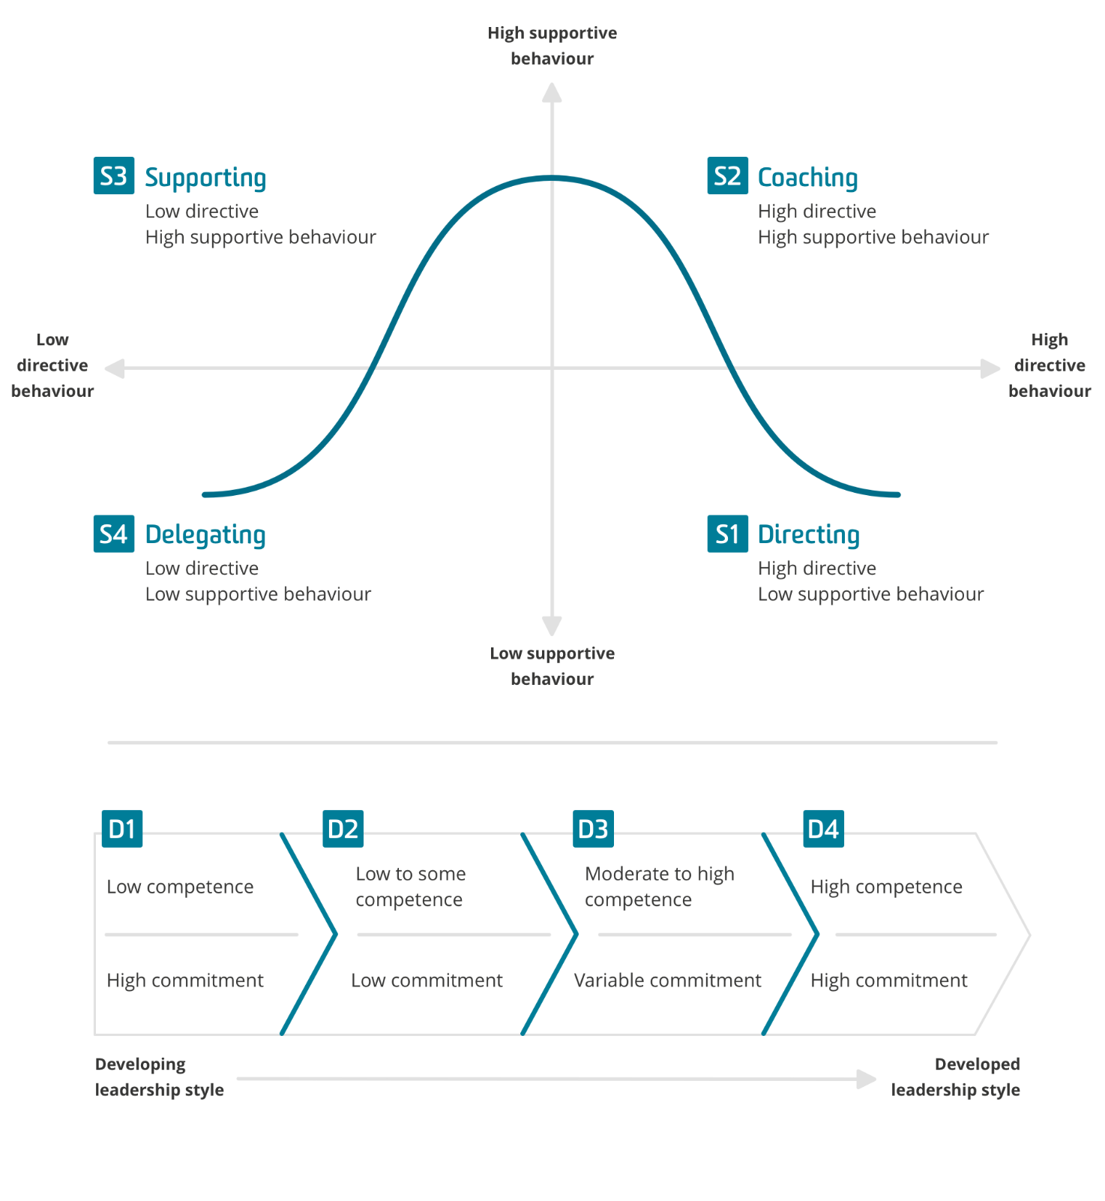
These four styles can be further summarised as follows:
Directing | Communication focuses on goal achievement by giving instructions about what and how to achieve outcomes, with careful supervision throughout.
Coaching | Leader focuses on both goal achievement and socio-emotional needs of followers. Leader is more involved by giving encouragement and seeking input. It’s similar to directing as the leader decides what and how to achieve goals.
Supporting | Emphasises followers’ skills to achieve outcomes as opposed to a goal focus. The followers have more control and the lead gives a lot of social support, such as active listening and praise.
Delegating | Followers take responsibility for goals and planning, and the leader has less input and social support, facilitating confidence and motivation.
The model suggests a matching of leadership style and development, as shown in the table below:
Development Level | Leadership Style
Low Development (D1) | Directing (S1)
Medium Development (D2) | Coaching (S2)
Medium Development (D3) | Supporting (S3)
High Development (D4) | Delegating (S4)
Therefore to effectively practice situational leadership, diagnose the development level of the followers, choose the appropriate leadership style and demonstrate the appropriate mix of supporting and directive behaviours as per model.
As with all theories, there are strengths and limitations of situational leadership.
In summary, there’s not a lot of evidence for the model actually working in practice though people do find it useful nonetheless.

Contingency leadership
Video: 4.3 - MBA706_-_Going_with_the_flow

According to contingency theory, effective leadership is when a leader (and the leader’s style) is appropriately matched to the context, rather than solely focusing on the style of leadership. Compared to situational leadership, contingency leadership has more support in scholarly and practitioner research. One major difference between the two models is that role of the leader is actively included in contingency theory. It’s called ‘contingency’ theory because leader effectiveness is contingent on the match between the leader’s style and the situation.
The most popular approach to contingency leadership was developed by Fred Fiedler in the 1950s and 60s. Fiedler, a psychologist, studied different leaders in different environments, determining which matches produced the best results. In the face of continued criticism of his theory, Fiedler (cited in Miner 2005) wrote that the greatest contribution of contingency theory to an understanding of leadership was ‘the conceptualisation of leadership effectiveness as the product of an interaction between personality and situational factors’ (Miner, 2005 p. 245).
Contingency leadership has strengths and limitations.

Contingency leadership - strengths and limitations

Strengths
On the upside, there’s a lot of research supporting contingency leadership as a viable theory. It’s forced leadership scholars to look beyond the leader and learn more about how environmental factors impact on leader success. It’s also removed some of the pressure on leaders from any expectation that they’ll be effective in all circumstances. For practical purposes, contingency theory can predict the likelihood of a leader being successful in a particular situation. The data gathered from Least Preferred Co-Workers (LPC) questionnaires can be useful for organisations to understand the preferred leadership styles of their employees.

Limitations
Unfortunately, we don’t quite know the finer details about how or why contingency theory works in practice and this is one limitation of this approach. For example, the theory argues that those who score high on the LPC scale are more relationship-oriented and are most effective when situations have moderate stability. Fiedler posited that when there’s a mismatch, leader stress and anxiety leads to poor outcomes. However, why styles match their particular situation is unclear beyond the assumption that task-oriented people like control, and control is most needed in extreme circumstances. There are also questions about whether the LPC scale is entirely accurate and the instructions clear since it requires respondents to characterise another person’s behavior, which can lead to projection. Another limitation is that it doesn’t provide suggestions for what to do when there is a mismatch beyond encouraging the leader to change the situation rather than themselves, which isn’t always realistic.

Leader-Member exchange
What has been missing so far is attention to how leaders interact with their followers.
Video: 4.3 - MBA706_-_Leader_member_exchange

These approaches take a slightly different view than the other theories we’ve examined, as they view leadership as a process. That is, leadership only happens due to an interaction between leaders and followers; it doesn’t occur in a social vacuum and, as such, without followers there is no leadership.
While contingency theory acknowledges that the nature of the relationship between leaders and followers impacts on the efficacy of leadership, it also assumes leaders treat all followers in the same way. Leader-member exchange (LMX) is based on the proposition that, within a group of people, the leader will have better relationships with some followers than others.
In the earliest research, the focus was on vertical dyads: put simply, this means the reciprocal relationship between leader and follower.
In examining these relationships, researchers found that within most work teams, ie based on the relationships between leaders and followers, there were ‘in-groups’ and ‘out-groups’; with ‘in-groups’ receiving the most favourable treatment from the leader.

Is LMX theory an effective way to practice leadership?
Leader-member exchange (LMX) theory, like all of the theories examined so far, also has strengths and limitations.

Leader-Member Exchange - strengths and limitations

Strengths
LMX theory is useful in understanding how and why some relationships between leaders and followers are inconsistent. For example, it shows that followers should invest more in their relationship with their leader to reap rewards, while, for leaders, it suggests that cultivating relationships can afford positive outcomes at both individual and group levels. Research by Graen and Uhl-Bien (1991) advocates developing relationships and, instead of only identifying those who may be in the in-group and out-group, suggests that leaders should aim for developing high-quality relationships with everyone, even those outside of their immediate teams. In this sense, LMX theory is both descriptive and prescriptive. Another benefit of this approach is that it looks at the interactions and relationships between leaders and each subordinate, something the other theories don’t do. It also emphasises the importance of communication to facilitate relationships, particularly when it comes to developing mutual trust and respect. By highlighting the presence of in- and out-groups, leaders are alerted to develop as many positive high-quality relationships as possible. Indeed, there’s significant evidence pointing to a vast array of positive outcomes afforded by this approach, including commitment, innovation, citizenship, empowerment, justice and career progression.

Limitations
LMX theory does have drawbacks in that it doesn’t fully explain how to communicate in order to develop trust and respect. It also doesn’t account for how different situations may impact on the nature of relationships

Takeaway messages
Workplace norms, organisational culture and social networks can all impact leadership relationships, but these aren’t addressed in LMX theory. However, what you can take away is this:
- LMX theory alerts us to the fact that there will naturally be in- and out-groups in teams, and that leaders (and followers for that matter) need to actively try and subvert these to create fair and equitable workplaces.
- LMX theory shows that people who have high-quality networks in an organisation are more likely to extract benefits from these relationships. For followers, this applies largely to individuals, while for leaders, the benefits should not be self-interested.

Summary
These approaches to leadership have a number of benefits and are still practised actively around the world, but there are some notable drawbacks too. What we can take away from them both is that:
- Leadership does not occur in a social vacuum.
- The environment in which we practice leadership can have a significant impact on our effectiveness as leaders.
- Our relationships with followers are key to leadership success
You should be starting to see the complex puzzle of leadership taking shape. In other words, leadership doesn’t just involve a leader deciding how to lead, but rather a process that involves engaging with others and seeing what leadership approach best suits different circumstances.
As leaders, we need to consider the people in our team with whom we don’t have such positive relationships. Not only can poor relationships with these people lead to poorer outcomes for them, but as leaders, it’s our responsibility to ensure that all our followers are performing to their best ability and that we’re not treating people inequitably.

References
Hersey, P. & Blanchard, KH., 1969 Life Cycle Theory of Leadership, Training & Development Journal, vol. 23, no. 5, p. 26.
Miner, JB, 2005 Organizational behavior 1: Essential theories of motivation and leadership, ME Sharpe, Armonk, NY.

4.4 - Contemporary leadership lenses

Even though we have moved on beyond looking at the individual attributes of leaders, one approach to leadership that emerged in the 80s still has lots of currency now, that is, transformational leadership. Transformational approaches to leadership dominate most contemporary research within this field and includes an attribute that has been rated as the number one attribute for effective leaders worldwide: charisma.
However, it is not just charisma that is deemed to be relevant. One of the most popular approaches to leadership these days is authentic leadership. Authentic leadership has received as much attention from practitioners as from academics.

The problem with this is that its popularity has lead to much confusion and ambiguity about what authentic leadership really means, and whether it works in practice. That is what we will be exploring in this key concept.
In this section, your learning will be guided by the following questions:
- What is transformational leadership and how does it work?
- What is the difference between charismatic and transformational leadership?
- Is being an effective leader simply a case of just being your authentic self?

Overview
In this last key concept we are addressing two of the most popular approaches to leadership, transformational leadership and authentic leadership.
Transformational leadership is related to both charismatic and transactional leadership. However they are all quite different so it is important to understand the differences. To do so we first start with an understanding of charismatic leadership and build this understanding to incorporate transformational leadership.
We will conclude this concept and this topic with authentic leadership, using the opportunity to reflect on whether we are being our authentic selves and if our authentic selves are the best representation of the effective leader we strive to be.

Charismatic leadership
Video: 4.4 - MBA706_-_Is_charisma_Important_for_leadership_

Charismatic leadership has become a significant topic of interest for both leadership researchers and those seeking to practice leadership in the workplace.
Charismatic leadership rose to prominence in the 1980s, but has a strong foundation in trait leadership. That is, charisma is largely seen as something you’re born with as opposed to something you can learn or acquire. This table outlines the personality characteristics, behaviours, and effects of charismatic leadership on followers that are most commonly accepted by contemporary researchers.
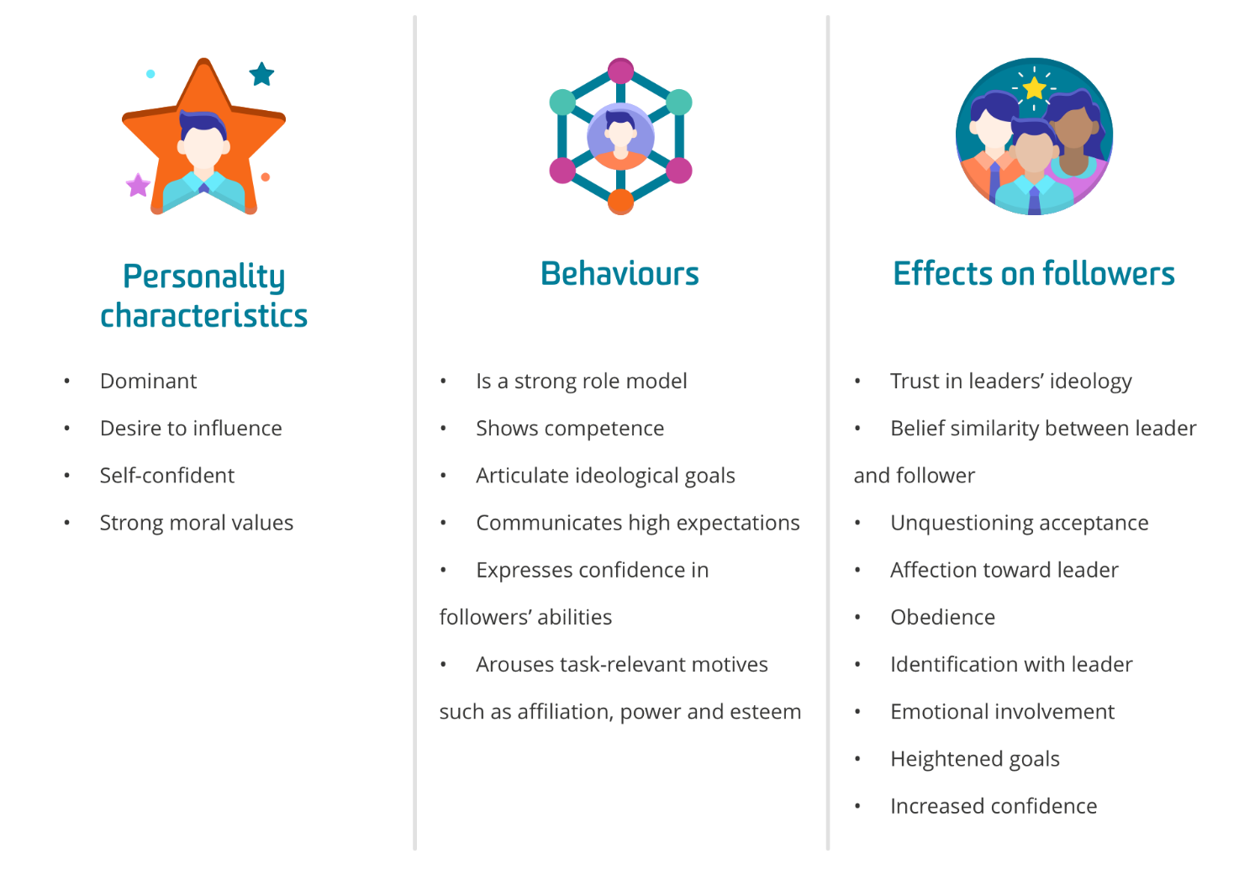
Charismatic leadership: text version

From charismatic to transformational
Although charismatic leadership remains a very popular way to look at leadership, it’s largely been superseded by transformational approaches to leadership. Transformational leadership provides a broader view of leader activities and is the first theory we encounter (though not the first one with the idea) that considers the importance of followers in the leadership process. Transformational leadership comes closest to our definition of leadership as a process of influence.

Video: 4.4 - MBA706_-_From_charisma_to_transformational_leadership

Both transformational and charismatic leaders achieve extraordinary results, are inspirational and are masterful communicators. There are many similarities between transformational and charismatic leaders. However, along with the positive similarities, both types are capable of influencing followers towards unethical behaviours and goals. The main difference between the two types is that the focus of a charismatic leader is more often on themselves, whereas the transformational leader has a greater regard for the values and needs of their followers.
For example, transformational leaders seek to make a contribution to the development of others through empowerment, which means when they leave an organisation, they leave behind followers with greater levels of morality and higher aspirations. In contrast, a charismatic leader’s attributes can’t be transferred to others, so when they leave the organisation, so do their characteristics (both actual and perceived).
Another key difference between these two types of leadership approaches is that followers tend to have stronger emotional attachments to charismatic leaders due to their likely emergence in times of crisis while transformational leaders are not dependent on uncertainty to gain power and influence.

Video: 4.4 - MBA706_-_Charismatic_vs_transformational_leaders

There’s also a third approach that we’ve previously alluded to: transactional leadership. The distinction between transformational and transactional leadership emerged in the 1970s based on the work of Burns and gained popularity with Bass’ work on transformational leadership in the 1980s.
The easiest way to distinguish between transformational and transactional leadership is to think back to the discussion on leadership versus management.
In summary, transactional leadership is more akin to management, using command, control and reciprocity to create outcomes. Transactional leaders tend to promote compliance through rewards and punishments. That said, keep in mind that a transformational leader can also engage in transactional leadership approaches if required — after all, not every leadership situation requires transformation. Transactional leadership sits between the relaxed laissez-faire styles of leadership and transformational. Laissez-faire leadership tends to be a ‘hands off’ style that, like other approaches, has its own advantages and disadvantages.

Authentic Leadership
Is ‘just be yourself’ good advice for leaders?

Video: 4.4 - MBA706 - To thine self be true

Authentic leadership has received as much attention from practitioners as from academics. The problem with this is that its popularity has lead to much confusion and ambiguity about what authentic leadership really means, and whether it works in practice. One of the key messages to emphasise is that being an ‘authentic leader’ is not as simple as ‘just being yourself’. Harter (2002) describes authenticity as ‘owning one’s personal experiences, be they thoughts, emotions, needs, wants, preferences or beliefs, processes captured by the injunction to “know oneself”’ (p. 382). Hence, authenticity involves being self-aware and acting in accord with one’s true self by expressing what one genuinely thinks and believes (Gardner et al 2011).
Being your authentic self as a leader assists in developing positive psychological well-being and self-esteem, and has been shown to lead to a number of other positive outcomes for both leaders and followers.
For example, it’s been shown to empower followers, increase satisfaction and performance, as well as reduce burnout. There’s even some evidence to show it can enhance an organisation’s overall financial performance (Gardner et al 2011).
Authentic leadership has strengths and limitations from both a research and a practical standpoint.

Authentic leadership - strengths and limitations

Strengths
As noted, authentic leadership leads to many positive outcomes for leaders, followers and the organisation. Trust is both an enabler and an outcome of authentic leadership. Individuals thrive in situations where trusting relationships with others are part of the norm, particularly in times of uncertainty. Authentic leadership can be used to analyse situations and provides prescriptive guidelines for how leaders can improve their leadership practice. It fits well in today’s workplaces where ethical behaviour and moral standards are exhibited, and—unlike earlier approaches to leadership (such as trait theory)—anyone can be an authentic leader.

Limitations
While anyone can be an authentic leader in theory, in practice authentic leadership is a little more challenging. For example, it’s extremely difficult to change your values, so if your moral and ethical standards aren’t compatible with your organisation and the people you work with, being your authentic self won’t necessarily be accepted. Leaders are urged to ‘do the right thing’, but what ‘the right thing’ is can be very subjective. And who’s to say someone is being their authentic self or not? Because of this, it’s very difficult for people to research authentic leadership. There’s some evidence that authentic leadership leads to positive outcomes, but findings are mixed and there’s not as much empirical support for authentic leadership as there is for other approaches, such as transformational leadership. Also, we don’t really have any evidence to show that people can become more authentic even though, as an idea, it makes sense to us. Because of this, authentic leadership is more popular with practitioners than researchers despite the lack of a full understanding of how the various elements of authentic leadership really work.

Summary
Interestingly, even though we know leadership is more about the leader, in charismatic, transformational and authentic leadership, we can’t help ourselves looking back at the leader.
Transformational leaders tend to be other-focused, while charismatic leaders tend to be self-focused. Transformational leadership is different from charismatic and transactional leadership because it focuses more on the follower. One of the key aims of transformational leadership is to engender followers to not just meet the leadership goal but to improve and grow during the process, essentially becoming better versions of themselves. This key difference is also relevant to the distinction between charismatic leadership and transformational leadership.
A transformational leader can be charismatic, but a charismatic leader is not necessarily transformational. This is because a charismatic leader can be a very compelling person who draws people in but is less focused on how to make followers’ lives better and more focused on how to improve their own circumstances.
Even though these are very popular approaches to leadership they’re not without their limitations. For example:
- The onus of success is on the leader, with no recognition of other factors that can impact on leadership effectiveness.
- The leader is viewed as a ‘hero’.
- Leadership effectiveness is seen to come from the leader’s innate traits.
This extends to authentic leadership that is also very leader-focused.
One of the main reasons for this might be that people hear the words ‘authentic’ and ‘leadership’ together and assume it means they just have to be themselves, and not put any work into their leadership practice. In reality, authentic leadership is a little more complicated than that as it gives specific attention to moral and ethical standards. An important topic these days, more than ever!

References
Gardner, WL, Cogliser, CC, Davis, KM & Dickens, M 2011, ‘Authentic leadership: a review of the literature and research agenda’, The Leadership Quarterly, vol. 22, no.6, pp. 1120-1145.
Harter, S 2002, Authenticity, in CR Snyder & SJ Lopez (eds), Handbook of Positive Psychology, Oxford University Press, Oxford, pp. 382-394.

