MBA706
Leading People in Organisations

Assignment 2

Group 8

Contents
Introduction 2
Key Issue 1: Implementation of Strategic Human Resource Management (SHRM) & HRM Delivery Model 3
Symptoms: Derived from SHRM 3
Resource Based Theory 3
Ability-Motivation-Opportunity (AMO) Model 3
Recommendation 4
Key Issue 2: Organisational culture – Business Wide re-definition and communication 5
Symptoms: Derived from organisational culture 5
Attraction-Selection-Attrition (ASA) Model 6
Team Effectiveness Model 6
Recommendation 7
Key Issue 3: Organisational leadership 7
Symptoms: Derived from organisational leadership 7
Situational Leadership Model 7
Recommendation 8
Proposed Recommendation 9
Action Plan 10
References 11

Introduction

The purpose of this report by Group 8 Consulting is to evaluate the strategic position and effectiveness of Australian Tyre Traders (hereafter “ATT”) in relation to internal resource (people) development and the impact on current business performance, culture, and overall competitive advantage.
ATT, one of Australia’s largest tyre wholesalers, commands an extensive supply chain and wholesale network nationally, achieving gross sales of circa $90m over the previous two years which has coincided with rapid business growth.
In support of ATT’s key strategic pillar “Human Resources”, Group 8 consulting has identified the following three issues for review:
- Implementation of Strategic Human Resource Management (SHRM) & HRM Delivery Model
- Misalignment between human resource management and business strategy – I.e., lack of a clear understanding of employee and organisational needs in relation to human capital to meet strategic goals and activities
- No formal policies or procedures relating to the management of people or on-going performance management

- Organisation culture – Business wide re-definition and communication
- Lack of clearly defined business-wide values and communication of desired culture
- Limited performance measures and feedback mechanisms, guiding employee behaviour and performance against defined values

- Organisation leadership
- Lack of understanding of employee capabilities, business strategy (amongst employees), staffing needs and motivating factors at individual level
- Lack of formal performance review processes, formal recognition of employee loyalty, and commercial acumen training for employees
- Lack of succession planning
The following concepts and models were utilised to evaluate options available for the identified issues, and derive key recommendations for the Senior Management of ATT:
- Resource Based Theory (“RBT”)
- Ability Motivation Opportunity (AMO) Model
- ASA Model
- Team Effectiveness Model
- Situational Leadership Model

Key Issue 1: Implementation of Strategic Human Resource Management (SHRM) & HRM Delivery Model

From the evaluation completed, ATT is currently operating without a defined value-driven approach to human resource management (Anderson et al. 2007). The following symptoms have been identified, positioning Strategic Human Resource Management (SHRM) as a key risk and opportunity.

Symptoms: Derived from SHRM
- Lack of understanding of current employee capabilities and requirements needed to meet long term strategic goals
- No formal policies, procedures or systems relating to the management of people

Resource Based Theory
Without established SHRM policies and procedures representing ATT’s values, strategic direction and boundaries for organisational performance, ATT is omitting a critical source of competitive advantage (Shuwen et al. 2021). Through application of Resource Based Theory (“RBT”), ATT can achieve and maintain a competitive advantage through its human capital, by further deepening it’s understanding at an employee level (Chadwick et al. 2015).
Due to the size and owner-manager operating structure of ATT, in comparison to large enterprise-businesses, the Senior Management not only have a large impact on financial performance and business strategy, but also a heightened level of influence on human resources and the associated systems, polices and frameworks (Atkinson et al. 2021).
Resource orchestration is a combination of resources, capabilities, and managerial acumen that ultimately results in superior business performance (Chadwick et al. 2015). Without defined systems and policies in place to ascertain employee capability, development and performance, Senior Management are not able to systematically identify, develop and sustainably manage key people within the business.

Ability-Motivation-Opportunity (AMO) Model
The Ability Motivation Opportunity Model (Shuwen et al. 2021) has been applied to evaluate employee capability, motivation and needs within ATT. Organizational Emotional Capability (“OEC”) can be defined as ATT’s ability to understand, assess organisational emotions at an employee and business level and pivot to develop and refine business process, systems, and organisational structure (Shuwen et al. 2021).
As outlined by Figure 1, within a mature established business, deepening ATTs understanding of employee emotions and development needs, coupled with value driven SHRM, can deliver a sustained competitive advantage.
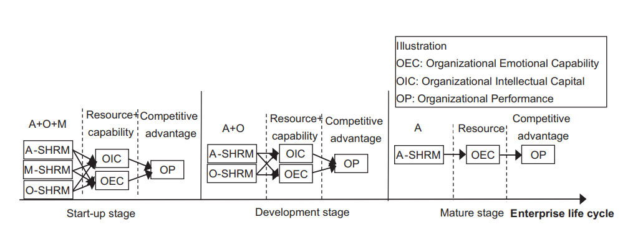
Figure 1: Ability-Motivation-Opportunity Model (Shuwen et al. 2021)

Recommendation
The following Human Resource Delivery Model (Table 1) has been developed for consideration by ATT. The strategic plan/model outlines the necessary focus and actions to further manage and utilise its current and future employee capability as ATT experiences future growth. Please note, elements of the below delivery model will be discussed throughout the following recommendations.
Table 1: ATT – Strategic Human Resources Delivery Model
ATT SHRM Focus | Definition | Actions
Organisational Development  (training, and capability assessment) | Implementation and development of systems, and procedures to foster development and support opportunities for current and future employees | - ATT story and history  - Business Vision & Mission Statement – Next 5 Years  - Systems, process, policies overview and hierarchy establishment
Leadership and Succession Planning | Focus on ATT business critical positions and capabilities, with the re-definition of current and future leadership needs identified against the current business strategy | - Development and implementation of internal leadership program(s)

Performance Management | Alignment of organizational, functional, and individual employee efforts toward the achievement of ATTs business objectives and goals. Clearly defined set of goals and tasks which outline business success, with systems that support feedback and corrective actions. | - Cloud Based Performance Management Tool  - Company-wide rollout
Strategic HR External Business Partner | Establishment of partnership with external HR Business Partner to enable optimized workforce design, HRM policy and procedure development and alignment to current industry standards. | - Review of HR strategy against business strategy  - Governance (metrics & reporting)  - Policy and Procedure development and review

Key Issue 2: Organisational culture – Business Wide re-definition and communication

Symptoms: Derived from organisational culture
Group 8 Consulting has identified the following critical issues:
- Lack of clear strategic vision throughout all levels of the business.
- Lack of clearly defined values
- No formal mechanism to assess employee performance
- Uncertainty surrounding the organisation’s ability to adapt through future growth periods.
Operations of an organisation can only be successful if there is a clear and common purpose across the organisation to establish a well-coordinated effort of the company’s resources (Groysberg et al., 2018).
Well-defined company values are important for the growth of any organisation. They provide management and employees a greater sense of purpose, focus, and engagement while reinforcing the company's wider objectives and feeding them through their daily work and decisions (Bussmann and Niemeczek, 2019).

There are several theories and concepts that can be used to analyse and explain the situation faced by the ATT.

Attraction-Selection-Attrition (ASA) Model
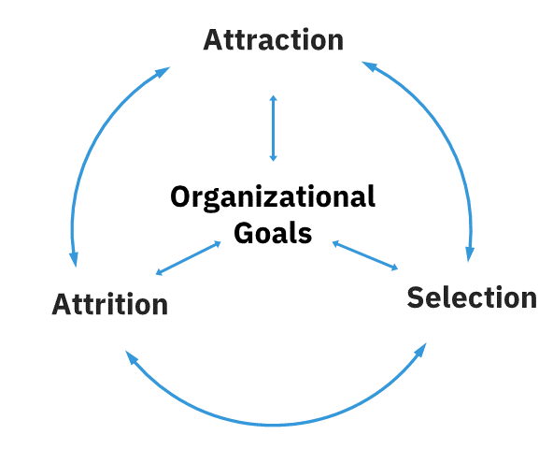
Figure 2: ASA Model

According to the ASA Model:
- Human resources are attracted to organisations whose staff resemble them in values, personalities, attributes, and interests.
- Organisations can recruit people with knowledge, abilities, and skills similar to what the existing workers possess (Kessler 2013).

ATT lacks a defined organisational culture, which provides the guiding framework for its employees to achieve the organisational objectives. There are no proper mechanisms to measure performance, evaluate and promote its employees.

Team Effectiveness Model

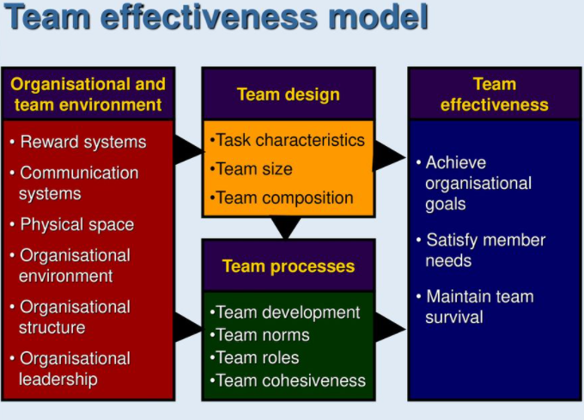
Figure 3: Team Effectiveness Model

According to the Team Effectiveness Model
- Teamwork is the ultimate competitive advantage because it is quite rare but powerful.
- Cohesive and effective teams are the lifeblood of powerful and successful organisations (Abuzid 2017).

Recommendation
Based on the ASA and Team Effectiveness Model, it is recommended that ATT:
- Develop and communicate well-defined company values, which will help employees understand what ATT stands for while guaranteeing employees a sense of security (Dermol and Širca 2018). Embedding strong organisational values will improve performance and ensure greater stakeholder satisfaction and engagement levels.

Whilst this will support creating a healthy workplace culture (strength), it may create confusion amongst some employees, mainly who are resistant to change (weakness).

Key Issue 3: Organisational leadership

Symptoms: Derived from organisational leadership
Group 8 Consulting has identified the following symptoms in relation to organisational leadership.
- Lack of understanding of:
  - capabilities of current employees
  - business strategy orchestration and impact throughout all levels of the organisation
  - what customers think of how ATT’s performance
  - staffing needs and lack of forward-looking plans
  - the motivating factors at individual level
- Lack of:
  - workforce diversity
  - formal performance review processes
  - formal recognition of employee loyalty
  - commercial acumen training given to employees
  - succession planning

Situational Leadership Model
Performing analysis based upon Situational Leadership Model, ATT can make use of the following advantages by adopting the model.
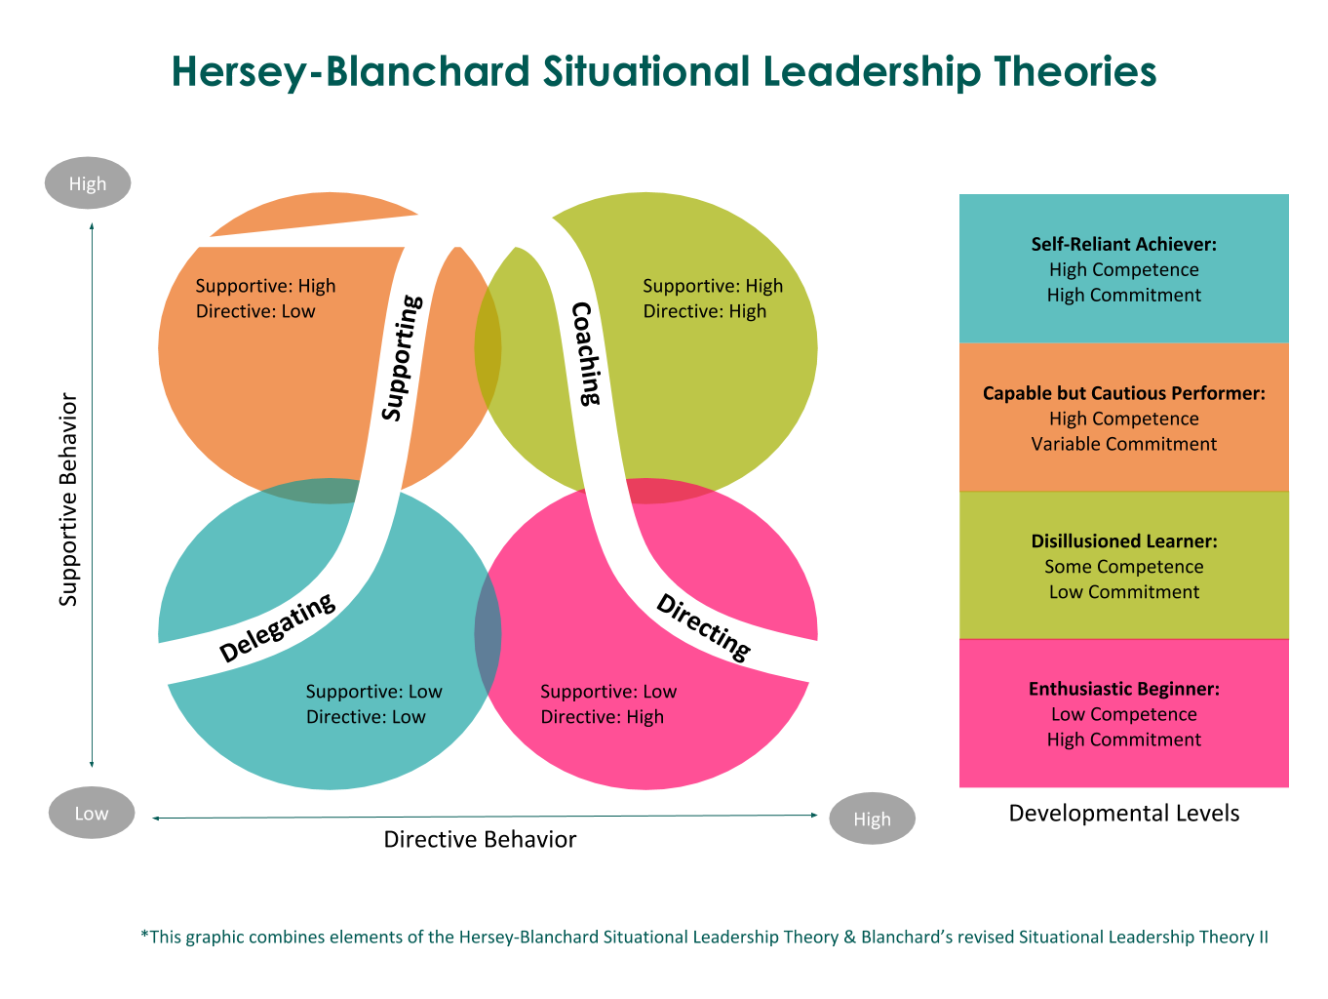
Figure 4: Situational Leadership Model
- Implementation of proposed SHRM Delivery Model and in support of the Ability Motivation Opportunity Model (Shuwen et al. 2021) will allow the ATT leadership to achieve a greater assessment of employee performance and capability.
- The situational leadership style will increase ATT’s ability to adequately influence employees based on style and behaviour.
- Increased flexibility by allowing ATT leadership to adapt its own style to meet the needs of employees (Graeff 1983).

ATT can separate out its staff, their development needs and future goals into respective quadrants and develop strategies to achieve them (Hersey and Blanchard 1969). The ATT leadership team needs to assess the respective development levels of the employees and adopt the most suitable leadership style. By adopting this model of leadership, ATT can find ways to:
- Identify and improve on capabilities of current and future employees.
- Communicate business strategy amongst employees.
- Identify staffing needs and formulate forward-looking plans; and
- Identify motivating factors at an individual level and organisational level.

Recommendation
To advise the ATT leadership team and deliver the proposed SHRM Delivery Model, it is recommended to appoint a dedicated, National People and Capability (P&C) Manager. By moving the HR function within the business to a global, overarching position, the HR practices will transition to a ‘centrally governed, regionally executed operating model’. This change assists ATT’s ability to orchestrate the required systems, procedure, and policy implementation throughout the business, by ensuring buy-in by all management levels through the actions and messaging of the ATT directors (Chadwick et al. 2015). The below are the expected positive management improvements of this strategic change:

- People leadership
- Influencing leadership behaviours that ensure effective people management activities.

- Strategic HR planning
- Providing strategic guidance on ATT’s human resource needs.
- Developing annual HR plan that aligns with the organisation and team goals.
- Human resources
- Implementing HR best practices.
- Developing leaders to manage people-centric issues to effective outcomes.
- Providing sound advice and developing strategies to prevent and resolve employment relations, performance, disciplinary, and grievance issues.

- Organisational development
- Providing advice, direction and leadership on ATT’s organisational culture and capability development.
- Engaging staff in creating a high performing culture that drives the organisation through a customer focused, flexible, and dynamic workforce.
- Managing training and development needs in a planned approach.

- Health and safety
- Managing and coordinating an Employer Assistance Program (EAP) (Lyubomirsky et al. 2005).

Whilst this initiative will support achievement of overall business objectives (strength), it will increase operational costs (weakness).

Proposed Recommendation

Group 8 Consulting is proposing the senior leadership to:
- Identify current capabilities and define the gap in relation to the core business areas against the required skillset to achieve the strategic objectives by the development and implementation of the agreed Strategic Human Resources Delivery Model / Plan
- Formulate and drive operational plans to bridge the gap by appointing a dedicated P&C Manager and obtaining external HR support.

Action Plan
Task/ Activity | Goal | Performance Measures | Timeline
Understanding strategic alignment between the roles and ATT’s strategic objectives  Staff planning and identifying gaps in staffing levels and capabilities  Formulation of HR processes and policies  - Employee Assistance Program  - Personal development plans  - Performance evaluation criteria | Obtaining employee buy-in for future growth  Smooth and uninterrupted transition into the growth phase  Increase employee loyalty and motivational levels  Reduce staff turnover and ambiguity around performance evaluation | Achievement of organisational growth KPIs  Reduced staff turnover  Increased staff satisfaction (measured through staff surveys) | Stage 1 (Immediate)  On-going and to be reviewed bi-annually
Formulating and executing a structured recruitment plan to fill the gap in staffing needs to the expected growth | Attracting the skillset that cannot be sourced internally | Attraction and retention of new staff in line with the recruitment plan | Stage 2 (upon completion of Stage 1)  On-going
Executing a leadership development program for staff to explore in-house leadership opportunities | Capability development  Staff motivation | Reduced staff turnover  Increased staff satisfaction (measured through staff surveys) | On-going
Undertaking a culture health check in view of maintaining an agile and less-bureaucratic organisation | Improve organisational culture | As above | Health check – Stage 1  Positive workplace culture – Ongoing

References
Abuzid, H. F. 2017. impact of teamwork effectiveness on organisational performance vis-a-vis role of Organizational Support. Journal of Engineering and Applied sciences, 12(8), 2229-2237.
Allen, M.R., Ericksen, J. and Collins, C.J. (2013), Human Resource Management, Employee Exchange Relationships, and Performance in Small Businesses. Hum. Resour. Manage., 52: 153-173. https://doi-org.ezproxy-b.deakin.edu.au/10.1002/hrm.21523
Andersen, K.K., Cooper, B.K. and Zhu, C.J. (2007), The effect of SHRM practices on perceived firm financial performance: Some initial evidence from Australia. Asia Pacific Journal of Human Resources, 45: 168-179. https://doi-org.ezproxy-f.deakin.edu.au/10.1177/1038411107079111
Atkinson, C., Lupton, B., Kynighou, A., & Antcliff, V. (2021). Small firms, owner managers and (strategic?) human resource management. Human Resource Management Journal, 1– 21. https://doi-org.ezproxy-f.deakin.edu.au/10.1111/1748-8583.12406
Bussmann, K.D. and Niemeczek, A., 2019. Compliance through company culture and values: An international study based on the example of corruption prevention. Journal of Business Ethics, 157(3), pp.797-811.
Chadwick, C., Super, J.F. and Kwon, K. (2015), Resource orchestration in practice: CEO emphasis on SHRM, commitment-based HR systems, and firm performance. Strat. Mgmt. J., 36: 360-376. https://doi-org.ezproxy-b.deakin.edu.au/10.1002/smj.2217
Dermol, V. and Širca, N.T., 2018. Communication, company mission, organisational values, and company performance. Procedia-Social and Behavioral Sciences, 238, pp.542-551.
Graeff, C.L. (1983). The Situational Leadership Theory a critical review. Academy of Management Review, 8 (2), 285-291. https://doi.org/10.2307/257756
Groysberg, B., Lee, J., Price, J. and Cheng, J., 2018. The leader’s guide to corporate culture. Harvard Business Review, 96(1), pp.44-52.
Hersey, P. & Blanchard, KH., 1969 Life Cycle Theory of Leadership, Training & Development Journal, vol. 23, no. 5, p. 26.
Kessler, EH ed., 2013. Encyclopedia of management theory. Sage Publications.
Li, S., Jia, R., Seufert, J.H., Hu, W. and Luo, J. (2021), The impact of ability-, motivation- and opportunity-enhancing strategic human resource management on performance: the mediating roles of emotional capability and intellectual capital. Asia Pac J Hum Resour. https://doi-org.ezproxy-b.deakin.edu.au/10.1111/1744-7941.12293
Lyubomirsky, S., King, L., & Diener, E. 2005, The Benefits of Frequent Positive Affect: Does Happiness Lead to Success? Psychological Bulletin, vol. 131, no. 6, pp.803-855, doi:10.1037/0033-2909.131.6.803.
Shuwen, L., Ruiqain, J., Juergen, H., Wenan, H., Jinlian, L. 2021, The impact of ability-, motivation- and opportunity-enhancing strategic human resource management on performance: the mediating roles of emotional capability and intellectual capital, Asia Pacific Journal of Human Resources, doi:10.1111/1744-7941.12293
Spicer, A., 2020. Organisational culture and COVID-19. Journal of Management Studies, 57(8), pp.1737-1740.
Thompson, N., 2018. Effective communication: A guide for the people professions. Macmillan International Higher Education.

