Natural gas consumption and its effect on natural resource depletion
Jasmine Martinez
Scientific Writing (Sci 291), University of Northern Colorado, Winter Interim, 2020
INTRODUCTION
Natural resources are in danger of disappearing worldwide, yet; the world depends on natural resources such as water, natural gas, and plants to live. There are very minimal resources to educate society about natural resource depletion, but this must change. Natural resource depletion is an environmental problem because there is not an infinite supply of natural resources for societal needs. Therefore, natural resources' insufficiency is a problem the world faces today and future generations if it does not get fixed. Many studies have been conducted to investigate the depletion of natural resources and their negative impact on society. Rimos, Hoadley, and Brennan (2014) highlight the case of fossil fuel; once it is consumed, it cannot be reused. Such natural resources, negative consequences may lead to scarcity of the resource, the quality it, and the selling price (Rimos et. al., 2014).
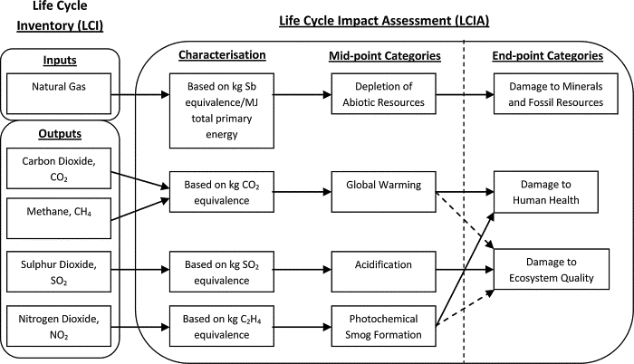
Figure 1. Shows the damages (Rimos, S., Hoadley, A.F.A., and Brennan, D.J., 2014 p.851)

DISCUSSION
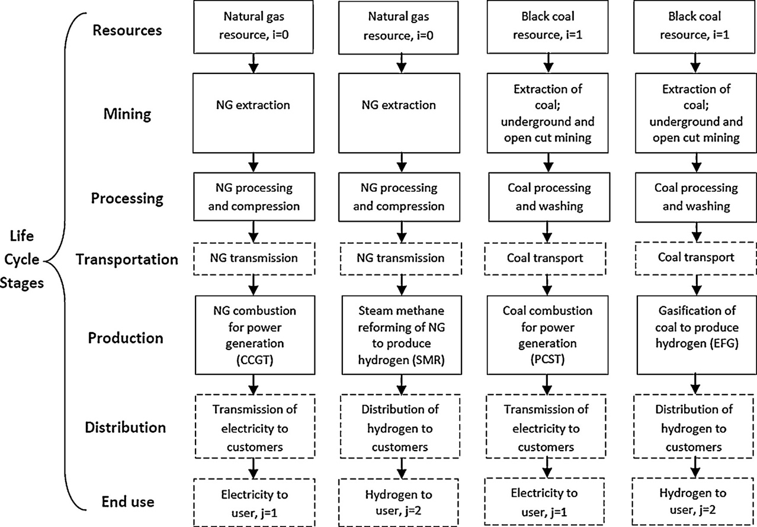

Figure 2. Diagram (Rimos, S., Hoadley, A.F.A., and Brennan, D.J., 2014 p.851)

Figure 2 shows the methodology of natural gas and black coal systems (Rimos, S., Hoadley, A.F.A., and Brennan, D.J., 2014). Black coal should be active because the studies have presented that black coal will be more obtainable in years to come based on the estimates of this study. Compared to natural gas, the life cycle stages of black coal shows that the substitution of natural gas is nonexistent to resemble (Rimos, S., Hoadley, A.F.A., and Brennan, D.J., 2014 p.854).
CONCLUSION
ACKNOWLEDGEMENTS
I want to thank my family and friends for always supporting my academics; primarily, my mom. Also, I would like to thank Professor Straw for taking time out of his holidays to instruct this class. Lastly, I would like to thank the UNC library for providing me with all my resources to write this scientific paper.

REFERENCES CITED
Kim, S., Lee, S., Kim, S., Kang, S., Lee, D.S., and Lim, S., 2019, Environmental effects of the technology transformation from hard‐disk to solid‐state drives from resource depletion and toxicity management perspectives: Integrated Environmental Assessment and Management, v. 15, p. 292-298, doi: 10.1002/ieam.4127.
Marton, Z., Ernszt, I., Rodek, N., and Máhr, T., 2020, Hope and responsibility vested in younger generations: The case of Hungary: Interdisciplinary Description of Complex Systems, v. 18, p. 286-298, doi: 10.7906/indecs.18.2.15.
McCabe, P.J., 1999, Energy mix of the 21st century; lessons from the 20th century: Abstracts with Programs - Geological Society of America, v. 31, p. 30.
Ploeg, F.v.d., 2011, Natural Resources: Curse or Blessing? Journal of Economic Literature, v. 49, p. 366-420, doi: 10.1257/jel.49.2.366.
Rick van der Ploeg, 2014, Guidelines for exploiting natural resource wealth: Oxford Review of Economic Policy, v. 30, p. 145-169, doi: 10.1093/oxrep/gru008.
Rimos, S., Hoadley, A.F.A., and Brennan, D.J., 2014, Environmental consequence analysis for resource depletion: Process Safety and Environmental Protection, v. 92, p. 849-861, doi: 10.1016/j.psep.2013.06.001.
Schäfer, A., 2014, Technological change, population dynamics, and natural resource depletion: Mathematical Social Sciences, v. 71, p. 122-136, doi: 10.1016/j.mathsocsci.2014.06.001.
Zaman, K., Abdullah, I., and Ali, M., 2017, Decomposing the linkages between energy consumption, air pollution, climate change, and natural resource depletion in Pakistan: Environmental Progress & Sustainable Energy, v. 36, p. 638-648, doi: 10.1002/ep.12519.

