Project Title: (18 pt Times New Roman Bold, Upper and Lower Case)

Group ##: Group Members’ Names

1 INTRODUCTION

The main purpose of the introduction section is to provide background information about the organization or process you study, such as the name of the organization, the products and/or services offered by the organization, sales or market share, and competitive advantage.

Headings are Caps, Bold. Text must flow in one column spreading over the full width of the page. All text is 11 pt Times New Roman, fully justified. 1’’ margin on all sides. Leave one space below headings, sub-headings, and paragraphs. All paragraphs are single line spacing. Sections 1-6 (from the Introduction to the Conclusion) should NOT exceed 10 pages. Appendices should NOT exceed 15 pages and may be used sparingly for raw data, references, and/or supplementary materials. Do not include a cover page in your report. There is no minimum page requirement.

Please note that this document is not only a template but also guidelines for the final report. Please read through the whole document including the grading rubric table in the appendix.

2 QUALITY PROBLEM STATEMENT

The main purpose of this section is to clearly state what quality problem(s) your group chose to study. The section should include solid evidence that the quality problem(s) exists and a brief discussion on the impacts of the quality problem. Cite references if applicable.

3 DATA DESCRIPTION

The main purpose of this section is to provide a clear summary of the data used in this report and a brief justification of the validity of the data. Details of the data, such as the type of data (primary data if your group collected the data or secondary data if the data was collected by someone else or found online), data size, time frames for your data collection process or time range of the data used for this project, how the data was generated (manually recorded, equipment, software, etc) should be explained in the corresponding subsection(s) where the data were analyzed.

4 DATA ANALYSIS

- choose at least four of the following TQM tools for data analysis.
(1) Benchmarking, (2) QFD (House of Quality), (3) Gap Analysis and SERVQUAL, (4) Service Blueprinting, (5) Control Charts, (6) Process Capability Analysis, (7) Process Map, (8) Cause and Effect (Fishbone) Diagram, (9) Pareto Analysis, (10) Gauge R&R, and (11) Taguchi Method.

In each subsection, describe in details the type of data (primary data if your group collected the data or secondary data if the data was collected by someone else or found online), data size, time frames for your data collection process or time range of the data used for this project, how the data was generated (manually recorded, equipment, software, etc). Citations to secondary data, if any, including location and access details of the source data, should also be provided. Attach raw data in the Appendices. Below are the detailed requirements for the implementation of each TQM tool.

4.1 Benchmarking

Secondary headings (sub-headings) are Upper and Lower Case, Bold.

Conduct benchmarking to identify the strengths and weaknesses of the process. In your analysis, choose at least four different types of benchmarking from the following: process benchmarking, financial benchmarking, performance benchmarking, product benchmarking, strategic benchmarking, functional benchmarking. Your benchmarking analysis should have at least one paragraph for each type of benchmarking. For each type of benchmarking, explain what measure(s) is used and the current performance of both the initiator firm and the target firm in terms of the measure(s). Your analysis should also include how the process or business you study can benefit from each type of benchmarking.

4.2 QFD (House of Quality)

Develop the QFD for a process or a business. The house of quality should include at least six customer requirements, at least five technical/functional requirements, and at least two competitors. Customer competitive assessment and customer importance data should be based on real data (primary or secondary data). Your analysis should lead to the conclusion of how to prioritize customer requirements and technical requirements.

Here is a QFD template that you can download and modify (need to sign in to your Google account to make a copy to your own Google drive). Attach your complete QFD in your report.

Figures must be of high quality and should be in color. Figure numbers and captions appear at the foot of the figures. Figures should be numbered consecutively with Arabic numerals, in the order in which reference is made to them in the text, e.g. Figure 1, Figure 2, etc.

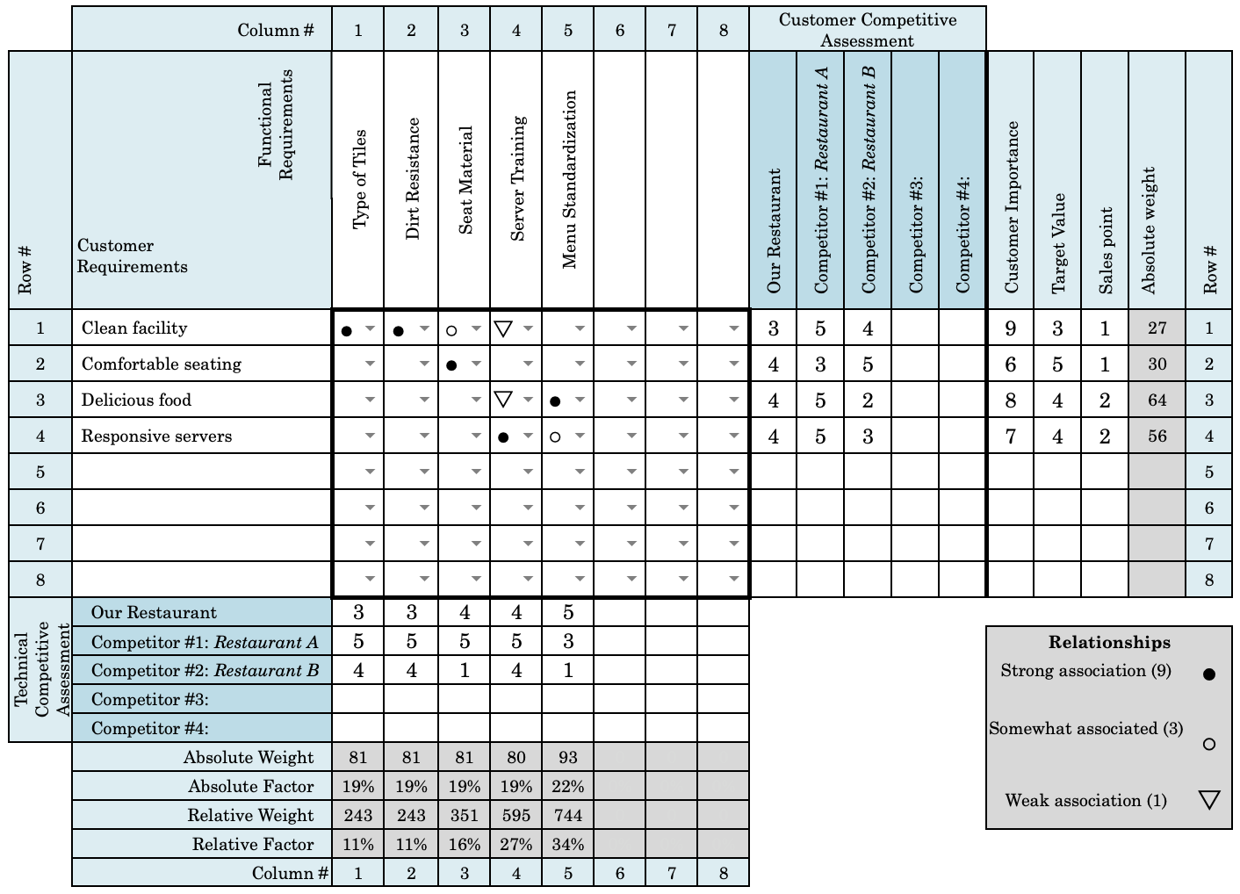
Figure 1. QFD of Company ABC (11 pt Times New Roman, centred)

It is not recommended to add photographs. Photographs should only be used if essential to the clarity of the report.

4.3 Gap Analysis and SERVQUAL

Perform gap analysis based on the SERVQUAL survey. Collect first-hand data (at least 25 responses for each question). Raw data should be attached to the Appendix. Your analysis should lead to the conclusion of whether Gap 5 exists and which service quality dimension(s) needs improvement.

Create a SERVQUAL Gap Scores Table as shown below. Or use this link to generate a table. Table numbers and captions appear at the top of the tables. Tables should be numbered consecutively with Arabic numerals, in the order in which reference is made to them in the text, e.g. Table 1, Table 2, etc.

Table 1. SERVQUAL Gap Scores (11 pt Times New Roman, centered).
 | Average  Perception | Average  Expectation | Difference  (Perception-Expectation)
Tangibles
Reliability
Responsiveness
Assurance
Empathy

4.4 Service Blueprinting

Depict the complete service process with customer actions, visible contact employee actions, invisible contact employee actions, and support processes. Based on the service blueprinting, identify at least four fail points (moments of truth) and design poka-yokes for each fail point.

4.5 Control Charts

Create control charts ( and R charts, p chart, or c chart) using real data (first-hand or secondary data) in order to determine process stability. Raw data should be attached to the Appendix. Your analysis should lead to the conclusion of whether a process is in control or not. Your raw data should have at least 10 samples. The control chart(s) should be created using Minitab.

4.6 Process Capability Analysis

Conduct process capability analysis in Minitab and obtain process capability ratio and/or process capability index using real data (first-hand or secondary data). Perform the normality test and include the output in the report. Raw data for process capability analysis should be included in the Appendix. Explain how lower and upper specification limits are determined. Your analysis should lead to the conclusion of whether a process is 3-sigma capable.

4.7 Process Map

Draw a process map of the current process you study and a process map of the projected process after improvement. The two process maps should be comprehensive with responsibility and time for each activity. Your analysis should include to what extent the process can be improved.

4.8 Cause and Effect (Fishbone) Diagram

Analyze and find the root cause of a quality problem by creating a cause and effect diagram. The diagram should contain at least four major causes (ribs) and each major cause should have at least four sub-causes (smaller bones) attached to it. Identify the core causes based on the diagram.

4.9 Pareto Analysis

Display the relative importance of problems in a Pareto chart using real data (first-hand or secondary data). Include raw data (at least 40 records) in the appendix. Your analysis should lead to the conclusion of how to prioritize the problems to be solved. The Pareto chart should be created using Minitab.

4.10 Gauge R&R

Conduct Gauge R&R to separate various sources of variation using real data (first-hand or secondary data). Your Gauge R&R study should have at least 10 parts, 2 operators, and 2 trials . The report should be generated using Minitab. Include raw data in the appendix. Your analysis should lead to the conclusion of which factor(s) contributes to the measurement variation.

4.11 Taguchi Method

Derive the Taguchi loss function for a process. Your analysis should include how you obtain or derive the nominal value and Taguchi constant. Your analysis should also include a cost-benefit analysis of whether or not to invest in variation reduction.

5 RECOMMENDATIONS AND FEASIBILITY ASSESSMENT

The main purpose of this section is to provide improvement action plans. List at least three action plans (suggestions) and explain why each plan is feasible and actionable, one paragraph for one suggestion. All the action plans should address the quality problem(s) stated in Section 2 (quality problem statement) and should be based on your data analysis in Section 4.

6 CONCLUSIONS (Optional)

This section is optional. This section should be an effective summary of the project you did. It should not contain any new information, but should describe the main outcomes of your project. Your conclusions should focus on what you accomplished and why it is important, you may also point at potential limitations of the work.

Appendix A: References

Start the first appendix in a NEW page (Insert > Break > Page break). Each report should have at least five references and all references listed in the appendix should be cited in the main body of the report. The references must be listed in alphabetical order of author’s names and increasing dates of publication, with the addition of an ‘a’ or ‘b’ to the date, where necessary. In the text reference is made to writing the surname of the author, followed by the date of publication in square brackets, e.g. “it was shown by Hanke (1970a) that ...”. Where more than two authors were involved, the reference in the text should be of the form: “it was shown by Jones et al. (1994). Use APA citation format. References should include (in the following order): Author Name(s), Initials, Date, Title of article with first letter uppercase, full Journal name/Publisher, Volume (Number), page range. The page range must be hyphenated. A 0.5” indentation must be left for each reference. Examples are given below:

- ASQ (2019). Cost of Quality (COQ). Available at https://asq.org/quality-resources/cost-of-quality (last accessed Oct 10, 2019).
- Camp, R. C., & Camp Robert, C. (1989). Benchmarking: the search for industry best practices that lead to superior performance. ASQS Quality Press, Milwaukee, WI.
- Chan, L. K., & Wu, M. L. (2002). Quality function deployment: A literature review. European journal of operational research, 143(3), 463-497.
- Foster, S. T., & Ganguly, K. K. (2007). Managing quality: Integrating the supply chain. Upper Saddle River, New Jersey: Pearson Prentice Hall.
- Kackar, R. N. (1985). Off-line quality control, parameter design, and the Taguchi method. Journal of Quality Technology, 17(4), 176-188.

Appendix B: Raw Data

Include primary or secondary data such as survey responses, samples for the control charts or process capability analysis, review data for Pareto charts, etc.

Appendix C: Supplementary Materials (Optional)

Include any supplementary materials. Figures and Tables should be in the main body of the report unless they are preliminary or supplementary.

Table 2. Grading Rubric for Final Report
Category  (Possible  Score) | No  Evidence | Does not  Meet  Standard | Nearly  Meets  Standard | Meets  Standard | Exceeds  Standard
Introduction  (20) | Absent, direct quotation, or other form of plagiarism  0 | There is no clear introduction, or the Introduction section does not include all required information.  10 |  | Provide background information about the organization or process you study. See Section 1 for details.  20
Quality Problem Statement  (20) | Absent, direct quotation, or other form of plagiarism  0 | Unclear problem statement, insufficient evidence or lack of discussion on the impacts of quality problem(s).  10 |  | A strong, clearly stated quality problem statement, with solid evidence that the quality problem(s) exists and a discussion on the impacts.  20
Data  Description  (20) | Absent, direct quotation, or other form of plagiarism  0 | Unclear summary of the data used in this report or the justification of the validity of the data is unsound or missing.  10 |  | A clear summary of the data used in this report and a brief justification of the validity of the data.  20
Data Analysis  (180 in total)  for individuals:  for a group of 2: for a group of 3: | Absent, direct quotation, or other form of plagiarism  0 per tool  0 per tool  0 per tool | The tool was implemented incorrectly.  9 per tool  7.2 per tool  6 per tool | Two or more requirements are not met.  27 per tool  21.6 per tool  18 per tool | Meet all the requirements but one.  36 per tool  28.8 per tool  24 per tool | For each tool implementation, meet all the requirements specified in Section 4.  45 per tool  36 per tool  30 per tool
Suggestions  and  Feasibility  Assessment  (30) | Absent, direct quotation, or other form of plagiarism  0 | List only one action plan, or each plan is either infeasible, non-actionable, not directly addressing the quality problem(s), or not based on data analysis.  6 | List only two action plans, or there are two plans that are either infeasible, non-actionable, not directly addressing the quality problem(s), or not based on data analysis.  18 | List at least three action plans (suggestions). Only one plan is either infeasible, non-actionable, not directly addressing the quality problem(s), or not based on data analysis.  24 | List at least three action plans (suggestions) and explain why each plan is feasible and actionable. All the action plans should address the quality problem(s) and should be based on data analysis.  30
Title, Appendices, Organization, Format & Others  (30) | Absent  0 | Evidence of 3 or less  6 | Evidence of 4  18 | Evidence of 5  24 | (1) Include main points from the title. (2) All citations and references are correctly formatted. (3) Punctuation, capitalization, spelling, and sentence structure are all correct. (4) Clear, consistent fonts. (5) Figures and tables presented in correct format. (6) Appendices are presented in correct format. The report was neatly finished.  30

