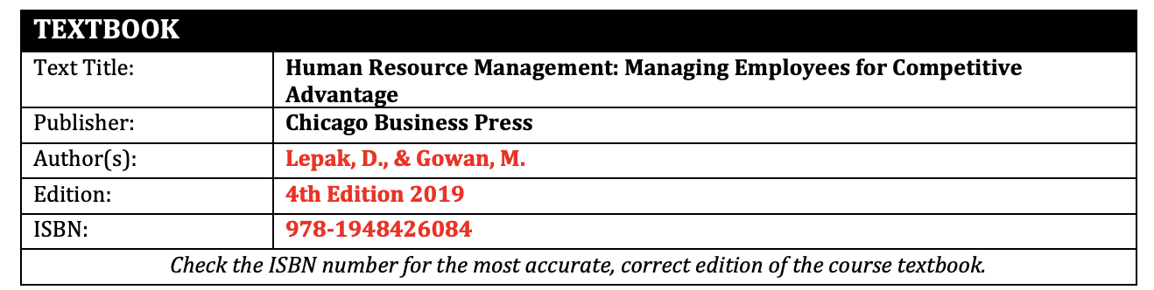
Curse name: MGT 510 Human Resource Management

Summary:
CASE STUDY.
Chapter 10 - Compensation At W. L. Gore
Answer in essay form and not Q&A format with at least TWO peer-reviewed sources & a similarity index score of < 30%.
Chapter 10 – Compensation At W. L. Gore (pp. 416-417)
W.L. Gore & Associates is a company well known for its GORE-TEX fabric for protective outerwear. The company was included on Fortune’s “100 Best Companies to Work For” list for 20 consecutive years. Gore has received numerous other recognitions as well, including being ranked number 15 on the 2017 World’s Best Multinational Workplaces list by the Great Place to Work Institute, was named a best workplace in France, Germany, Italy, Korea, Sweden, the United Kingdom, and China, and frequently has been used as an example of a company that is innovative. Rather than job titles, bosses, and organization charts, Gore uses a team approach, with leaders, sponsors, and team members.
The main objective of Gore’s compensation plan is to ensure that employees, referred to as associates, are paid for their contributions to the success of the company. Their compensation plan is focused on both internal fairness and external competitiveness. Gore uses two approaches to achieve these goals. The first is straightforward and typically used by companies: comparing pay at Gore with pay for comparable jobs at other companies. In other words, Gore does a lot of benchmarking to be sure their salaries are competitive with the relevant labor markets. That takes care of the external competitiveness part.
The internal competitiveness part is what is different at Gore. The process works like this: Associates on the same team rank each other based on contributions to the company for the year. Team members provide a numerical ranking and can provide comments to support their rankings and identify strengths or areas for improvement of the associates they rank. This information is then used for determining raises.
Answer the following questions by applying the concepts learned in Chapter 10. Please post as one MS Word document. Note: See template provided for case study paper. Also, conduct literature reviews on the subject of discussion and use to support your case study answers:
- What type of compensation approach is Gore using to be externally competitive?
- What are the pluses and minuses of this approach?
- Discuss the pros and cons of the internal competitiveness strategy at Gore.
- Do you think that Gore can achieve its goals of internal fairness and external competitiveness with the two approaches used
- Would you want to work for this company? Why or why not?

