

MQP– OPERATIONS MANAGEMENT

FALL 2020

**Project Work (25%)**

General Instructions:

1. The project work is a group work (three to four members only) or an individual work.
2. Assuming that each business partner will give 300,000AED capital to start a business.
3. Propose one feasible business.
4. For the introduction write down the concept of the business, logo and its meaning.
5. Business partners (for group) and sole proprietorship (for individual). Discuss how the capital will be divided by the partners and describe its job title and brief of descriptions of each functions.
6. Explain the choice of your business partner’s location for your company.
7. Draw the very detailed interior and exterior lay out of your business building.
8. Describe how the use of technology will be used in your company’s operations.
9. Over-all apply the models of operations management (INPUT-TRANSFORMATION-OUTPUT) to describe the entire operations of your business.

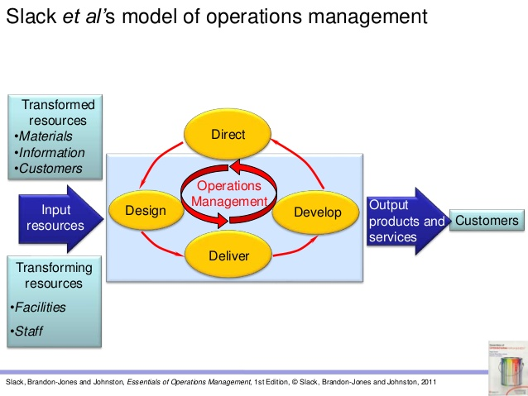

1. If in group only the leader will upload the project work to the TURNITIN. Leader ensure that all the names and ID numbers of your group members are listed before uploading.
2. Only 20% plagiarism is allowed.
3. Deadline for submission will be on November 30, 2020.