Rapid Fire (18 pts / 3 pts each)
Provide a brief solution to each of the following questions. (1-2 sentences)

- Define the “Complete Streets” concept.

Complete Streets are streets designed and operated to make users feel safe and support mobility. Users are people of all ages; maybe they are drivers, pedestrians, bicyclists, and public transportation riders. The concept of complete streets includes approaches to plan, design, operate roadways and rights of way with users to make transportation safer and more efficient. The policies of the complete street are coped with the state, regional, and local levels.

- Who is responsible for the continuing increase of private automobile use in the developed world and why?

The multinational automobile manufacturers are responsible for private automobile use in the developed world to stay always benefit. It supposes to help regulate the manufacture of the automobile and advise the production of environmentally friendly vehicles that are less harmful to human beings' health.

Governments world are responsible for the continuing increase of private automobile use because there are not enough mass transits that encourage people to use them and reduce buying private vehicles.

- What are the benefits and drawbacks of raised intersections?

The benefits of raised intersections are:
- Slow down the vehicles and yield to pedestrians at the crosswalk.
- Helps reduce the speed and red light running.
- Provide better view for pedestrians during the waiting in the intersections to cross the street.
- Provide slow speed crossing with public space at minor intersections.
- Do not need to curb ramps.
- Possibility to have positive aesthetic value.

The drawbacks of raised intersections are:
- Result drainage issues.
- It is expensive to construct.
- Less effective that speed humps or tables.
- Texture pavement materials can make it difficult to distinguish detectable warnings.

- Which design option (A or B) is better (with respect to sustainability objectives) and why? 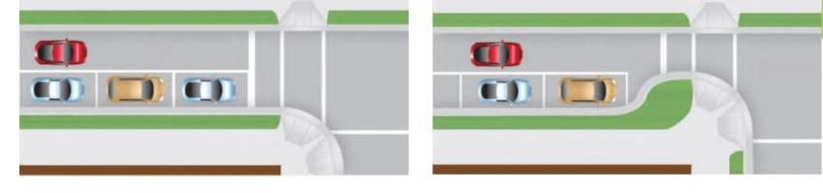
Option A Option B

Option B. I chose this option because curb extensions improve sight distance between pedestrians and motorists. Also, to reduce the cross walk and exposure time for pedestrians.

- Observe the picture that follows and mark (or list) 4 changes that would transform the existing design to a more livable street design.

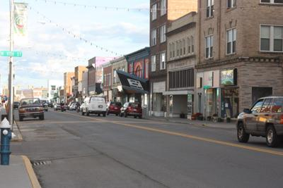

- Add biking lane.
- Add pedestrian crosswalk with yellow alert in the middle of the street.
- Add shorter streetlights with closely spaced lamps.
- Add trees in the street is encouraged to make the street more aesthetic.

- Propose two traffic control interventions (Week 8) in order to increase “user” safety at the site below.
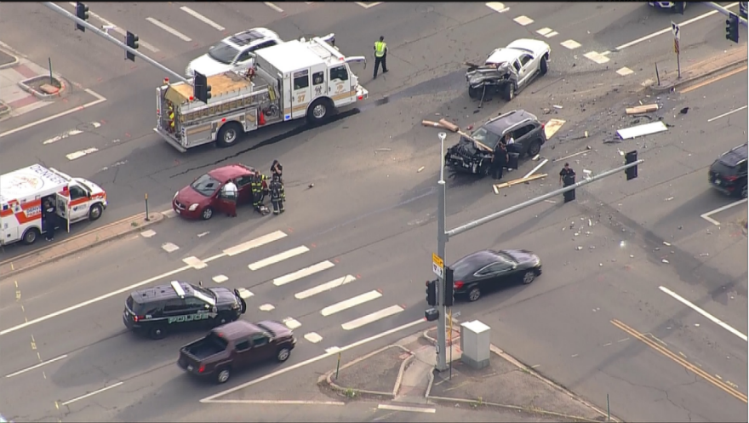

- Put speed bump and stop sign in each intersection.
- Modify existing intersection geometry by Putting large traffic circle that fit to emergency vehicle with splitter islands to prevent vehicles from turning left by taking a shortcut to prevent driving around the outside of the island.
Short Answer (36 pts /6 pts each): Pick 6 from the following (Only first 6 will be graded):
Provide a brief answer (150-200 words) to the following questions.

- Describe what an ideal future transit network would look like and why we are experiencing delay in implementing these design elements.
Not Selected

- List four key challenges that sustainable transportation is facing today.

- Negative environmental impacts. Most of our roads are environmentally hazardous since they do not meet the standard set by the international organization’s standards. Most automobiles produce environmentally hazardous gases, which pollute the environment, so; transit agencies need to work hard to create a sustainable transit system that uses alternative fuels. These agencies, by a cooperation with governments, need to the employ their efforts to show the safety and efficiency of alternative fuels and let the culture shift away from the use of fossil fuel. Still, the USA is not putting the perfect environmental policies that help to make transportation more sustainable.

- Negative economic impact. There is not enough money to finance sustainable transportation projects, which will effect on project's life cycle and government states focus on expanding or building highways that encourage using vehicles.

There is a lack of economic analysis, which is a considerable challenge for sustainable transportation today.

- Negative social impact. People used to use vehicles, especially in the USA, and changing their trends will not be easy for them and sustainable transit agencies. People do not have immense knowledge about sustainable transportation, and at the same time, there is a lack of awareness about sustainable transportation programs to help people understand what the benefits will be if they will change their trends to use sustainable transportation for them and the environment.

- Governments lack full guidance and guidelines for sustainable transportation planning and policies, which has a significant effect on sustainability development. Also, there is a lack of data collected. Data is still insufficient for sustainability performance monitoring, and no single integrated multi-modal database is at the federal level.

- Define the term “Transit Oriented Development”.

Transit-Oriented Development is a type of urban development that create livable and sustainable communities. Also, it means creating compact, walkable, pedestrian-oriented, and mixed-use communities centered. TOD leads to living in a less stressful life without depending 100% on the car for mobility and survival. Another definition of TOD is designed to bring people, activities, buildings, and public spaces together with walking, cycling Connection, and near transit service to the rest of the city. It is accessible to all local and citywide resources using efficient and healthful combination modes at the lowest financial and environmental cost. TOD is essential for long term sustainability, equity,
and civil peace in cities. Multiple and interdependent elements come together with infrastructure, streets, building planning and design, codes, and regulations. It needs collaboration between investors, developers, professional technicians, future residents, tenants, and decision-makers. TOD has many benefits, such as reduced car traffic, healthier lifestyles, lower pollution, decreased suburban sprawl, etc. TOD is very important because it gives solutions to the series problems like climate change, and global energy security through creating dense, walkable communities that reduce the driving, energy consumption, reduce carbon footprint, allow residents to do all daily life in the same area, provide excellent accesses to better job, entertainment, and between urban and suburban area.

- Describe the typical concerns for pedestrians associated with street width and curb radii at intersections and propose an engineering countermeasure to address them.

Pedestrians' typical concerns are wide streets that make pedestrians take a longer time to cross than narrow streets. In this case, pedestrians are exposed to a longer time to risk being hit by a vehicle when they cross a wide street. Another concern for pedestrians when crossing the streets is visibility; for example, park cars on the streets make pedestrians face difficulty seeing oncoming vehicles and vice versa. Furthermore, when streets intersect at an acute angle, or there is a large curb radius, drivers can take turns at high speeds. In contrast, 90-degree intersections and corners with tight curb radii lead to a slow driver down and make them more cautious. Another concern is when there are obtuse angles, especially when a vehicle on an arterial street turns into a residential street; when pedestrians crossing the residential streets adjacent to the arterial streets, they do not expect high speed turning traffic or may be their backs turned toward the turning cars which cause safety trouble for pedestrians.

The Engineering solution shortens pedestrians' crossing distance by installing curb extensions, which are also known as chokers or flares; this can do when parking on streets is permitted. It is preferable the distance equal to the depth of parallel parking space. This solution leads pedestrians to see approaching traffic and make it easier for drivers to view pedestrians better. This solution will decrease the crash that might be happened. The decreasing crossing distances for pedestrians also reduce the time a right or left turning vehicle needs to wait for a pedestrian to cross before exiting the street or roadway. It is better to make the corner radius as small as possible, especially if there is no heavy truck traffic, by designing curb extensions at intersections to slow down the right-turning motor vehicles.

Another engineering solution is changing the curb radii by making it suitable for drivers and pedestrians without forming pedestrians' risk and not delaying drivers. Adding bollards to make the corner more visible might be another solution. When a residential street meets an arterial, creating an intersection closer to 90 degrees makes it possible to reduce curb radii and create curb extensions.

- Provide 3 examples of site design elements that can help reduce the number and severity of conflicts between motor vehicles and non-motorized users.
Not Selected

What is the purpose of sidewalks and what elements are important in the design of urban sidewalks?

The purpose of sidewalks is to separate from the roadway and are preferred accommodation for pedestrians. Also, sidewalk provides safety, mobility, a healthier community, and reduce walking along with the street crashes and pedestrian crashes. There are many sidewalks' values, such as increasing the property value, encouraging people to walk comfortably, and improving neighborhood walkability score. There are many design urban sidewalks like sidewalk width, tree height, shrub width, treewidth, component area ratio for sidewalk, roadway, and greenery and sky are essential elements in the design sidewalk. Other elements need to put under consideration, such as

- Proper size like sidewalk furnishing zone, pedestrian zone, frontage zone.
- Clear signage like informative maps and signs, pedestrian traffic signals, and intersections.
- Safe connections such as street corners, stairs, public transport stops.
- Universal accessibility like curb ramps, long- angle running slope, tactile surface.
- Attractive spaces like vegetation and urban furniture.
- Security such as public lighting and active frontage.
- Quality surfaces like a stable, slip, and flood-resistant materials.
- Efficient drainage like rain garden and cross slope at the appropriate angle.
To encourage walkability, sidewalks in every street is essential for people to help people become healthier, improve the environment, and more socialist.

- What is the fundamental difference between a neighborhood and a subdivision? And how is the concept of new urbanism attempting to redefine both?

The neighborhood is a district characterized by similar or compatible land uses. Usually, neighborhoods know by place name and have boundaries that include streets, barriers, and others in land use. There are three types of neighborhoods residential, commercial, and industrial. Isolated dense block neighborhood includes police, commuters, government, and at the same time, there is a dense residential block neighborhood that connects through streets between these hubs. Each of these blocks has a different neighborhood, elements, and there is a movement between them.
The subdivision is a tract of land that includes lots suitable for home building purposes.

The difference between a neighborhood and a subdivision is neighborhood larger than a subdivision and includes complimentary land uses, while a subdivision is a tract of land divided into smaller pieces for individual sale and development. The connection in a subdivision is much less between houses and driveways than the neighborhood; also, there is a lack of density in the housing and increasing density in traffic ways and roadways which needs management and maintenance services. As a result, it transitions from connection shared use (neighborhood) to isolated personal use (subdivision). More congestion, more delays will be seen in subdivision even if adding more roads despite neighborhood that residents depend on more mass transit and walking and because of the multi hubs of transportation, there will be less congestion and delays. Lands and roads will not be used efficiently and see more congestion in subdivisions.

The new urbanism concept means encouraging compact, walkable neighborhoods. It is also essential to be a mixed-use connected street network to attract more residences and be getting a sufficient density. Building design will play a useful role that supposes to be on a human scale. Serving diverse populations is very important, such as creating inclusionary zoning, requiring new construction that includes affordable units. Also, create increased zoning for construction to multi-family and rental units and increased density close to waterfront amenities as an example, etc.

For subdivision, the new urbanism concept is a concept that will help in the development of the subdivided area by designing it in a way that it will fully utilize. It will help apply different designs, which help improve the structure so that it occupies less space. The subdivision new urbanism concept is designed in a way that it cannot only be applied in urban but also in rural main street areas. The subdivision's new urbanism will create a sustainable human-scaled place where people can live a happy and healthy life.

- What is the role of the federal, state, and local transportation agencies toward the development and implementation of successful non-motorized transportation programs?

Not selected

- Define the concepts of “Leap-Frog” development and why it encouraged historical urban
sprawl.

Leap-Frog means developing cheaper land that far from the city rather than on more costly land closer to the city. Building new residences separately or in a subdivision, in the distance from existing built up areas. So, Leapfrog development happens when developers omit real estate to earn land at a down price further, leaving empty stretch behind regardless of services and other infrastructure that treat the bypass parcel (Heim, 2001).

Leap-Frog encouraged historical urban sprawl because of the low price of lands, easy access to appropriate housing, and other advantages such as the low price of the transportation system, building new centers for jobs in the suburbs opened up to encourage farmers to find opportunities in factories. For example, in 1920, farmers did not want to work on the farms because if they had a tough year, they would not produce enough food and crops; they would get by even on good years.

https://www.cabq.gov/neighborhood-traffic-management-program/documents/raised-intersection.pdf

https://safety.fhwa.dot.gov/ped_bike/univcourse/pdf/swless124.pdf

https://thecityfix.com/blog/8-principles-better-sidewalks-hillary-smith-paula-manoela-dos-santos/

https://activerain.com/blogsview/1280189/neighborhood-or-subdivision---what-s-the-difference-

https://coastalsmartgrowth.noaa.gov/elements/housing.html

https://www.vtpi.org/tdm/tdm24.htm

https://www.researchgate.net/publication/273353521_Leapfrogging_Urban_Sprawl_and_Growth_Management

https://www.fhwa.dot.gov/publications/research/safety/pedbike/05085/chapt11.cfm

https://www.unescap.org/sites/default/files/roadprice_ch1.pdf

