BUSM 4547 - Management in Practice

Student name: Bui Thi Lan Huong

Student’s ID: S3683555

Executive Summary
The report aims to provide a thorough understanding of the organisation TONIC 15 through evaluation and analysis of its external environment and internal environment. The report uses various techniques and methods to analyse the industry structure of the organisation. A problem statement will be recognised to address the organisational challenges faced by TONIC 15. Obstacles in the capability of securing working capital and expanding the business with sufficient support are the main issues that have a significant impact on TONIC 15’s growth at the moment. Thus, the report presents a complete analysis of TONIC 15 and provides recommendations to the challenges faced by the organisation.

Table of Contents
1. Introduction 4
2. Organisational Analysis 4
2.1 External Environment Analysis 5
2.1.1. PESTEL Analysis 5
2.1.2 VUCA Analysis 7
2.1.3 Porter’s Five Forces 9
2.2 Internal Analysis 11
2.2.1 Value Chain 11
2.2.2 7S Framework 12
2.2.3 VRIO Analysis 14
3. SWOT Analysis 16
3.1 Summary after Evaluation of SWOT Analysis 16
3.2 Problem Statement and Solution Reasoning 17
4. Conclusion 17
References 17

1. Introduction
This detailed report focuses on an elaborate study of the challenges faced by the company named “TONIC 15 LTD”, which operates in London, United Kingdom, together with its office in London and it primarily concentrates on the UK and EU markets. TONIC 15 connects the global market and the K-Beauty through B2B and D2C e-commerce. The company also stores its products at the major department stores including Fortnum & Mason, Harvey Nichols, etc. Having operated since 2018 by the founder named Ms Jin Kwon (TONIC15, n.d), she started the business with the intention to motivate women to recognize the importance of self-skincare in relation to having a quality lifestyle in such hectic pace of life nowadays. Premised on these, the report analyses the external and internal environmental factors of TONIC 15, by the implementation of various methods and tools and also evaluates the causes of the challenges in prior circumstances.

2. Organisational Analysis

2.1 External Environment Analysis

2.1.1. PESTLE Analysis
Factors | Descriptions
Political Factors | The political factor that generally affects the cosmetic industry in the UK includes political stability, taxation, the legal framework for contract enforcement and pricing regulations (Suranga and Garg, 2016). The Cosmetic products (safety) regulations, 1996 are a set of rules that the cosmetic industries need to follow to sell its products in the market. TONIC 15 connects the K-beauty market through its D2C and B2B e-commerce hence it is significant for the company to follow the act. Also, it is imperative to note that taxation of the cosmetic industry has not increased in the recent years.
Economic Factors | The purchasing powers of the customers are mainly affected by economic factors. The factors that influence TONIC 15 economically include unemployment rate, interest rate and the economic growth rate (Boome, 2018). The growing unemployment rate is capped at 8.6% (Hard times UK Economic Outlook, 2020) due to the spread of the pandemic Covid-19, has impacted TONIC 15’s business growth significantly as consumers will either cut on their spending for cosmetic products or they will be more reluctant to purchase due to income losses. Moreover, the GDP in the UK has fallen by 7.2% in 2020 (Hard times UK Economic Outlook, 2020) due to the virus outbreak which provides a negative sign to the company, whereas the prevailing low interest rate, which is at 0.1 % (Hard times UK Economic Outlook, 2020) contributes to the expansion of the company greatly.
Social Factor | TONIC 15 is a cosmetic based company, so their major customers are young and middle-aged individuals. In the new era, customers are increasingly concerned about their skin and trying to look for appropriate products that suit certain skin types, so the growth of cosmetic company remains high (Azizpour, Abbasnejad and Siyavooshi, 2016). Therefore, ingredients in skincare and cosmetic products, especially those with fewer chemical content or made with natural ingredients play a crucial role in affecting customers’ purchase. TONIC 15 should address such concerns in its communication message to better serve customers and reap better growth.
Technological Factor | It is evident that technology advancement has accelerated more shopping venues for customers as they are able to get more information about certain products and compare them with others from different websites to reach final buying decisions. TONIC 15 provides its K-Beauty products through online platforms, whereby customers can get access to its products within a single click. Online shopping creates different choices for customers and provides interactive communication channels for sellers and buyers, especially during this pandemic, more people have been adopting the habit of shopping online as retail stores are closed. The company can further invest in online retailing and advertisement by including a comprehensive beauty selling and lifestyle products to expand its market.
Legal Factors | There are certain product regulation and rules that affect the cosmetic and lifestyle businesses in the UK. Moreover, branding and labelling of the companies are usually regulated to ensure that the products are listed with proper ingredients, precautionary information, warning statements, manufacturing and expiration dates, etc. TONIC 15 must maintain such legal regulations for further growth and development as well as to ensure consumer safety regarding its products.
Environmental Factors | It is assumed that companies that are eco-friendly and practice environmental awareness are more likely to develop faster than those, which are not (Amin, Manzoor and Farid, 2020). Therefore, with regards to skincare and cosmetic products, TONIC 15 can use natural ingredients that have gentle and soothing skin effects such as aloe vera, coconut, etc in its skincare range to attract more customers that further lead to its growth.
Table 1: PESTLE Analysis

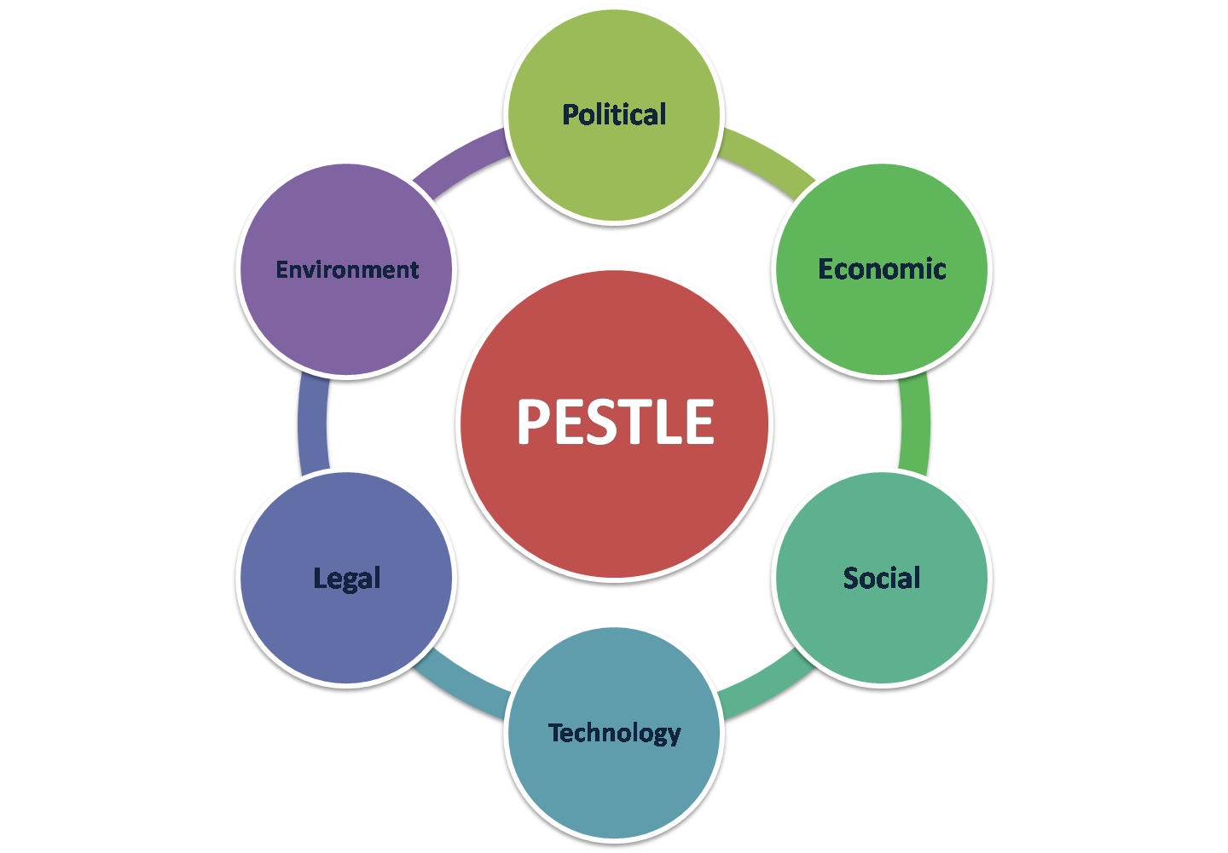
Figure 1: PESTLE Analysis
(Source: Suranga and Garg, 2016)

The Conclusion from PESTLE Analysis
The political, legal and social factors have a positive influence on TONIC 15 for its growth and development, as these factors serve to be favourable for the positive cash flow for the company and provide an opportunity for its further development.

The economic factor imposes some threats due to increased unemployment rate and fallen GDP as a result of the Covid 19 outbreak, customers may reduce spending on such products, though low interest rates could give the company’s expansion some optimistic signs .

The other factors which are social and technological may be presented as both opportunities as well as threats for the company, depending on its management and implementation of the strategies to get a positive impact.

2.1.2 VUCA Analysis
Volatility | Uncertainty
After the Brexit impact, the European markets, as well as the United States market, usually were separated from the UK. Due to this factor, there were usually fluctuations and turbulence in the cosmetic market. Moreover, there tends to be fluctuation regarding the price of the cosmetic industry and the Brexit crisis further caused accelerated turbulence in the operation of TONIC 15. Another factor that contributes to the speed of change in the cosmetic company includes the seasonal price and product change. | Uncertainty in the cosmetic industry is usually associated with people's inability to understand a specific situation. Uncertainty is common in every sector of the industry, and it largely depends on the economic, political, social, legal and environmental factors. As TONIC 15 is a cosmetic based company, it is uncertain to predict consumers’ preferences and tastes, mainly because they change with time. For instance, in the summer, a consumer prefers a product that they do not usually prefer in winter. Thus, there is uncertainty regarding the preferences of customers, which may impede the business profitability.
Complexity | Ambiguity
TONIC 15 produces a wide variety of cosmetic products that are interconnected. For example, there are products that need to be followed in steps such as cleanser, toner and moisturizer. Complexity arises when different products need to be produced as per skin tone and skin type of customers. It is seen that under high complexity, it is impossible to analyze things to withdraw a conclusion. Complexity also arises under many factors such as environmental, economic and political that usually influences the operational environment in an organisation. | Ambiguity happens when there is a lack of clarity in interpreting things. When cosmetics companies are unable to predict and understand consumer preferences, it usually suffers from a loss in its business. To avoid ambiguity, TONIC 15 should produce its products according to customers’ requirements and should enhance the quality and quantity of its products. The management of the company should understand clearly the needs and requirement of the company to produce its products as per the consumer needs.
Table 2: VUCA
(Source: Kotlyk and Jamal, 2018)

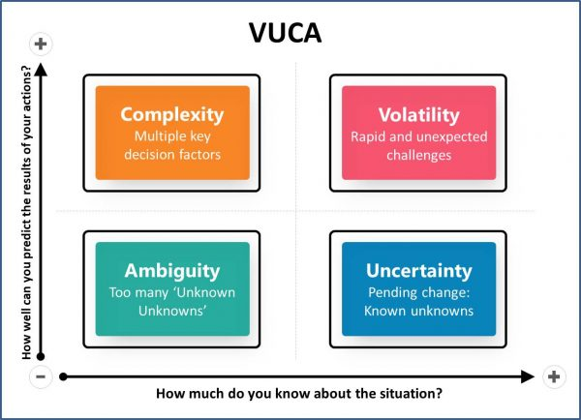
Figure 2: VUCA Analysis
(Source: Kotlyk and Jamal, 2018)

2.1.3 Porter’s Five Forces
Forces | Impact
Bargaining Power of Buyers | The bargaining power of buyers tends to be high in the cosmetic industry because customers usually have many choices available coming from different manufacturers and thus depending on their requirements, they will favour certain cosmetic companies. TONIC 15 can control the bargaining power of the buyer by improving the quality of its products within a reasonable and affordable price so that customers cannot bargain for purchasing its products (Mavlanova, Benbunan-Fichand Lang, 2016). Moreover, these skincare products are frequently considered as luxury items, so TONIC 15 must ambiguously increase its quality for gaining access to a wider market.
Bargaining power of suppliers | The bargaining power of suppliers usually tend to be high as for making cosmetics, the company usually needs various ingredients and packaging materials. Suppliers usually bargain as they can get a lot of options, as many renowned cosmetic firms tend to pay more for quality raw materials. TONIC 19 can create multiple chains of suppliers that will help the company to lessen the bargaining power of the supplier and get the raw materials at a reasonable price. Depending on multiple suppliers, they usually limit the bargaining power of the suppliers and help in making a profit for the business.
Rivalry | TONIC 15 usually faces rivalry from its competitors that includes the small size K-Beauty shops in and across the EU as well as it faces major rivalry from its large online K-Beauty store in Korea and other Asian countries. The competition of the company mainly depends on the quality as well as a range of its products(Galetić and Požega, 2019). In order for TONIC 15 to remain competitive in the market, they can improve the quality of the products by further including natural ingredients, with fewer chemicals and free from paraben as customers tend to get attracted to these products.
Substitutes | With regards TONIC 15 and cosmetic industry in general, it can be seen that they usually have many substitute products in their line-up for added customer convenience. They usually stack a variety of skincare range for all types of skin that helps the company to develop its business (Bobińska, 2020). It is imperative to note that substitute products are necessary for the growth and development of a company, as there are usually variations with regard to consumer's choice. Thus, substitute products are essential for the operational development of TONIC 15, mainly due to fact that it will help them to expand their market footprint alongside remaining competitive in the market.
Threat from new entrants | It is evident that the developments of technologies have generally facilitated new entrants into the cosmetic industry generally. It is known that in the past, the capital requirement used to be very high, so small companies could not enter the markets (Kornberger, 2017). Moreover, as the cosmetic industry is growing rapidly in the present era, many new companies began to develop its business. In order to cope up with competition from the new entrants, TONIC 15 can further enhance quality as well as quantity of its product to develop a trustworthy consumer base.
Table 3: Porter’s Five Forces

2.2 Internal Analysis

2.2.1 Value Chain
Primary Activities
- Inbound Logistics: An effective relationship with suppliers is very significant for storing, receiving and for the process of internal distribution of raw materials or fundamental elements of products in TONIC 15.
- Operations: The operational system is the supporting principle to form a value of the entire operational activities of TONIC 15. Due to the practices like a production line, and production floor, the entire operation has been impacted to provide effective products.
- Outbound Logistics: TONIC 15 distributes its products to its consumer through both online and offline ways that enhance the value of selling system of the organisation and make it more user friendly and intuitive.
- Marketing and Sales: In the case of TONIC 15, the organisation has been able to establish an effective relationship with its consumer through deliver appropriate products as consumer choices.
- Service: The service of valuable products creates an effective image in the market. The provision of appropriate product service helps the organisation to enhance its influence in the market.
(Source: Horng, Chang and Chen, 2016)
Secondary Activities
- Firm Infrastructure: In the case of TONIC 15, the organisation has to effectively manage the production line, financial stability, etc. to maintain a positive environment within the organisation.
- Human Resource Management: TONIC 15 needs to recruit some efficient employees to operate in the market to achieve an effective outcome.
- Technological Development: The firm needs to fetch some development in its manufacturing process of cosmetics products to provide better quality to its customers.
- Procurement: The administrator of TONIC 15 has to be more concentrated on negotiations and forming of an effective relationship with its suppliers, and other stakeholders to fluently operate in the market.
(Source: Prajogo, Oke and Olhager, 2016)
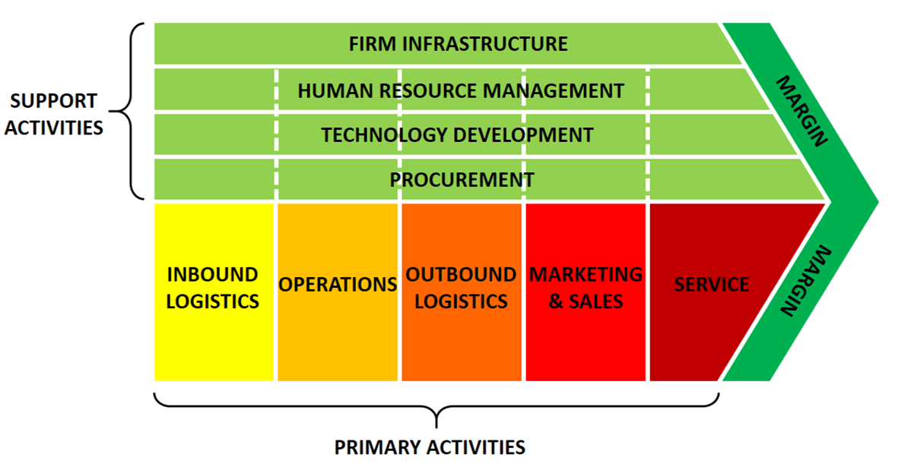
Figure 4: Porter’s Value Chain Model
(Source: Horng, Chang and Chen, 2016)

2.2.2 7S Framework
Factors | Descriptions
Strategy | TONIC 15 has to mitigate its current operational risk by developing an effective marketing plan, and through implementing the strategies like relationship marketing, undercover marketing, etc. the organisation will achieve more success in its organisational operations (Rabbanikhah, MousaGholizadeh and Alirezaei, 2017). Thus, the organisation can get a more positive outcome in the market.
Structure | In the case of TONIC 15, the organisation has to fetch some improvement in its existing process of production and external business operation. Moreover, it needs to create an efficient marketing plan and guide its employees with more confidence to enhance the workability of its organisational staffs.
System | The system of production and business operation of TONIC 15 is very effective till now. But among the influence of the upcoming competitive market, the organisational operation could become a weak part, which could negatively impact on its future operations (Shaqrah 2018). Therefore, the organisation needs to reconstruct its business process for both internal and external activity.
Style | TONIC 15 is being managed by only three individuals, though the organisation wants to recruit third party employees that will help to provide more fashionable products to its consumers (Malivan and Thanakunwutthirot, 2019). Through this way, TONIC 15 main operators will need to remain positive culture and staff will be more motivated to provide better quality products than its existing product service.
Staff | TONIC 15 started to recruit its third-party employees to store its stocks, picks of products, enhance the quality of product packaging and also for dispatching. In this way, the organisation can provide a more effective service of products to its consumer by recruiting more efficient staffs for its operations.
Skills | Efficient employees help the organisation enhance productivity through maintaining the high quality and also help increase the operational area of its business. Due to getting knowledge about the workability of efficient employees, TONIC 15 started to recruit its third-party staffs by noting the efficiency to fulfill the gap of employees (Rabbanikhah, MousaGholizadeh and Alirezaei, 2017).
Shared Values | After the recruitment of efficient employees, the administrative team of TONIC 15 has to provide appropriate guidance with sufficient knowledge about the organisational operation. Thus, staffs can perform their jobs roles/duties efficiently.
Table 4: 7S framework
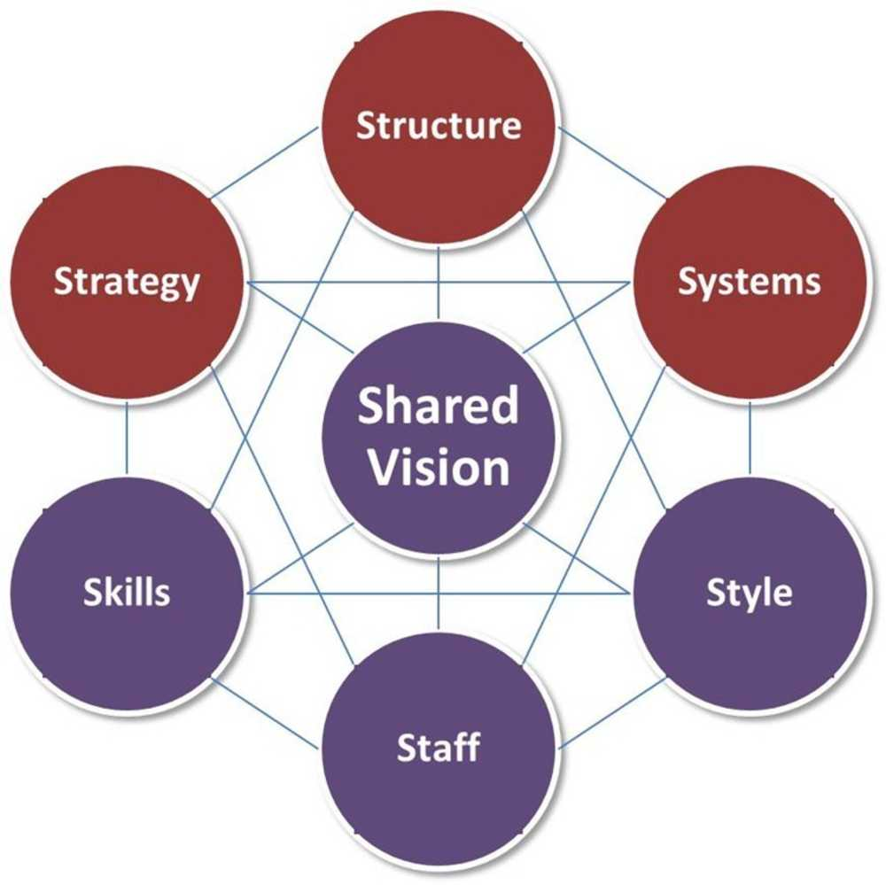
Figure 5: 7S Model
(Source: Buzatu, Pleșea and Iulian, 2019)

2.2.3 VRIO Analysis
- Value: The organisation has formed an effective relationship with its both internal and external stakeholders. Thanks to this, TONIC 15 has been able to get more advantages from its operation in a competitive market. TONIC 15 can enhance its value by providing effective products to its customers and through maintaining a good relationship with them. Therefore, their values have also been recognised by leading beauty and lifestyle magazines such as Glamour, Byrdie, PopSugar, etc.
- Rarity: at the moment, TONIC 15 has been able to provide certain skincare brands from Korea that their competitors cannot, making their products rare. However, there are a lot of suppliers in cosmetic industry, they will try to compete
- Imitability: TONIC 15 sometimes does provide substitute products in exchange for an already available product, based on consumer's needs and market feedback. Through this way, the organisation can gain the ability to tackle similar products in the marketplace, but on the flip side, a substitute product can also hamper the bonding between the customers and the organisation, if it fails to fulfil the desires.
- Organisation: Via recruiting new and efficient employees as well as by implementing advanced business strategies, TONIC 15 will be able to enhance its productivity and provide better product/service. This is by far the most efficient way in which the organisation can create value in its operational market.
(Source: Yudiono, Wilopo and Iqbal, 2019)

3. SWOT Analysis
Strength | Weakness
TONIC 15 claims to be the one and only brand in the UK that is able to provide Korean Beauty Products and brands that other competitors seem incapable of doing, which is a significant advantage at the moment. Furthermore, TONIC 15 can filter-in the facility of a warehouse in the UK to its customers, whereby they can receive products without any custom payments. | Due to the process of import and export of its products, the operating expense does seem to rise, which directly reflects on the price hike of the end product as TONIC 15 has to pay 20% of VAT. The high amount of pricing can negatively influence the company’s profitability mainly via decreasing the consumer engagement and value proposition. Also, due to the UK/EU regulations, the organisation is suffering from changes in the political, regulatory system.
Opportunity | Threats
The consumer community in the UK has been fed up with the use of regular and domestic cosmetic products. Therefore, via the variety of international cosmetic product line, TONIC 15 could be able to grab a vast range of market in the UK. It is imperative to keep in mind that the value proposition will act as the main opportunity amid the growing competition in the market. | Due to the division of the UK from the EU, TONIC 15 is not able to operate within a larger range of the market. On the other hand, the rising cost of importing international cosmetic products is becoming a big threat throughout its profit gaining.
Table 5: SWOT Analysis
(Source: Phadermrod, Crowder and Wills, 2019)

3.1 Summary after Evaluation of SWOT Analysis
Throughout the evaluation of SWOT Analysis, it has been discovered that the Korean Beauty Products sold by TONIC 15, helps them achieve more consumer engagement within its operational marketplace, attributed by their specialisation in wide range cosmetic products. However, the division of the UK from the EU and also the high amount of expense for import and export hamper its business operations negatively.

3.2 Problem Statement and Solution Reasoning
TONIC 15 now faces some issues in its business operation like, limited number of employees, high cost for its product service, division of UK/EU, and the ongoing Covid 19 pandemic through which the organisation is greatly affected. Through these disruptions in its operations, the organisation cannot provide appropriate service to its consumer, and due to the virus, the organisation lost many of its existing consumers as people are less able and willing to purchase such skincare products, hence these negatively affect its profitability. In order to deal with these interruptions, the organisation started its recruitment process to accomplish its third-party employment. Also, the organisation started to reduce its cost of production as well as its end products. Thus, the organisation can be able to mitigate its entire issues in its future operations.

4. Conclusion
To conclude, the report lays emphasis on TONIC 15's external and internal environment with the use of various tools and methods to study thoroughly the challenges faced by the company.
As the external analysis of PESTLE, VUCA and Porter’s Five Forces is conducted, we can see that there are apparent obstacles for TONIC 15 in this ongoing pandemic. The advancement of technology serves as an opportunity to provide competitive value as more people turn to shop online when retail stores are closed. However, the cosmetic industry has high rivalry and threats of entry. Therefore, indicating that TONIC 15 should focus on creating more competitive values. As for the internal environment, SWOT, value chain, 7S Framework and VRIO are conducted to identify the company’s strategic capabilities. Since the company itself is created to emphasize the importance of skincare with regards to quality lifestyle, the internal environment presents more strengths than the weaknesses itself.
In conclusion, TONIC 15 has various opportunities and potential to expand their business further. Reviewing strategic capabilities and competitive value is important to enhance their job scope.

References
Amin, S., Manzoor, A. and Farid, F., 2020, ‘The Role of Social Class on Consumer Behavior: A Study of Eco-friendly Cosmetic Products’. Journal of Business and Social Review in Emerging Economies, 6(1), pp.113-134.
Azizpour, R., Abbasnejad, T. and Siyavooshi, M., 2016. ‘Effective factors on purchasing intention of cosmetics and health products in Tehran city’. International Journal of Academic Research in Business and Social Sciences, 6(11), pp.449-458.
Bobińska, P.R., 2020. Business analysis and comparison of selected companies from cosmetic industry (Doctoral dissertation, KatedraFinansówiSystemówFinansowych).
Boome, M., 2018. Cosmetics: Consumers' Choice, Consumers' Policy (Doctoral dissertation, Evergreen State College).
Buzatu, A.I., Pleșea, D.A. and Iulian, C., 2019. ‘MANAGING ORGANISATIONS FOR SUSTAINABLE BUSINESS DEVELOPMENT: INTERACTION BETWEEN VRIO FRAMEWORK AND McKINSEY 7S FRAMEWORK’. New Trends in Sustainable Business and Consumption, p.243.
Corporate Finance Institute n.d., viewed 22 August 2020, <https://corporatefinanceinstitute.com/resources/knowledge/strategy/organizational-analysis/>.
Galetić, F. and Požega, N., 2019. ‘Estimating the Determinants of Demand for Cosmetic Face Care Products’. In 7th International OFEL Conference on Governance, Management and Entrepreneurship: Embracing Diversity in Organisations. April 5th-6th, 2019, Dubrovnik, Croatia (pp. 485-500). Zagreb: Governance Research and Development Centre (CIRU).
Hard times UK Economic Outlook 2020, viewed 22 August 2020, <https://assets.kpmg/content/dam/kpmg/uk/pdf/2020/06/uk-economic-outlook-june.pdf>.
Horng, S.C., Chang, A.H. and Chen, K.Y., 2016. ‘The business model and value chain of cultural and creative industry’. In Thriving in a new world economy (pp. 198-203).Springer, Cham.
Kornberger, M., 2017. ‘The values of strategy: Valuation practices, rivalry and strategic agency’. Organization Studies, 38(12), pp.1753-1773.
Kotlyk, A.V. and Jamal, Y., 2018. ‘Methodical approach to analysis of volatility, uncertainty, complexity and ambiguity of the external environment’. Актуальныепроблемыинновационнойэкономики, (4), pp.65-69.
Malivan, A. and Thanakunwutthirot, K., 2019, October. MODERN OFFICE MANAGEMENT: MCKINSEY 7S FRAMEWORK. In INTERNATIONAL ACADEMIC MULTIDISCIPLINARY RESEARCH CONFERENCE IN BERLIN 2019 (pp. 92-95).
Mavlanova, T., Benbunan-Fich, R. and Lang, G., 2016. ‘The role of external and internal signals in E-commerce’. Decision Support Systems, 87, pp.59-68.
Nordeatrade.com. (2020). ‘The economic context of the United Kingdom - Economic and Political Overview - Nordea Trade Portal’, viewed 22 August 2020, <https://www.nordeatrade.com/en/explore-new-market/united-kingdom/economical-context#:~:text=Economic%20Indicators&text=Sixth%20largest%20economy%20in%20the>.
Phadermrod, B., Crowder, R.M. and Wills, G.B., 2019. ‘Importance-performance analysis based SWOT analysis’. International Journal of Information Management, 44, pp.194-203.
Porter, M E 2008, ‘The five competitive forces that shape strategy. (Special HBR Centennial Issue)’, Harvard Business Review, vol. 86, no. 1, pp. 78-93.
Prajogo, D., Oke, A. and Olhager, J., 2016. ‘Supply chain processes’. International Journal of Operations & Production Management.
Rabbanikhah, F., MousaGholizadeh, R. and Alirezaei, S., 2017. ‘Pathology of Organizational Training in Universities of Iran Medical Sciences based on McKinsey 7S Mode’. Evidence Based Health Policy, Management and Economics, 1(2), pp.80-86.
Shaqrah, A.A., 2018. ‘Analyzing business intelligence systems based on 7S model of McKinsey’. International Journal of Business Intelligence Research (IJBIR), 9(1), pp.53-63.
Suranga, M. and Garg, K., 2016. ‘The Importance of Strategic Direction for the Growth of Small and Medium Scale Enterprises: A Case Study’. International Journal of Research in Social Sciences, 6(6), pp.1-21.
TONIC15. (n.d.). Meet Our Founder | TONIC 15, viewed 22 August 2020,
<https://www.tonic15.com/pages/about-us_jin>.

Yudiono, N., Wilopo, W. and Iqbal, M., 2019. ‘VRIO Analysis to Measure E-Business Readiness in the Automotive Industry in East Java’ (Study on Otobus Company Kalisari and Otobus Company Menggala). Wacana Journal of Social and Humanity Studies, 22(4).
‌

