Assignment #1
After reading the case “Bayer, Ethics, and the Anthrax Scare: Leveraging National Crisis for a Public Relations Bonanza" by Gringarten & Fernández-Calienes, pages 69-79, write a case study using the Case Analysis Outline below.
(Link to article below)
https://books.google.com/books?id=9s6SDwAAQBAJ&pg=PT99&lpg=PT99&dq=Bayer,+Ethics,+and+the+Anthrax+Scare+Leveraging+National+Crisis+for+a+Public+Relations+Bonanza+Hagai+Gringarten&source=bl&ots=QqxLzKR6Fl&sig=ACfU3U1HiKkxkN630nrQYmsEdTiPOprpJQ&hl=en&sa=X&ved=2ahUKEwjRvtva4t3rAhUj01kKHepQDxkQ6AEwB3oECAoQAQ#v=onepage&q&f=false
Submission Instructions:
The paper is to be clear and concise and students will lose points for improper grammar, punctuation, and misspelling.
The paper is to be 1000 words in length, current APA style, excluding the title, abstract and references page.
No references required.
Total Words 1000
NOTE: Must follow the Case Analysis Outline / Template below (page 2)
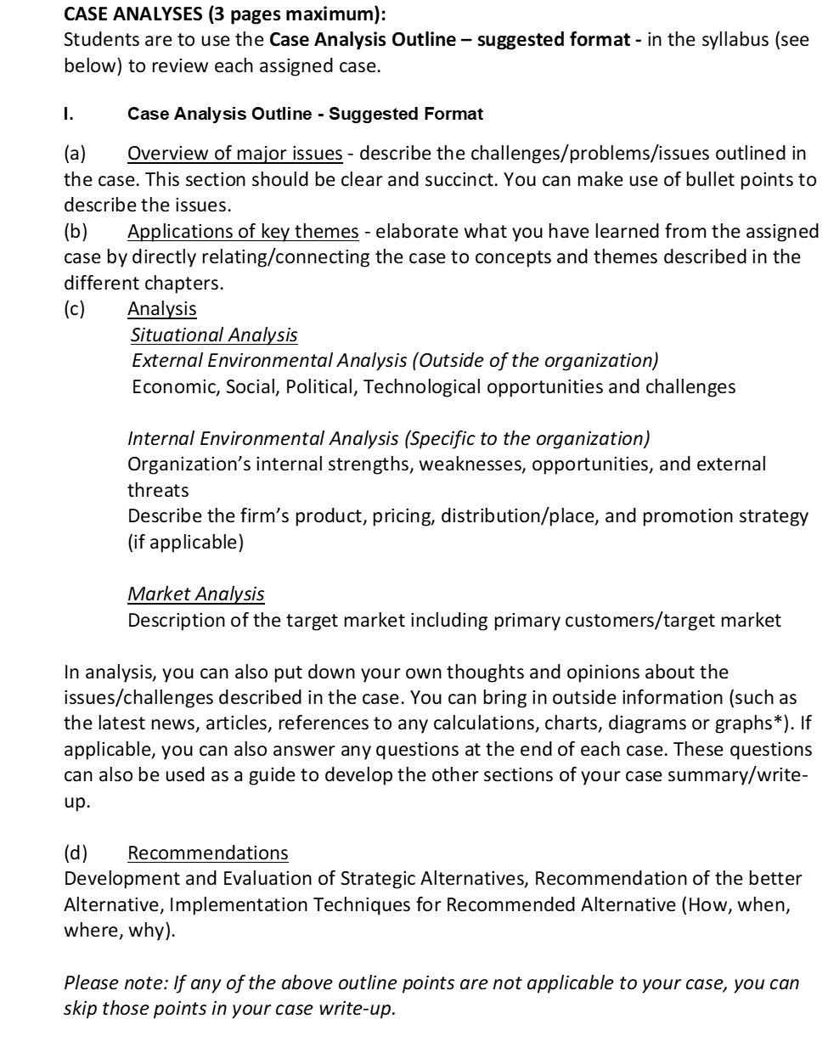

Assignment #2
Read the article and write a summary of the article and answer the questions at the end of the article.
Article Link: https://www.fastcompany.com/40547805/nike-has-a-new-digital-playbook-and-it-starts-with-sneakerheads
Is Target Marketing Ever Bad?
As marketers increasingly tailor marketing programs to target market segments, some critics have denounced these efforts as exploitative. They see the preponderance of billboards advertising cigarettes and alcohol in low-income urban areas as taking advantage of a vulnerable market segment. Critics can be especially harsh in evaluating marketing programs that target African Americans and other minority groups, claiming they often employ stereotypes and inappropriate depictions. Others counter that targeting and positioning is critical to marketing and that these marketing programs are an attempt to be relevant to a certain consumer group.
Take a position: Targeting minorities is exploitative versus Targeting minorities is a sound business practice.
Submission Instructions:
- The paper is to be clear and concise and students will lose points for improper grammar, punctuation, and misspelling.
- The paper is to be 300 words in length, current APA style, excluding the title, abstract and references page.
- Incorporate a minimum of 2 current references (published within the last five years) scholarly journal articles or primary legal sources (statutes, court opinions) within your work.
TOTAL 300 Words

Assignment #3
Completing a Marketing Plan:
Develop the initial outline of your Complete Marketing Plan.
Topic: Sephora (makeup)
Questions:
- What do you want to market?
- What is your target market?
- Where do you want to market your product?
- Why do you want to market this product to that target market in that physical environment?
Submission Instructions:
The paper is to be clear and concise and students will lose points for improper grammar, punctuation, and misspelling.
The paper is to be 300 words in length, current APA style, excluding the title, abstract and references page.
No references required.
TOTAL 300 words

Assignment #4
Develop the Situational Analysis for the Marketing Plan.
You must develop the Customer characteristics/Market Demographics, Market needs, SWOT analysis.
Submission Instructions:
The paper is to be clear and concise and students will lose points for improper grammar, punctuation, and misspelling.
Current APA style.
No references required.
TOTAL 400 words

