Assignment Task
Scenario
As a computer network engineer, you have been assigned a task to study and evaluate a third party proposed network submitted to comit.co.uk. The company consists of 3 departments; Sales, HR/Finance and Engineering. Each of the departments use a dedicated file server.
The company uses two other servers; web and email by which all departments have access to. The web and email server should be accessible via the internet (external access).
The network infrastructure floor-diagram, shown in figure 1, illustrates the proposed distribution and location of network components provided by a third-party company. Figure 2 illustrates the network topology provided by third party.
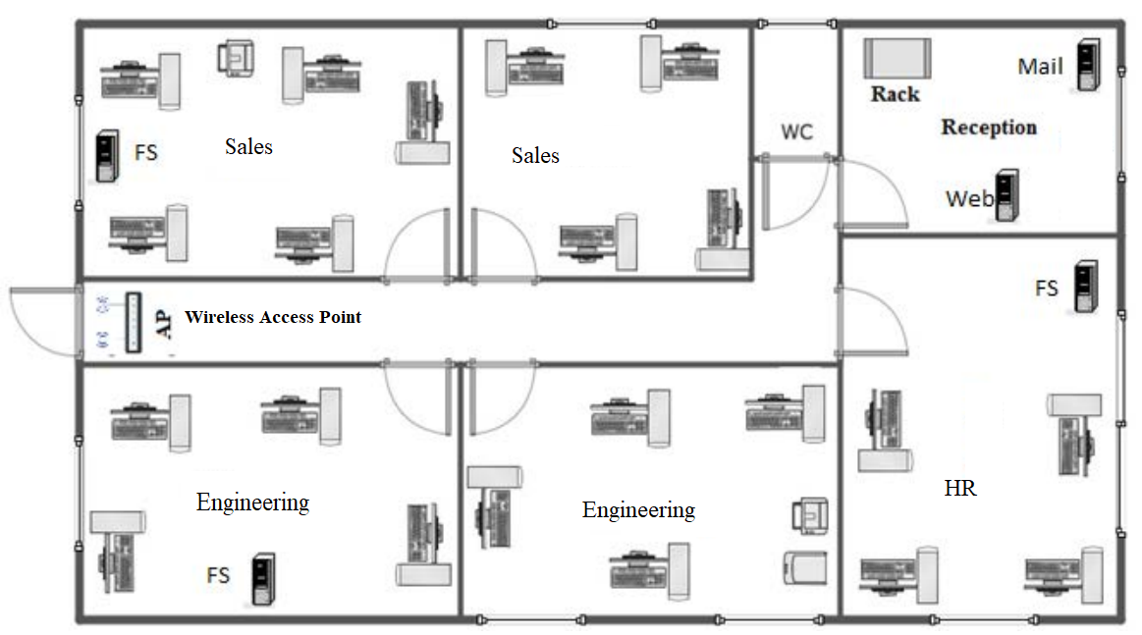
Figure 1: Existing network floor diagram

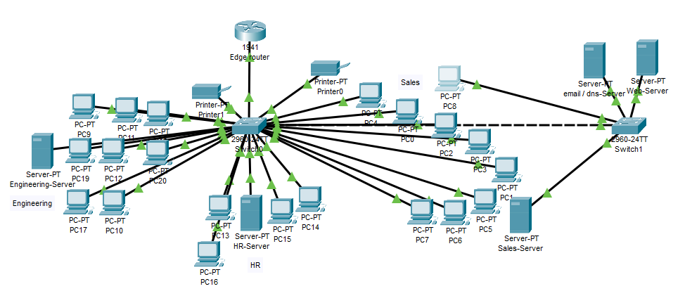
Figure 2: Proposed Network topology

The proposed third party company provided the following design consideration and reasoning as it has been configured based on some of the considerations listed as follows:
- The existing network was not segmented into many VLAN due to the limited number of 21 users.
- Each and every department assigned a dedicated file server, which will be managed by the department staff and hence will be located as close to the users as possible to ease the management, for example, HR/Finance server will be close to the HR/Finance users and so is sales etc..
- The backup services will be performed automatically on an external Hard Disk Drive, the backup device will be placed as close to each server as possible and will be secured in a local cabinet.

The company director expressed concerns and asked you to evaluate the third party network solution and based on which you are to design a new solution.
Comit.co.uk uses private network address of 192.168.21.0/24, and a public IP address of 221.222.223.160/29. Security, availability and scalability are paramount and hence your design and configuration must be based on these criteria.
Table 1 shows the users distribution and requirement according to comit.co.uk’s policy.
Department | Hosts | Security Requirements
HR/Finance | 4 PC | Need a complete isolation from all users of other groups
Engineering | 8 PC  1 Printer  1 Scanner | Need a complete isolation from all users of other groups
Sales | 9 PC  1 Printer | Need a complete isolation from all users of other groups
File Servers | 3 servers | Each server proposed to be placed near allocated ie. Sales, HR/ Finance and engineers.
Web, email Servers | 2 servers  1 will act as internal dns server | Web and email servers will be used by all users including external access.

NOTE:
- All computers will use a Microsoft product such as servers and workstations.
- LAN Network needs to be physically redundant at least at wiring / Switches level.

Deliverables
The network given in the above scenario may have many areas of network security concerns, you are to perform the following task and provide the following:
- Evaluate the given network design in terms of security, availability and scalability. Your evaluation should include discussions of potential security impacts of the given network.
- Using diagrams, design a new secured and reliable network. Your network design should include:
- Analysis and evaluation of topology used including Network documentation (topology documentation, Devices configuration tables and end devices configuration table).
- Analysis and evaluation of devices / technologies used.
- Network security consideration.
- Sample related configuration of Switches, Routers (a full configuration including network simulation file must be attached in the appendix).
- Test all servers including web and email servers functionality.
- Test the connectivity across all network including to/from DMZ.
Please include all configuration scripts and network simulation file in your assignment appendix.

Assessment criteria / Marking scheme
 | Assessment Criteria | Assessment Criteria
 | Introduction | Introduction
 |  | 6 | Introduction to the context and/or background to the topic, indicating the purpose of the report. | 10 Marks
 |  | 4 | The introduction includes some definitions of complex terminology or acronyms indicating ideas in view of the conclusion of the report.
 | Knowledge and understanding | Knowledge and understanding
 |  | 6 | Demonstrate effective approach to study and research including explanation and discussion of subject concepts, exploring requirements of given assignment. | 10 Marks
 |  | 4 | Using relevant information paraphrased / interpreted from sound sources, summarising and making sense of information.
 | Application and Analysis | Applying knowledge and analysis
 |  | 7 | Discussion, examination and analysis of different network components, exploring the relationship between different components. | 15 Marks
 |  | 5 | Reasoning of device/components selection based on priori-knowledge, backed by evidence of research from sound sources.
 |  | 3 | Discussion and analysis of different network models.
 | Evaluation and judgement | Evaluation of different components and network model
 |  | 8 | The judgment in selecting components shows understanding of issues based on evaluating and comparing different network components supported by literature. | 15 Marks
 |  | 7 | Evaluation of different technologies and/or protocols such as VLANs, Trunking, Access control, DHCP etc.
 | Design and Implementation | Network implementation and design
 |  | 10 | Implementation and Configuration of all network components and protocol with evidence (sample network configuration scripts). | 20 Marks
 |  | 6 | The plan accommodated the necessary devices and accounted for the unforeseen.
 |  | 4 | Evidence related to the work carried out in designing and implementation is apparent and demonstrate autonomy and independence.
 | Testing and documentation | Testing and documentation
 |  | 6 | A well-defined document that reflects testing of given requirements, protocol, and selected components used. | 10 Marks
 |  | 4 | Demonstrate and present network testing using appropriate technical language evidently related to the work carried.
 | Presentation / reflection | Presentation, document structure and reflection
 |  | 6 | The document is well styled using appropriate academic language, presenting information using many methods including graphs, text and diagrams where applicable. | 10 Marks
 |  | 4 | The report reflects autonomous and creativity including an insight reflection of learning supported by theory.
 | Referencing | Academic integrity and referencing
 |  | 6 | References are correctly presented to an appropriate academic style and relevant to the subject. | 10 Marks
 |  | 4 | References are from different sources (Books, journals, periodicals and technical reports) to support the discussion within the report, properly cited and paraphrased to relevant source of information.
 | TOTAL: | 100

