Managerial Economics

MOD 2
Start by reading and following these instructions:
1. Quickly skim the questions or assignment below and the assignment rubric to help you focus.
2. Read the required chapter(s) of the textbook and any additional recommended resources. Some answers may require you to do additional research on the Internet or in other reference sources. Choose your sources carefully.
3. Consider the discussion and the any insights you gained from it.
4. Create your Assignment submission and be sure to cite your sources, use APA style as required, check your spelling.
Assignment:
1. The manager of Collins Import Autos believes the number of cars sold in a day (Q) depends on two factors: (1) the number of hours the dealership is open (H) and (2) the number of salespersons working that day (S). After collecting data for two months (53 days), the manager estimates the following log-linear model:
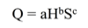
a. Explain, how to transform the log-linear model into linear form that can be estimated using multiple regression analysis.
The computer output for the multiple regression analysis is shown below:
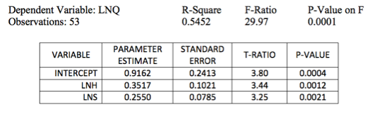
b. How do you interpret coefficients b and c? If the dealership increases the number of salespersons by 20%, what will be the percentage increase in daily sales?
c. Test the overall model for statistical significance at the 5% significance level.
d. What percent of the total variation in daily auto sales is explained by this equation? What could you suggest to increase this percentage?
e. Test the intercept for statistical significance at the 5% level of significance. If H and S both equal 0, are sales expected to be 0? Explain why or why not?
f. Test the estimated coefficient b for statistical significance. If the dealership decreases its hours of operation by 10%, what is the expected impact on daily sales?
2. Using the optimization theory, analyze the following quotations:
a. The optimal number of traffic deaths in the United States is zero.
b. Any pollution is too much pollution.
c. We cannot pull US troops out of Afghanistan. We have committed so much already.
d. If Congress cuts out the International Space Station (ISS), we will have wasted all of the resources that we have already spent on it. Therefore, we must continue funding the ISS.
e. Since JetGreen Airways has experienced a 25% increase in its insurance premiums, the airline should increase the number of passengers it serves next quarter in order to spread the increase in premiums over a larger number of tickets.
3. You are interviewing three candidates for one sales job position. On the basis of your experience and insight, you believe Jane can sell 600 units a day, Joe can sell 450 units a day, and Joan can sell 400 units a day. The daily salary each person is asking is as follows: Jane $200; Joe $150; and Joan $100. How would you rank the three applicants?
4. Bavarian Crystal Works designs and produces lead crystal wine decanters for export to international markets. The production manager of Bavarian Crystal Works estimates total and marginal production costs to be
and
where costs are measured in U.S. dollars and Q is the number of wine decanters produced annually. Because Bavarian Crystal Works is the only one of many crystal producers in the world market, it can sell as many of the decanters as it wishes for $70 apiece. Total and marginal revenue are TR = 70Q and MR = 70 where revenues are measured in U.S. dollars and Q is the annual decanter production.
a. What is the optimal level of production of wine decanters? What is the marginal revenue from the last wine decanter sold?
b. What are the total revenue, total cost, and net benefit (profit) from selling the optimal number of wine decanters?
c. At the optimal level of production of decanters, an extra decanter can be sold for $70, thereby increasing the total revenue by $70. Why does the manager of this firm not produce and sell one more unit?
5. A decision maker wishes to maximize total benefit, B = 3x + xy + y subject to the cost constraint, C = 4x + 2y = 70. Setup the Lagrangian and then determine the values of x and y at the minimum level of benefit, given the constraint. What are the maximum benefits?

MOD 3
Start by reading and following these instructions:
1. Quickly skim the questions or assignment below and the assignment rubric to help you focus.
2. Read the required chapter(s) of the textbook and any additional recommended resources. Some answers may require you to do additional research on the Internet or in other reference sources. Choose your sources carefully.
3. Consider the discussions and the any insights gained from it.
4. Create your Assignment submission and be sure to cite your sources, use APA style as required, check your spelling.
Assignment:
1. Bridget has a limited income and consumes only wine and cheese. Her current consumption choice is four bottles of wine and 10 pounds of cheese. The price of wine is $10 per bottle and the price of cheese is $4 per pound. The last bottle of wine added 50 units to Bridget's utility, while the last pound of cheese added 40 units.
a. Is Bridget making the utility maximizing choice? Why or why not?
b. If not what should she do instead? Why?
2. The owner-manager of Good Guys Enterprises obtains utility from income (profit) and from having the firm behave in a socially conscious manner, such as making charitable contributions or civic expenditures. Can you set up the problem and derive the optimization conditions if the owner-manager wishes to obtain a specific level of utility at the lowest possible cost? Do these conditions differ from the utility maximizing conditions?
3. The Dallas Morning News reported the findings of a study by the Department of Transportation that examined the effect on average airfares when new, low priced carriers, such as Southwest Airlines or Vanguard Airlines, entered one of the three city-pair markets: Baltimore-Cleveland, Kansas City-San Francisco, or Baltimore-Providence. Use the following excerpts from the newspaper article to calculate the arc elasticity of demand for each of the three city-pairs. How do the three computed elasticizes compare? Based on the computed elasticizes, describe travelers'' responsiveness to the reduction in airfares.
- "(In) Baltimore and Cleveland for example, …just 12,790 people between those cities in the last three months of 1992, at an average fare of $233. Then Dallas-based Southwest Airlines entered the market. In the last three months of 1996, 115,040 people flew between the cities at an average fare of $66."
- "(On) Kansas City-San Francisco connection… during the last quarter of 1994 some 35,960 people made the trip at an average fare of $165. Two years later, after the arrival of Vanguard Airlines, fares had dropped to an average of $107 and traffic had nearly doubled to 68,100."
- On the Baltimore-Providence, R. I., route, where the average fare fell from $196 to $57, …the number of passengers carried jumped from 11,960 to 94,116."
4. Rubax, a U.S. manufacturer of athletic shoes, estimates the following linear trend model for shoe sales.
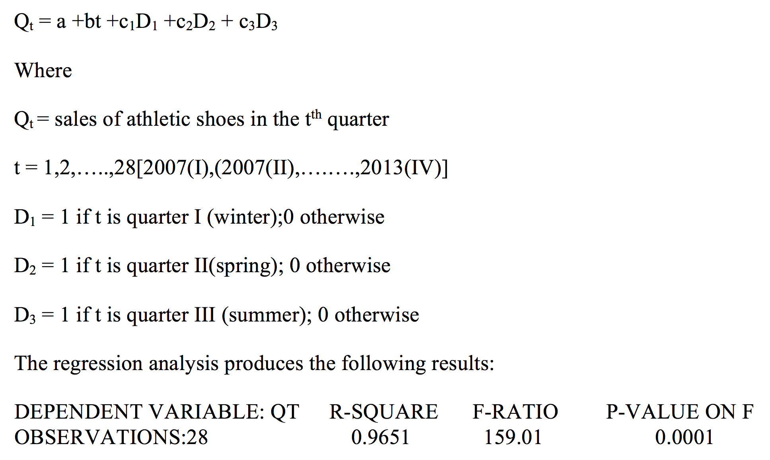
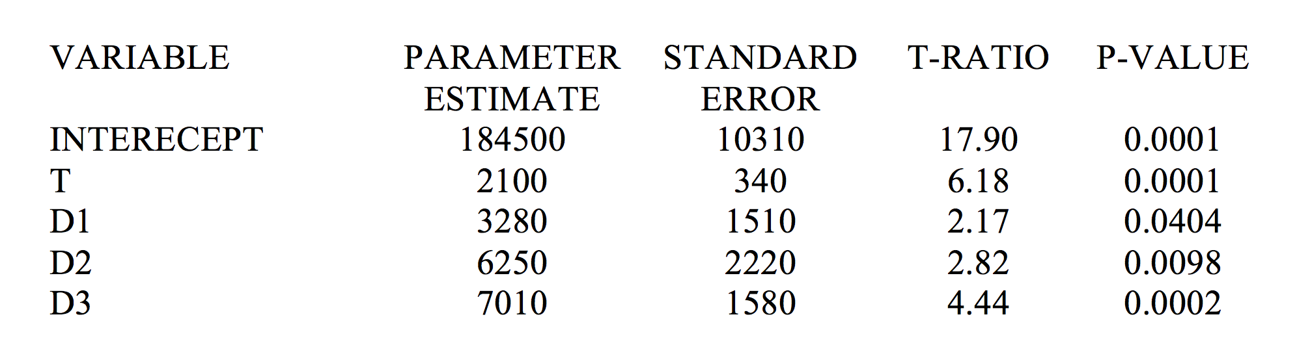
- Is there sufficient statistical evidence of an upward trend in shoe sales?
- Do these data indicate a statistically significant seasonal pattern of sales for Rubax shoes? If so, what is the seasonal pattern exhibited by the data?
- Using the estimated forecast equation, forecast sales of Rubax shoes for 2014(III) and 2015(II)
- How might you improve this forecast equation?
5. Cite the three major problems with consumer interviews or surveys and provide an example of each.

