**Contents**

**Executive Summary** 3

**Introduction - Background and Business** 4

**Company Analysis** 5

• **Current financial performance and economic outlook** 5

**Ratio Analysis** 6

• **Profitability ratios** 11

• **Efficiency ratios** 11

• **Liquidity ratios** 12

• **Market performance ratios** 13

• **Capital structure ratios** 13

**Horizontal Analysis** 14

**PESTLE Analysis** 17

• **Political factors** 17

• **Economic factors** 17

• **Sociocultural factors** 17

• **Technological factors** 17

• **Legal factors** 18

• **Environmental and ethical factors** 18

**Conclusion** 18

**References** 19

# **Executive Summary**

* **Introduction – Background & business**

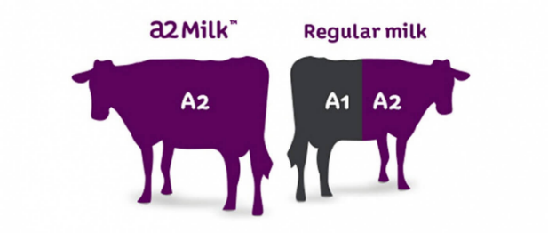The A2 Milk Company Limited is in the business of producing, marketing and selling branded diary and infant formula products in targeted global markets (thea2milkcompany.com).

The company was founded in 2000 by scientist Dr. C. McLachlan and business partner H. Paterson (thea2milkcompany.com). The company listed on the NZX alternative market in 2004, and on the ASX in 2015. In the same year the company launched its infant formula in China, Australia and New Zealand.

The company’s products differ from regular cows’ milk which contains 2 main types of beta-case in protein: A2 protein and A1 protein. The A2 Milk Company Limited’s branded milk contains only the A2 protein. It is comparable to regular cows’ milk in other respects (thea2milkcompany.com).

* **Company Analysis - Current Financial performance, economic outlook**

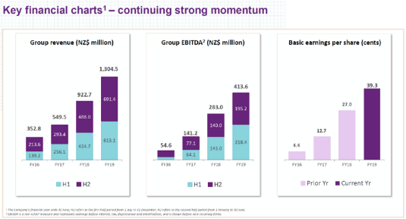The financial analysis of the company was done to evaluate it and to determine the performance and suitability for investment. Furthermore, it is used to analyse whether the company is stable, solvent, liquid, or profitable enough to warrant a monetary investment.

* **Ratio Analysis**

In the ratio analysis of A2 Milk Company Limited, the relationship between two quantitative amounts with the objective of expressing the relationship in ratio, or as a percentage, is examined. The purpose is to express a relationship between two relevant items that is easy to interpret and compare (Birt, J. 2012). In the ratio analysis of the company, the results of Bellamy’s Australia Limited was used as a comparison.

* **Horizontal Analysis**

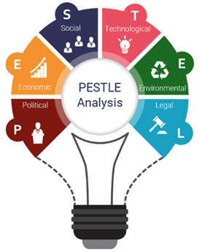In the horizontal analysis of A2 Milk Company Limited, a series of financial statement data is examined over a period of time. This analysis highlights growth and trend patterns.

* **PESTEL Analysis**

The PESTLE analysis, which includes political, economic, sociocultural, technological, legal, and ecological factors of the macro environment, is used in analysing the external environment of A2 Milk Company Limited.

.

* **Recommendation**

A2 Milk Company has experienced consistent growth and continual growth in both revenue *and*profit. The company produced a strong balance sheet which, combined with its continued strong cash generation, gives it the flexibility to support its growth potential in the future.

# **Introduction - Background and Business**

The A2 Milk Company Limited was founded in New Zealand in 2000. The company experienced many changes over the past two decades as presented in Figure 1.

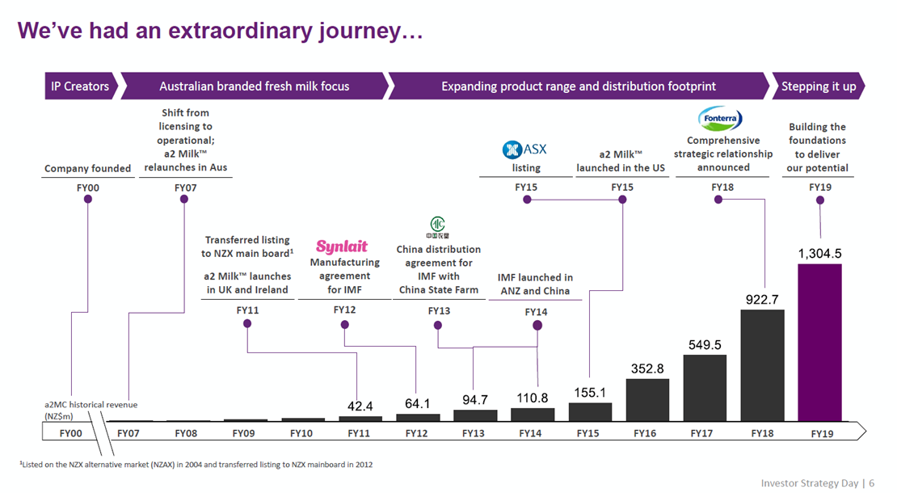

Figure 1. A2 Milk Company Limited – the journey. Retrieved from <https://thea2milkcompany.com>.

The company derives its revenue from the commercialisation of A1 protein free branded milk and related products. It employs approximately 230 people, operates in Australia, New Zealand, Asia, the United Kingdom and the United States, and is administered from its head office in New South Wales.

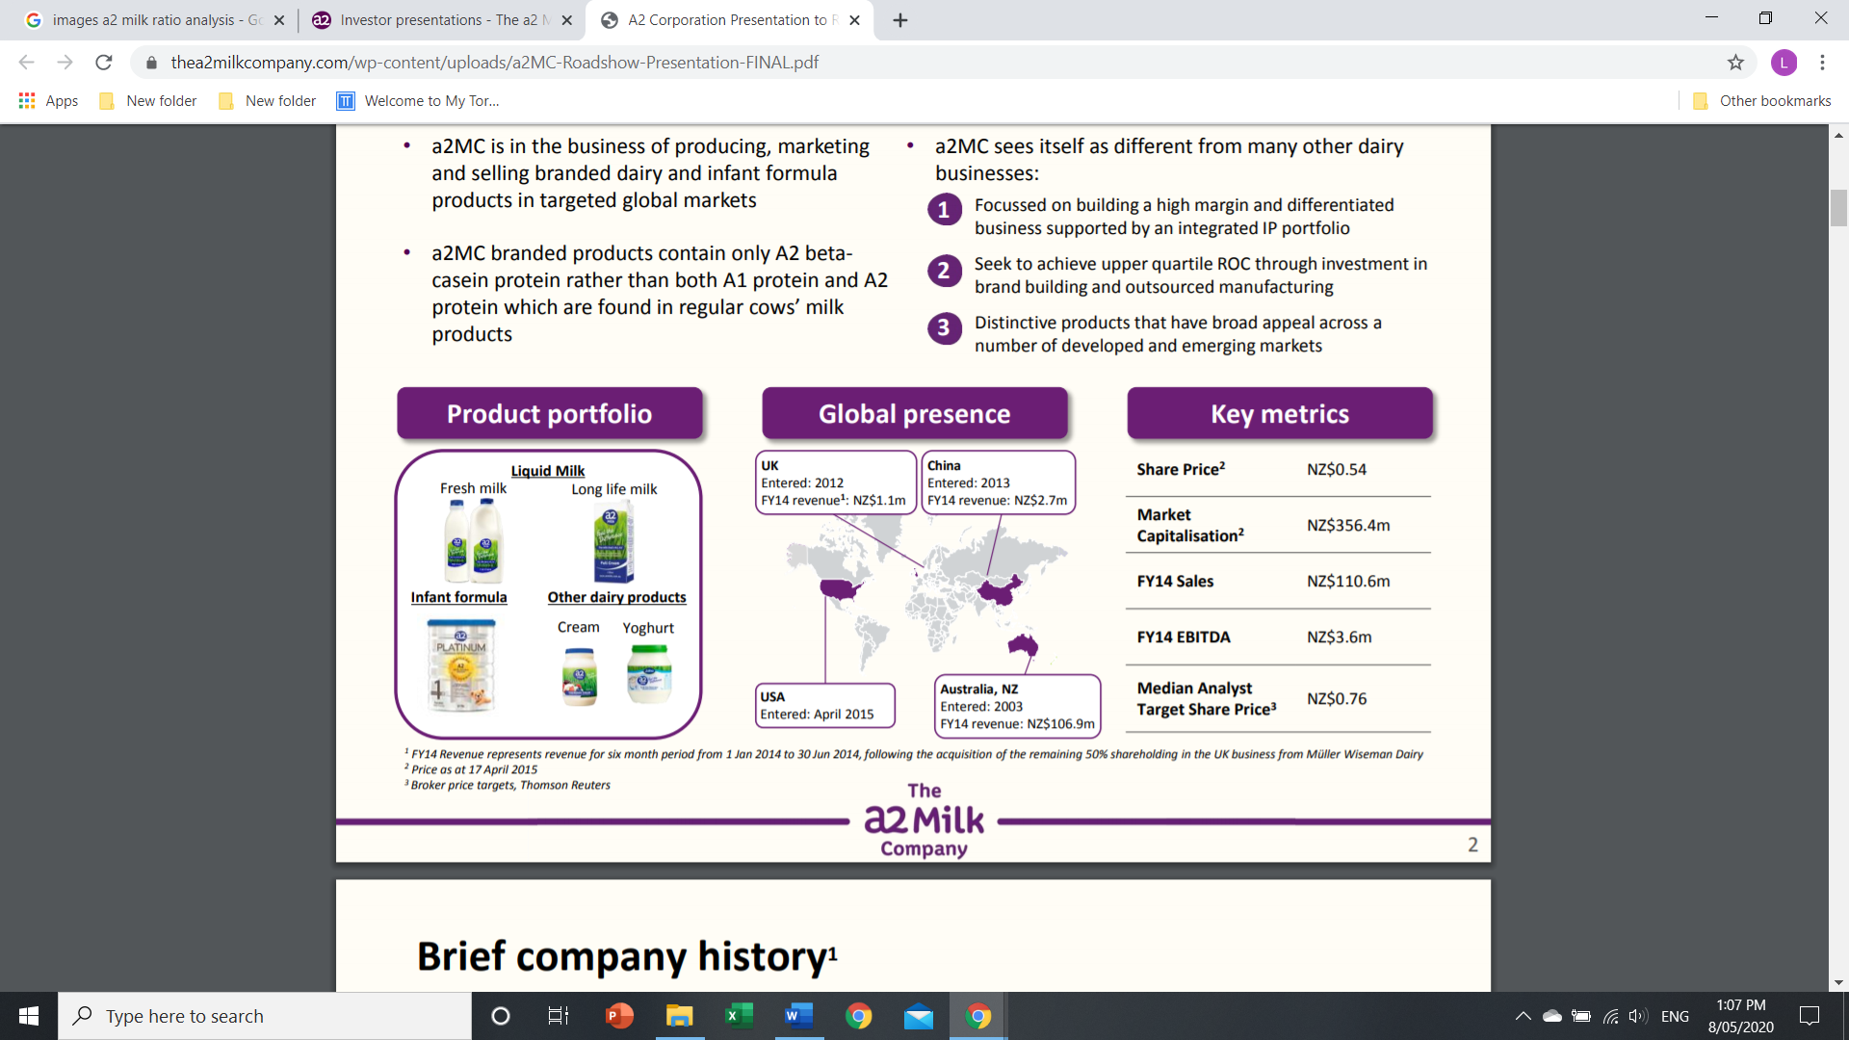

Figure 2. The company at a glance. Retrieved from <https://thea2milkcompany.com/wp-content/uploads/a2MC-Roadshow-Presentation-FINAL.pdf>.

# **Company Analysis**

According to Birt, J. (2012), financial statements are used by a range of parties making various decisions. Financial analysis is an analytical tool that involves expressing the reported financial numbers in relative terms. Financial analysis assists users to evaluate the company’s past decisions and form an opinion as to the company’s future financial health (Birt, J. 2012).

## **Current financial performance and economic outlook**

The A2 Milk Company achieved record financial and market share results for 2019. This was enabled by strong revenue growth across their key product segments of liquid milk, infant nutrition and other nutritional milk products, and across each of their key regions. The results were underpinned by growing brand awareness, expanding product distribution and strengthening in-market execution in their two most important regions of Greater China and the US.

The result highlights in its financial report for the year ended 30 June 2019 is presented in figure 2.

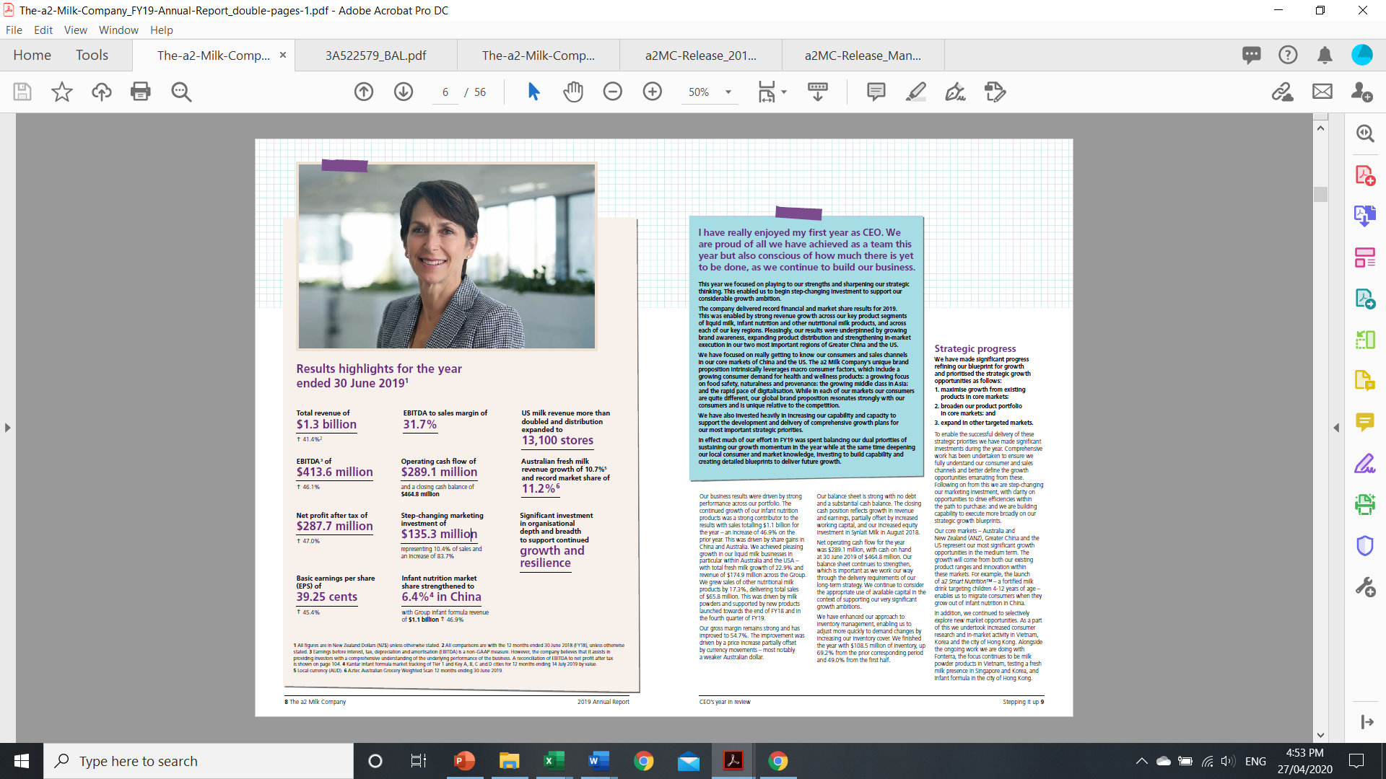

Figure 3. Result highlights for the year ended 30 June 2019. Annual financial report, 2019. Retrieved from https://www.asx.com.au/asx/share-price-research/company/A2M.

The company’s business results were driven by strong performance across their portfolio. The continued growth of the infant nutrition products was a strong contributor to the results with sales totalling $1.1 billion for the year. This was driven by share gains in China and Australia. The company also achieved pleasing growth in their liquid milk businesses in particular within Australia and the USA – with total fresh milk growth of 22.9% and revenue of $174.9 million across the Group. The sales of other nutritional milk products increased by 17.3%, delivering total sales of $65.8 million. This was driven by milk powders and supported by new products launched towards the end of FY18 and in the fourth quarter of FY19.

The company continue to consider the appropriate use of available capital in the context of supporting its very significant growth ambitions as presented in figure 3.

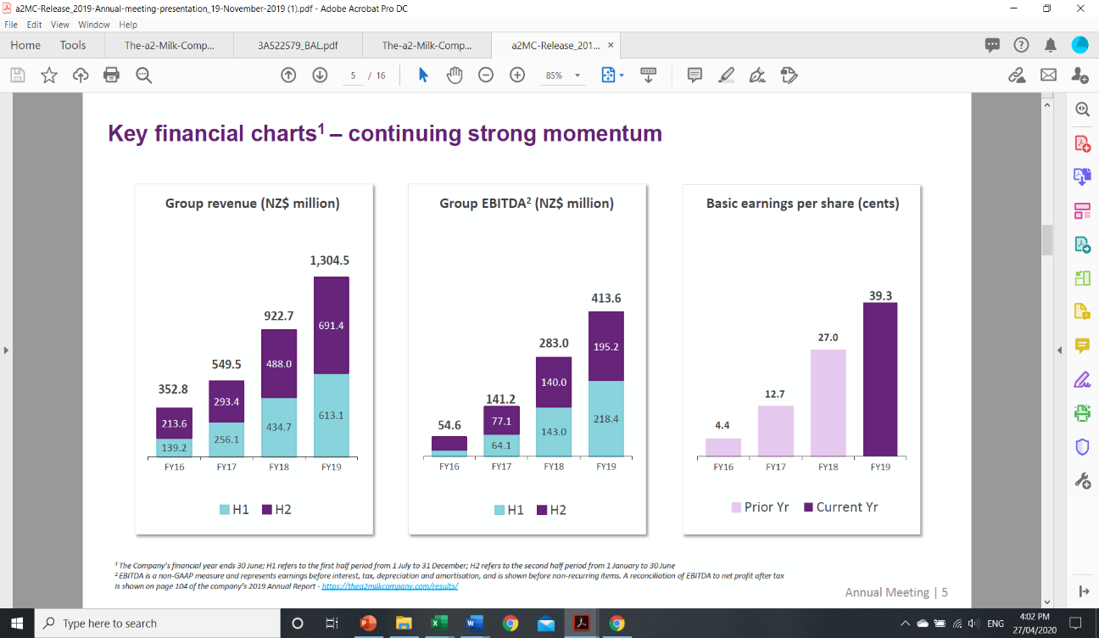

Figure 4. The company’s continued strong momentum. Rikard, P. (2019). Retrieved from https://www.nabtrade.com.au/investor/insights/latest-news/news/2019/10/the_land_of_a2_milk.

**Ratio Analysis**

Ratio analysis examines the relationship between two quantitative amounts with the objective of expressing the relationship in ratio or as a percentage (Birt, J. 2012. p. 324). The purpose is to express a relationship between two relevant items that is easy to interpret and compare. In the ratio analysis of a2Milk Company Limited the results of Bellamy’s Australia Limited was used as comparison.

Figures 5 to 9 presents calculations of the ratios in Excel spreadsheets.



Figure 5. Ratio calculation – The A2 Milk Company Limited – Profitability and Market Ratios (Excel Spreadsheet 1 – Sheet 1)

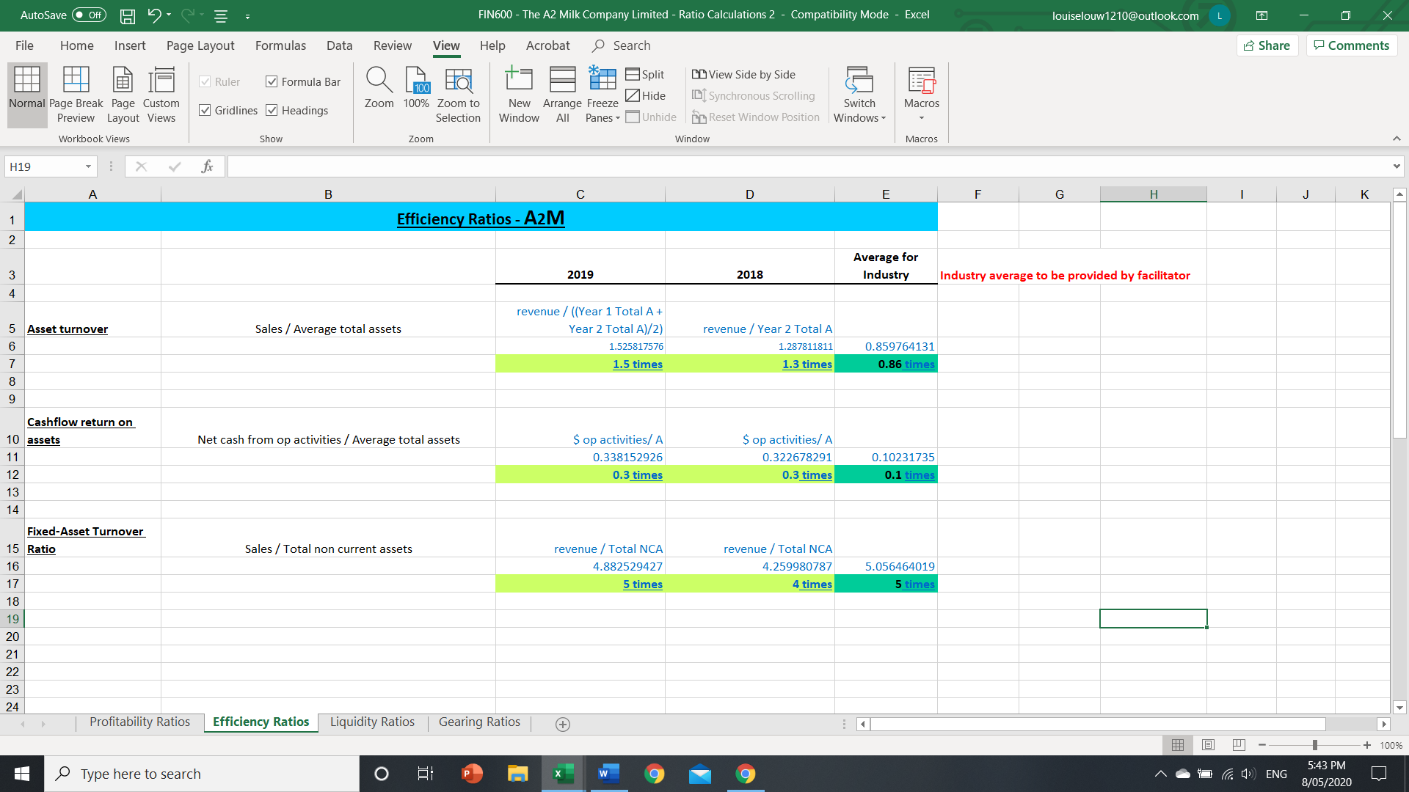

Figure 6. Ratio calculation – The A2 Milk Company Limited – Efficiency Ratios (Excel Spreadsheet 1 – Sheet 2)

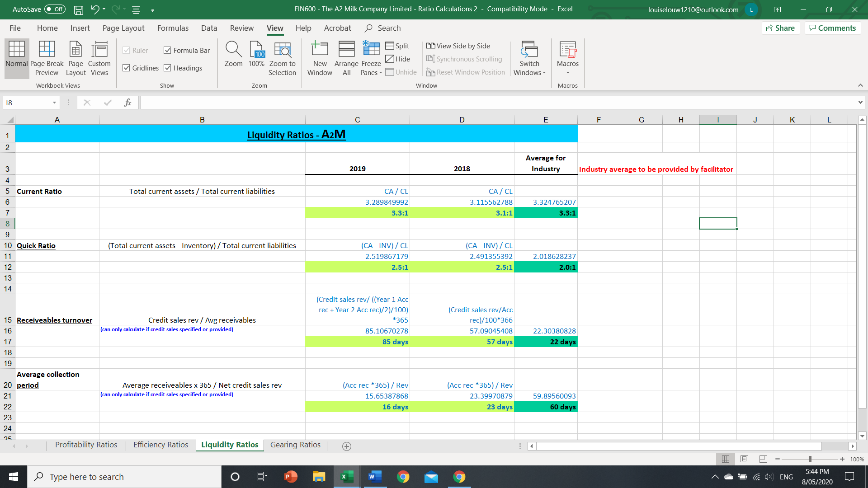

Figure 7. Ratio calculation – The A2 Milk Company Limited – Liquidity Ratios (Excel Spreadsheet1 – Sheet 3)

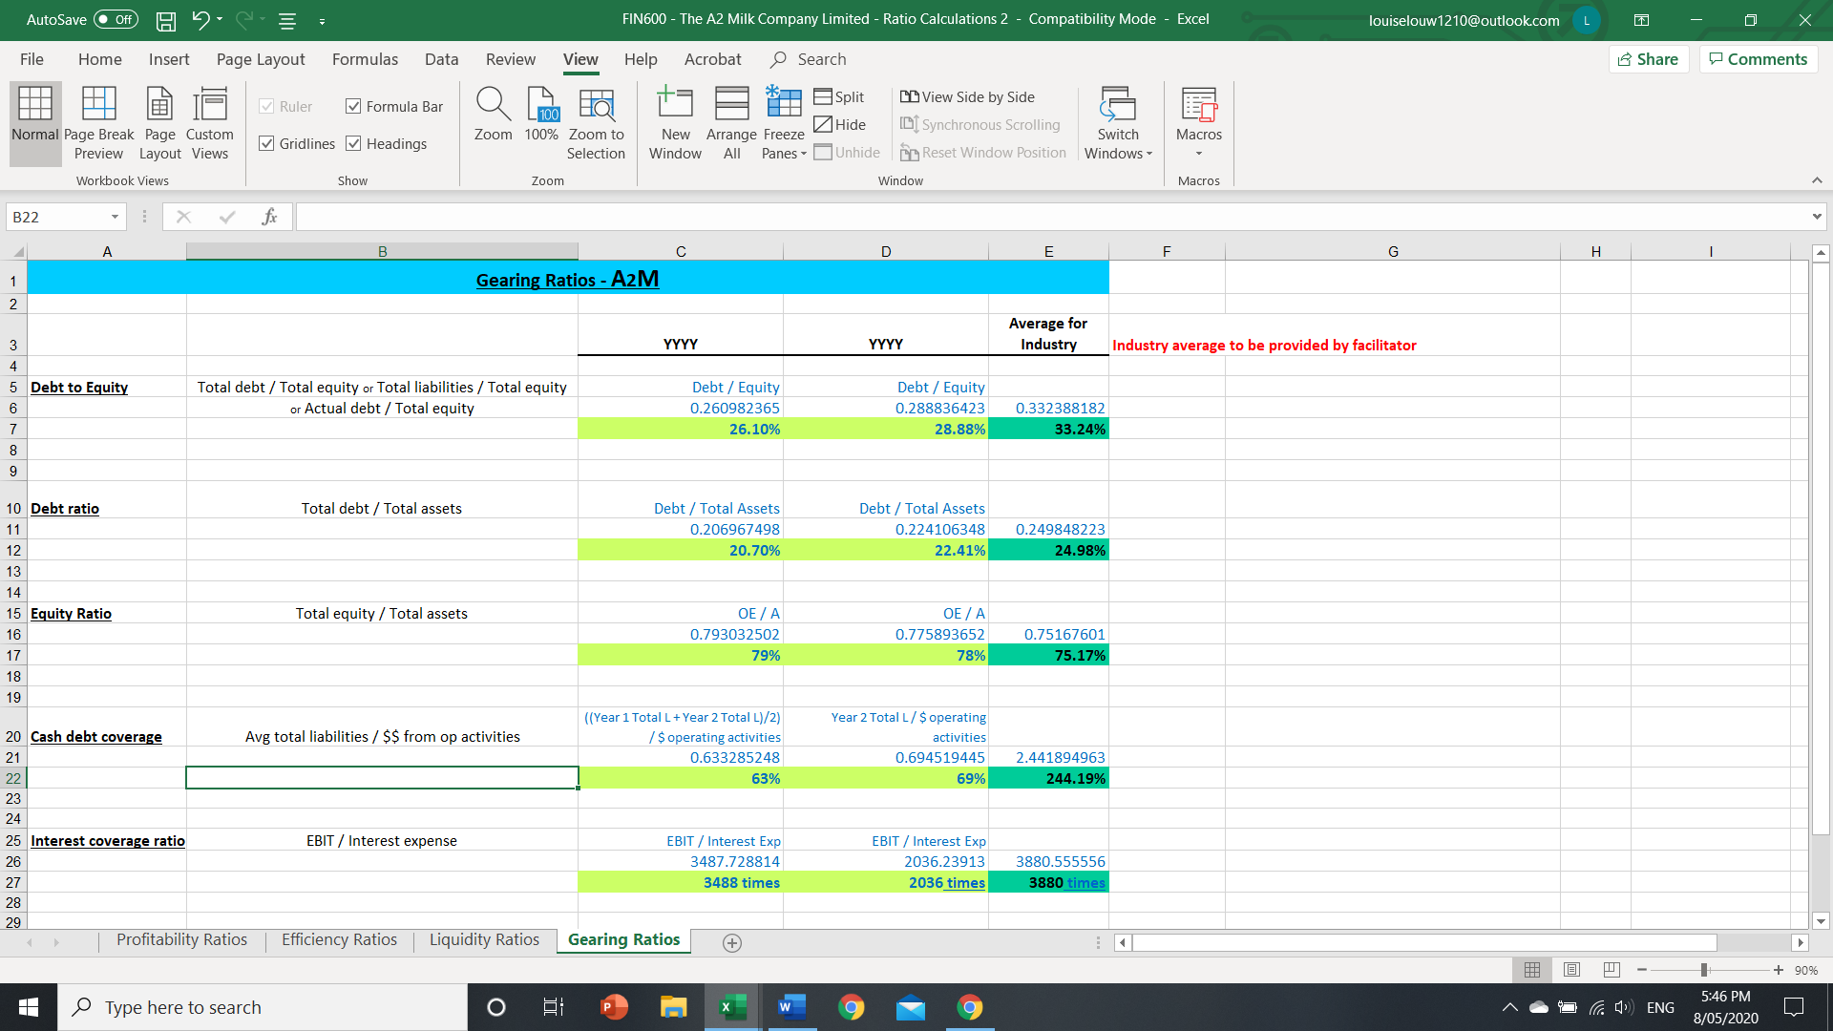

Figure 8. Ratio calculation – The A2 Milk Company Limited – Gearing Ratios (Excel Spreadsheet 1 – Sheet 4)



Figure 9. Ratio calculation – The A2 Milk Company Limited – Additional Ratio Calculations. (Excel Spreadsheet 2).

## **Profitability ratios**

These ratios measure the profit relative to the resources available to generate the profit (Birt, J. 2012).

The profitability ratios of the company are presented in table 1.



Table 1. Analysing profitability ratios - A2 Milk Company Limited.

Return on equity increased from 35.21%, FY2018 to 42.83% FY2019, and measures profit earned for each dollar invested by the owners. This ratio captures profitability, efficiency and capital structure within the company. The increase over time and the difference compared to Bellamy’s reflect the direction of the company’s profitability, asset efficiency and capital structure.

The return of asset ratio compares the company’s profit to the assets available to generate profits (Birt, J. 2012). Effectively the ratio reflects the results of the company’s ability to convert sales revenue into profit, and its ability to generate income from its asset investment (Birt, J. 2012). The company increased the return on assets from 27% FY2018, to 33.66% Fy2019, and this is a very good performance when comparing to its competitor which achieved 7% FY2019.

The gross profit margin compares the company’s gross profit to its sales revenue, reflecting the proportion of sales revenue that results in gross profit (Birt, J. 2012). The company managed to increase its profit margin from 50.34% FY2018, to 54.72% FY2019. This is also a very good performance when comparing to the 43.52% achieved by its competitor. The net profit margin reveals what percentage of sales revenue dollars result in earnings before tax (Birt, J. 2012).

## **Efficiency ratios**

These ratios measure the profit relative to the resources available to generate the profit (Birt, J. 2012). Furthermore, it highlights management’s effectiveness in managing the organisation’s assets. The efficiency ratios of the company are presented in table 2.



Table 2. Efficiency ratios – a2 Milk Company Limited.

The receivable turnover reflects the days it takes for the company to collects the amounts owing by its debtors. The number of days increased from 57 days, FY2018 to 85 days FY2019. The reason for this could be the massive increase of 41.4% in sales during the year. If the company has a 30-day policy, its average customer makes late payments, which could result in problems if not managed. Bellamy’s customers pay within 22 days, which is a better result.

Days for receivables to be converted to cash improved from 23 days, FDY2018 to 16 days, FY2019. Days for payables to be paid out as cash remained consistent during the two comparing years. The average days for inventory to be converted into cash also remained consistent. This performance has resulted in a cash conversion cycle of minus 14 days, FY2019 and minus 12 days, FY2018. The negative amount of days means less cash is stuck as inventory and receivables and the company might be holding the supplier’s funds. The company has performed well when compared to Bellamy’s with a cash conversion cycle of 116 days.

Inventory turnover ratio is the value of cost of goods sold as a proportion to inventory (Birt, J. 2012). The 7% achievement in both years could mean that the company holds high levels of inventory. Accounts receivable turnover ratio is the value of sales as a proportion of accounts receivable (Birt, J. 2012). The 23% achieved in FY2019 could indicate that much of sales revenue is locked up as accounts receivable. Accounts payable turnover ratio is the value of purchases as a proportion of money owing to suppliers as accounts payable. The 4% achieved in both years is low and indicates that much of the purchases are fully paid up and not much is owing to suppliers as a percentage of purchases.

* **Liquidity ratios**

The organisation’s ability to meet its short-term commitments is indicated by these ratios (Birt, J. 2012). These ratios are presented in table 3.



Table 3. Liquidity ratios – a2 Milk Company Limited.

The current ratio indicates the dollars of current assets the company has per dollar of current liabilities (Birt, J. 2012). The company has consistently managed a ratio of 3 to 1 which is in line with its competitors. The quick ratio evaluates how well the company can meet its short-term debt obligations without having to sell any of its inventory. A2milk again consistently managed a ratio of 2.5 to 1 which is a little better than its competitor which achieved 2 to 1. The cash ratio indicates the company’s ability to pay its short-term debt obligations with its cash and cash equivalents. The ratio of 2.26 to 1 means that the company is highly liquid and can easily fund its debt.

* **Market performance ratios**

These are ratios that generally relate the organisation’s financial numbers to its share price. The market performance ratios of the company are presented in table 4. The company did not pay dividends for the two years analysed. The earnings yield based on the current market price is 2.46% FY2019 increased from 10.7% for the previous year. The share price used in this calculation is $15.87 as at 27 March 2020. The price earnings ratio of 41 times in FY2019 and 49 times in 2018 reflects the times earnings is capitalized in the share price. This high value reflects that the company has done well and has good future prospects.



Table 4. Market performance ratios – a2 Milk Company Limited.

## **Capital structure ratios**

The company’s capital structure is the proportion of debt financing relative to equity financing and reflects the company’s financing decision. These ratios are presented in table 5.



Table 5. Capital structure ratios – a2 Milk Company Limited.

The debt to equity ratio indicates the relative proportion of the company’s equity and debt used to finance the assets (Birt, J. 2012). The decrease of 28.8%, FY2018 to 26.10% FY2019, indicates that the company is not being financed by its creditors but by its own financial resources. However, the low ratio may indicate that the company is not taking advantage of the increased profits that financial leverage may bring.

The debt to assets ratio indicates that 20.69%, FY2019 of the company’s assets are financed by debt. The equity to assets ratio indicates the percentage of the company’s assets that is owned by investors.

The cash debt coverage indicates the relationship between the operating cash flow of the company and its total liabilities and implies what the actual ability of the company is to pay back its debt from its operations. The interest coverage ratio is a measure of the company’s ability to meet its interest payments. It is calculated by dividing the company’s earnings before interest and taxes (EBIT) by its interest expense for the same period (Birt, J. 2012).

In comparing the two companies in the ratio analyses, it is noticeable that the A2 Milk Company Limited, performance was better than its competitor, Bellamy. This occurred across all the categories of the ratio analysis.

# **Horizontal Analysis**

According to Birt, J. (2012), horizontal analysis is the process of analysing a series of financial statement data over a period in time. All comparisons in this analysis are with the 12 months ended 30 June 2018 (FY18). An analysis of the consolidated statement of comprehensive income is presented in table 6 and the statement of financial position in table 7.

Results highlights for the year ended 30 June 2019 (Annual financial report, 2019)

* Total revenue of $1,304.5 million – an increase of 41.4%2
* EBITDA of $411.5 million – up 46.46%
* Net profit after tax of $287.7 million – up 47.0%
* Basic earnings per share (EPS) of 39.3 cents, an increase of 45.4%
* EBITDA to sales margin of 31.7%
* Operating cash flow of $289.1 million and a closing cash balance of $464.8 million
* The gross margin remains strong and has improved to 53.71%. The improvement was driven by a price increase partially offset by currency movements – most notably a weaker Australian dollar.

The company has significantly increased their investment in building brand value with a goal to accelerate brand awareness and trial in both China and the US. The investment in marketing for the full year increased by 83.7% to $135.3 million, primarily as a result of increases in advertising spend in China and the US.

Furthermore, the company invested in both internal and external capability by appointing a number of executives and other senior appointments. These roles build upon the existing strong and experienced group of executives in the organisation and increased much needed skills and capacity. Therefore, the investment in the workforce increased by 50.57%

The company has enhanced its approach to inventory management, enabling it to adjust more quickly to demand changes by increasing its inventory cover. The closing balance for the financial year is $108.5 million of inventory, an increase of 69.2% from the prior corresponding period. The greater investment in inventories is also noticeable in the sales growth.

Step-changing marketing investment of $135.3 million representing 10.4% of sales and an increase of 83.7%. The listed investment is in Synlait Milk Limited, which is a dairy processing company. In August 2018 the Company made a further investment in Synlait, acquiring 14,840,527 shares for $162,335,000, increasing its total holding in Synlait to 17.394% (Annual financial report, 2019). A fair value loss of $62,390,000 (2018: profit $108,741,000) was recognised for the year. This investment is evident in other financial assets increase of 53.49%.

The decrease in other revenue, which is interest received, of 50.46%, is as a result of the decrease of 10.79% of trade and other receivables. Customer contract liabilities are payments received in advance from customers. The amount of $898,000 recognised in customer contract liabilities at 30 June 2018 was recognised as revenue in the year ended 30 June 2019. Remaining performance obligations at 30 June 2019 have an original expected duration of one year or less. This item reflected an increase of 59.35%.

The performance of the company and specifically management’s effectiveness and efficiency, is proved in the increase of 98.98% retained earnings. This resulted in the overall increase of owner’s equity of 41.77%.

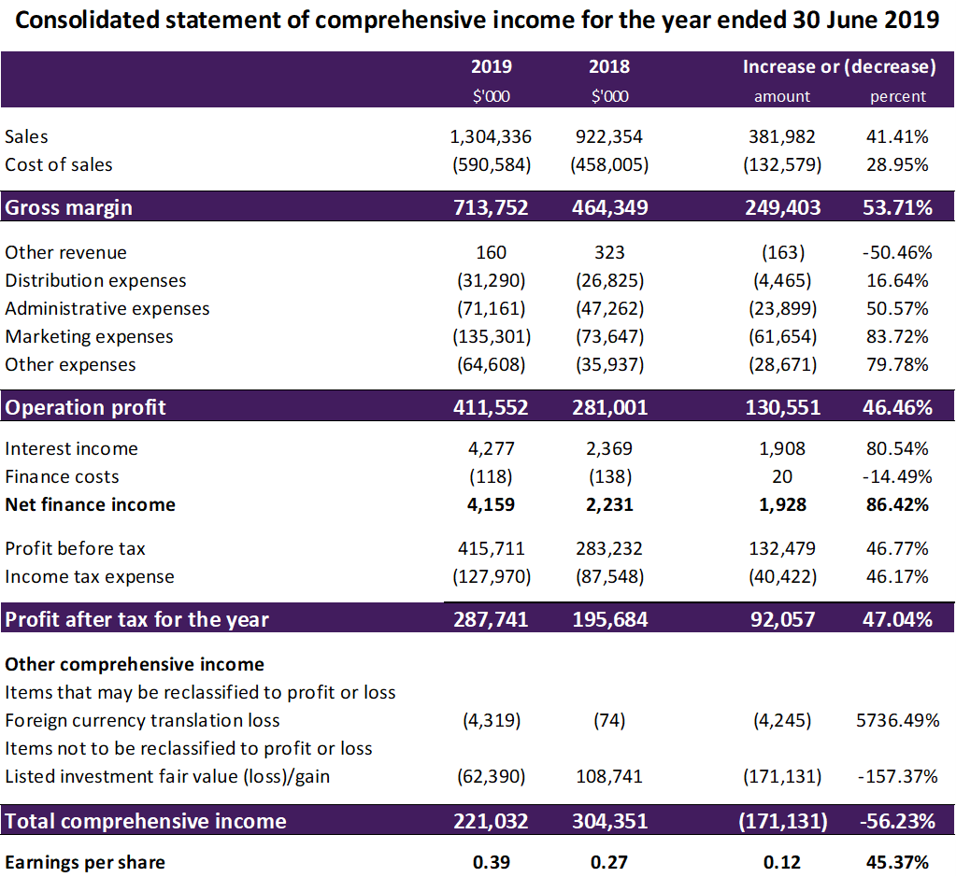

Table 6. Analysing statement of comprehensive income for the year ended 30 June 2019 – a2 Milk Company Limited. Created by author.



Table 7. Analysing statement of financial position as at 30 June 2019 – a2 Milk Company Limited. Created by author.

# **PESTLE Analysis**

This analysis will assist to identify and evaluate trends and events beyond the control of the business. Additionally, it will reveal key opportunities and threats for the business that could have a major influence on strategic decisions (Marmol, et al. 2015). The PESTLE analysis, which includes political, economic, sociocultural, technological, legal, and ecological factors of the macro environment, is used in the analysis.

## **Political factors**

According to the annual financial report, due to the company’s expanding footprint, the business is exposed to various risks associated with conducting business in international markets including in Australia, China and the US. As a result, it is inherently exposed to:

* dynamic political and regulatory environments in which government actions influence or restrict international trade in products. This can occur through the use of tariffs, quotas, price controls, taxes and non-tariff barriers such as product registrations, competition and consumer laws; and
* litigious environments that could result in claims against the company from consumers and other market participants.

## **Economic factors**

According to the annual financial report, market risk is the risk that changes in market prices will affect the Group’s income or the value of its holdings in financial instruments. The Group’s activities expose it primarily to the financial risks of changes in foreign currency exchange rates to the NZ dollar. The Group’s holding of a listed investment also exposes it to equity price risk. Market risk exposures must be monitored by management on an ongoing basis.

Furthermore, the annual financial report states that the Group’s exposure to foreign currency risk arises principally from its operations in Australia, the US, the United Kingdom, and China; and the resultant movements in the currencies of those countries against the NZ dollar. The Group does not hedge this risk but may transfer cash balances from time to time between currencies to reduce exposure or to match underlying liabilities.

## **Sociocultural factors**

Consumers are increasingly conscious of food safety and product origins, demanding more transparency on where and how their food is produced. This is driving significant demand for naturally healthy, premium quality and sustainable food choices.

A2 Milk Company has to take its responsibility to the communities it serves, very seriously. The company plays an important role in supporting the healthy development of some of the world’s youngest and most vulnerable people. Furthermore, the company must recognise its responsibility to support the resilience of farming communities, including through events such as the drought in Australia.

## **Technological factors**

The rapid change in IT provides both opportunities and risks. Incidents of cyber-attack and the release of data have become an increasing threat for all companies. According to the financial report, the cyber security and data environment are continuously evolving and, as a result, A2Milk company is inherently exposed to inadequate IT security leading to a compromise of its IT system and potential data theft, data loss or corruption. Such a compromise could result in economic or reputational loss. The company remains focused on further strengthening its governance, processes and technology controls to continue to protect the integrity and privacy of data and maintain compliance with regulatory requirements. The company has to invest in increased cyber security systems and protections, including restricted and segregated access to sensitive company and stakeholder data, implementation of regional specific cyber security audits and cyber security insurance.

## **Legal factors**

A2 Milk Company supplies food products for human consumption, including complex nutritional products for consumption by infants and children. As a result, the business is inherently exposed to potential product quality, food safety and food integrity events, including counterfeiting or tampering. This may cause injury to consumers, and disruption to business activities, and could result in overall damage to its brand and reputation.

According to the annual financial report, the company put a range of product quality and food safety systems, protocols and technologies in place to minimise risk in this area, including:

• food safety and quality management systems;

• high-quality third-party manufacturing partners;

• positive release protocols (comprehensive testing of product quality and protein integrity);

• testing of distributed products in selected markets;

• employment of product innovation and technology to improve product security;

• product recall and crisis management systems; and

• consumer support systems.

## **Environmental and ethical factors**

Access to natural resources and a thriving agricultural sector is fundamental to A2 Milk Company. The company is committed to finding unique and high impact solutions across its value chain to help address these challenges. Globally, food production systems are facing a transformational challenge to meet the demands of a growing population within environmental limits. Appropriately meeting this challenge will enable the company to continue providing premium a2 Milk™ based products to its consumers and long-term value to their shareholders.

# **Conclusion and recommendations**

A2 Milk Company has experienced consistent and continual growth in both revenue *and*profit. The company produced a strong balance sheet which, combined with its continued strong cash generation, gives it the flexibility to support its growth potential in the future. FY19 saw the highest growth in fresh milk since FY15 with value market share of 11.4% and achieved a 10-year CAGR (compound annual growth rate) of over 20%.

The company’s continued impressive growth in revenue and earnings over the last five years supports its

expansion plans. It is recommended that the company take into consideration and manage the price of building a brand and scaling distribution. This is especially important for the company’s pursue of growth in China and USA, which could put pressure on the margins.

After analysing the company and taking all the information into account, I will invest in this company.

# **References**

Annual Financial report. Retrieved from https://www.asx.com.au/asx/share-price-research/company/A2M

Birt, J. (2016). *Accounting: business reporting for decision making 6e.* Retrieved from https://ebookcentral-proquest-com.ezproxy.laureate.net.au/lib/think/detail.action?docID=3059041

David, F. (2009). *Strategic management: Concepts* (12th ed.). Upper Saddle River, N.J.: Pearson Education.

https://thea2milkcompany.com/our-businesses/

https://thea2milkcompany.com/wp-content/uploads/The-a2-Milk-Company_FY19-Results-Commentary_21-August-2019.pdf

https://www.ibisworld.com.au/australian-company-research-reports/manufacturing/the-a2-milk-limited-company.html

https://www.marketmatters.com.au/news/2019/08/21/a2-milk-shares-fall-sharply/

https://www.pwc.com.au/industry/agribusiness/assets/australian-dairy-industry-nov11.pdf

Marmol, T. del, Feys, B., & Probert, C. (2015). *PESTLE Analysis : Understand and Plan for Your Business Environment*. 50Minutes.com.

Rikard, P. (2019). Nabtrade. *The Land of A2 milk and money*. Retrieved from https://www.nabtrade.com.au/investor/insights/latest-news/news/2019/10/the_land_of_a2_milk

Sodhi, G. 2020. Intelligent Investor. A2 Milk's formula for success. *A2 is the most profitable milk business in the world. Or is it?* Retrieved from https://www.intelligentinvestor.com.au/investment-news/a2-milks-formula-for-success/146654