Student’s Name

Professor’s name

Course

Date

Social Media Impact on Mental Health

**Introduction**

Human beings were created as social creatures; hence, they need the companion of others for them to blossom in life. The strength of interconnections has a significant impact on mental well-being and contentment. Being socially interconnected to others can help cut anxiety, stress, and depression, prevent loneliness, be a source of joy, enhance self-worth, and to an extent, adding more years to one's life. On the flip side, failure to have robust connections can pose to be a serious threat to emotional and mental health. In the modern world, a majority of persons globally rely on social media platforms such as Twitter, Facebook, Instagram, YouTube, My Space, and Snapchat. While each of the mentioned platforms has its advantages, human beings need to remember that social media can never replace real-world interconnection (O’Reilly et al. 4). Person-to-person contact is the most effective type of connection as one can alleviate any anxiety or stress to make one happier and healthier. Ironically, the technology is that meant to bring persons together, spending too much time on the platforms can be a source of mental health conditions. From an extensive research of various sources, it is evident that social media has a strong correlation with mental health conditions such as anxiety, depression, FOMO (Fear of Missing Out).

**Busby, Eleanor. "Sadfishing: Social media trend threatens teenagers’ mental health, report warns." Independent 1 Oct. 2019: n. pag. Web.**

"Sadfishing" has been a recent trend in social media websites that have attracted attention globally. Sadfishing relates to posting something emotional on social media just to attract attention. Continuous use of this trend by various celebrities led to the coining of the name Sadfishing. The sadfishing trend has negatively impacted teenagers' mental health. The trend is among the newest that damage adults' self-esteem contrary since they are bullied rather than getting moral support.

The trending show presented in the article is relevant to the topic under study. It presents a current example of an event that relates to how social media negatively impacts teenagers' mental well-being. The article relies on actual data and results from various organizations such as Digital Awareness UK to present the current event. While trying to follow similar paths as celebrities, teenagers end up being bullied, thus living in distress. "Students can be left feeling disappointed at not getting the support they desire, and it can subsequently make their emotional or mental health problem worse." From the article, some teenagers join sadfish to get attention online. The impact of social media on mental health is an issue that has left many parents wondering how children could navigate safely on the internet and the social media world.

**Dutton, Jack. "Frequent social media use can damage children's mental health, study warns." The National 14 Aug. 2019: no. page. Print.**

Social media websites such as Facebook, Twitter, Instagram, WhatsApp, and Snapchat are among major platforms that have a major impact on adults and children's mental well-being. Social media is a source of obstruction to many adults from doing constructive things due to addiction. In comparison, between boys and girls, Girls seems to be the most affected by social media use to a great extent than boys. Cyber-bullying and exposure to harmful content such is a significant concern with social media use.

The article is of importance concerning the topic under study. It is a current formation taking the issue at a different angle of the impact of social media in relation to gender. The article has collections of scientific investigations and a questionnaire report relevant to the topic. The impact of the social media on mental well-being is undeniable and is evident with investigation results arriving at 60% experience sleep disruption due to cyberbullying exposure, while only 12 % in boys. A well-being questionnaire conducted in 2014 showed that the majority of girls who are more frequent users of social media reported more cases of mental distress as compared to those who used social media less frequently. From the article, the use of social media itself is not harmful to one's mental health, but continuous use may disrupt activities that have a positive influence on psychological health.

**Glazzard, Jonathan, and Colin Mitchell. Social Media and Mental Health in Schools. Critical Publishing, 2018. Print.**

The contribution and the role of social media to the mental well-being of adults and children is an area of major concern, since it has become an integral part of their lives. Despite the world's development to a digital web where better learning opportunities for learning are provided, social media has unignored impacts on the mental condition if uncontrolled. From the book, the impact of social media on young adults and children is visible and evident through their conduct. It is only through collaboration of the social media industries, parents, and teachers that the impacts can be reduced to isolation.

The book poses an important topic to the topic of study as it provides current information regarding the importance of safety in social media platforms. Reasons why the social media industries should have systems that have warnings, effective mechanisms are due to the impacts that result from the media. As per Glazzard (12), females are depicted by body images posted on the platforms and may end up getting depression and anxiety; thus, they undertake surgeries to have similar body figures. Men and boys are also likely to develop low-esteem due to the desire for body-building, and dissatisfaction from one's looks triggers mental state to engage in behaviors such as smoking and alcoholism. Digital companies and various events and advertisements need to be aware of the impacts of the social media platforms on people's mental well-being even while trying to realize as much learning benefits for the children from the platforms.

**Lunsford, Andrea A., et al. "CHAPTER 26 Has the Internet Destroyed Privacy?" *Everything's an Argument: With Readings*, 8th ed., Bedford, 2018, pp. 1247-1252**.

The use of social media is not without pitfalls, and hacking is one of such. Lindsay McKenzie’s article *Getting Personal about Cybersecurity* explores how campaigns can be done to encourage students to set more secure passwords for their social media handles. The author notes that students are significant contributors and consumers of the information found on social media accounts; hence they need security information more than any other group. However, not many students deem security awareness programs useful, and most of them abscond such programs. Hence, more appealing means for security awareness while using social media such as the use of images with pets discouraging their names from being used as passwords are an excellent way to pass the message of setting stronger passwords (Lunsford, Andrea A., et al.1247-1252).

The article's information is relevant to the topic at hand because it reflects one cause of mental disturbance to social media users. When personal data gets into the wrong hands, it is the beginning of distress to the concerned individual that may result in one mental health issue or several problems. The information in the article also presents a way of protecting the mental health of social media users by urging them to set passwords that are hard to crack so that their personal information can stay protected.

**Luxton, David D., Jennifer D. June, and Jonathan M. Fairall. "Social Media and Suicide: A Public Health Perspective." American Journal of Public Health 102.S2 (2012): S195-S200. Print.**

Social media's impact on health-related issues is an area of concern. Social media platforms are a source of many suicide-related cases among youths. Through an analysis of various articles, books, and journals by the author, Luxton et al., the journal concludes that interconnection and social media platforms are the main sources of suicide-related behaviors. Primary ways through which social media do have a negative impact on suicide-related conduct is a significant focus in the journal. Evaluation of suicidal cases is presented to affirm the claim. Despite having many suicide cases resulting from social media influence, the journal focuses on how it can be used to alleviate the negative impact.

The article is relevant to the topic of study since it provides a resourceful and extensive research and analysis from various sources, providing statistical data to arrive at its conclusion. According to the journal, social media platforms lead to mental health conditions that even triggers suicide cases among many individuals. According to Luxton et al. (2), cyber harassments and cyberbullying are one of the various ways that trigger prevalent negative mind perceptions through texts, E-mail harassments, and threats. From the analysis, it is evident that cyber-bullying offenders are reported to have 1.5 times likely to report suicide attempts. To an extent, cyber-harassment poses an amplifying risk factor of suicide through amplification of hopelessness, and loneliness. Social media is a contagion effect; it has a mental impact through media influence via suicide means well documented. According to the journal, 79 % of 719 are exposed to suicide-related content through internet sources. From the source, it is evident that social media can be a source of exposure to mental conditions that may lead to suicide cases.

**Naruse, Kevin. "Painted Brain | 7 Ways Social Media Can Benefit Mental Health." Painted Brain. N.p., 27 Sept. 2017. Web. 10 Aug. 2020.**

Despite many claims regarding the impact of social media on mental health, For Naruse, social media is a way of releasing loneliness and social isolation via exploring new interaction channels. The editorial presents information regarding the flip side of the topic. Despite numerous studies, surveys, and investigations by different scholars, Naruse believes that social media has a positive impact on mental health.

While many articles discuss social media posts as a way of competition, for Naruse, some posts are aimed at announcing objectives that may impart accountability to viewers (positive emotional contagion). As per Naruse, social media platforms help relieve stress, as people can easily interact, communicate, and share emotions online and help prevent depression cases.

**Pantic, Igor. "Online Social Networking and Mental Health." Cyberpsychology, Behavior, and Social Networking 17.10 (2014): 652-657. Print.**

Social media has dramatically changed the way people communicate and interact. Many social media websites have billions of users who show a rising trend in the near future. However, some of the social media websites claimed to have a negative impact on psychiatric health are used for commercial purposes, thus an effective system to control the harm. Changes in self-esteem, depressive symptoms, and many other mental conditions are linked to social media. Addiction, Facebook, Self-esteem, Twitter, and Instagram are major terminologies in the concept of how social media impacts the mental health state.

The research relies on recent data regarding research on various impacts resulting from social media use. Low self-esteem, depression, and anxiety are major mental related conditions that are arrived from social media addiction. Many young adults develop depression due to the pressure of admiring various celebrities on social media. The prospects of handling the issue are likely to face many challenges since social media has established to become a communication channel.

**Parnell, Bailey. "Social Media Hurting Your Mental Health." 22 June 2017. Lecture.**

Bailey presents a personal experience to affirm how social media can lead to mental health issues. People get stressed and depressed as they try to fit lives they cannot afford. Social media may pose a harmless effect on people's lives, but according to social media experts, long-term mental conditions can result from social medial influence and obsession. Social media can be a source of mental states in many ways such as social harassments, FOMO, using it as a highlight reel, and a currency base. Bailey presents four major stressors from social media that trigger the mental state of many individuals.

Bailey's talk is relevant to the major topic of study since it is based on personal experience, and statistical figures from health organizations and news reported cases, giving information on how easily the social media sway a person's mental state. According to Bailey, four major stressors (FOMO, online harassment, social currency, and highlight-reel) from social media, if unchecked has the ability to lead full-blown mental health conditions. First, social media platforms such as Facebook are where persons post their best life moments, wins, and great looks. An Individual's mental state is disturbed by comparing what they have with what other people or celebrities posts on their websites, which is a source of depression or stress. In her talk, Bailey presents online harassment cases, which resulted in suicide cases when people are exposed to social media platforms. From the Canadian Association of Mental Health, high levels of anxiety, suicide levels, and depression were reported to students in grades 7-12 who spent two hours a day on social media from Bailey's talk. It is evident that social media has an impact on mental health regardless of age. For Bailey, social media is a weird tool that can harm your life or uplift one to a better life, and it is a personal decision.

**Royal Society for Public Health. Mental Health: The Impact of Social Media on Young People. Photograph. 2019. Statista. Web.**

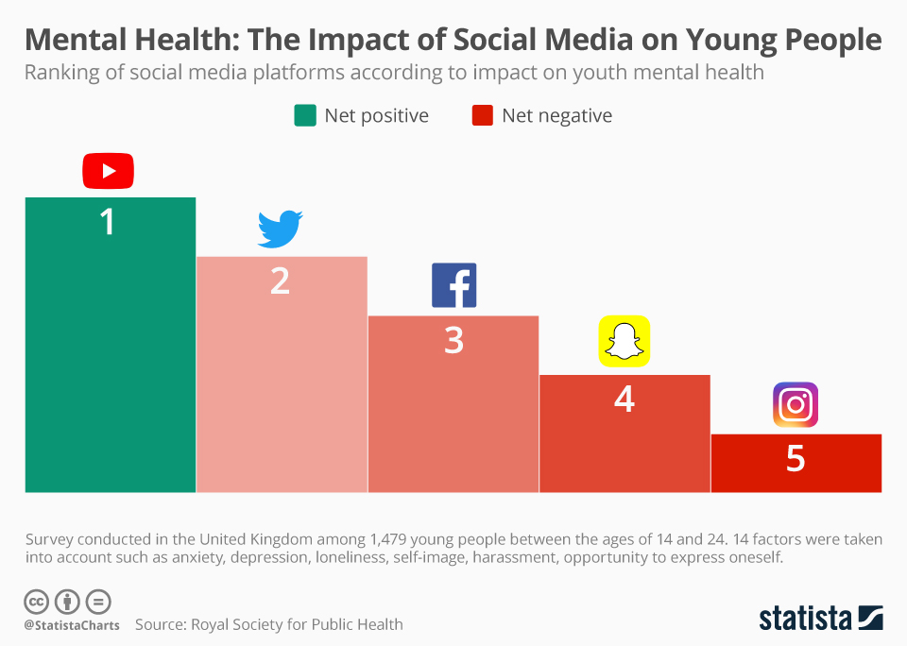

The visual image, Bar graph, is relevant to the topic under study as it compares and ranks various social media platforms such as Facebook, YouTube, Twitter, Snapchat, and Instagram according to how they influence mental health. A specific number of likes on a particular post may have an impact on individual feelings. The "more likes" have inducted a sense of continual competition and social pressure among adults. Social media platforms are currently being used as a basis of competition to earn more likes, which has impacted mental health. The visual statistical chart, Instagram, poses to have the most damaging impact on health well-being while YouTube, poses to have the least mental implications.

**Seabrook, Elizabeth M., Margaret L. Kern, and Nikki S. Rickard. "Social Networking Sites, Depression, and Anxiety: A Systematic Review." *JMIR Mental Health* 3.4 (2016): e50. Print.**

Social networking sites are a major source of pervasive culture in modern society, influencing people's mental health. Depression and anxiety are major psychiatric issues linked to social networking sites. High levels of comparisons and competition lead to anxiety and depression problems while social support and social interconnection lower mental issues.

The article is significant as it provides background information and context related to the topic under investigation. The article emphasizes that reducing social networking, which is linked to adverse effects such as reduced esteem, mediates the occurrence of potential mental conditions. The report presents result from relevant sources analysis, showing that 70 % of social networking sites are a significant source of anxiety and depression.

**Conclusion**

The issue of the impact of social media has led to different opinions globally. Social media has become an essential tool for communication, interaction, and to an extent for commercial gains. The issue of the impact of social media has led to different opinions globally. Social media has become an essential tool for communication, interaction, and to an extent for commercial gains. However, social media has been linked to increased cases of psychiatric conditions among many adults. Platforms such as Facebook, Instagram, Twitter, Snapchat, and YouTube are significant websites commonly used. From the extensive research in the above sources, it is evident that social media can impact individuals' mental well-being irrespective of age. Depression, anxiety, and low-self-esteem are closely linked to social media. Online-harassments, cyber-bullying, and FOMO, among other online mistreatments, pose a risk to increased suicide rates resulting from social media. Social media is a "necessary evil". It is only through a well-established system of social media industries to limit the posting of harmful content online that young adults can derive positive impacts from social media.

Works Cited

Busby, Eleanor. "Sadfishing: Social media trend threatens teenagers’ mental health, report warns." Independent 1 Oct. 2019: n. pag. Web.

Dutton, Jack. "Frequent social media use can damage children's mental health, study warns." The National 14 Aug. 2019: no. page. Print.

Glazzard, Jonathan, and Colin Mitchell. Social Media and Mental Health in Schools. Critical Publishing, 2018. Print.

Lunsford, Andrea A., et al. "CHAPTER 26 Has the Internet Destroyed Privacy?" *Everything's an Argument: With Readings*, 8th ed., Bedford, 2018, pp. 1247-1252.

Luxton, David D., Jennifer D. June, and Jonathan M. Fairall. "Social Media and Suicide: A Public Health Perspective." American Journal of Public Health 102.S2 (2012): S195-S200. Print.

Naruse, Kevin. "Painted Brain 7 Ways Social Media Can Benefit Mental Health." Painted Brain. N.p., 27 Sept. 2017. Web. 10 Aug. 2020.

O'Reilly, Michelle, et al. "Is social media bad for mental health and well-being? Exploring the perspectives of adolescents." *Clinical child psychology and psychiatry* 23.4 (2018): 601- 613.

Pantic, Igor. "Online Social Networking and Mental Health." Cyberpsychology, Behavior, and Social Networking 17.10 (2014): 652-657. Print.

Parnell, Bailey. "Social Media Hurting Your Mental Health." 22 June 2017. Lecture.

Royal Society for Public Health. Mental Health: The Impact of Social Media on Young People. photograph. 2019. Statista. Web.