**Textbook Login Instructions:**

**First Textbook:** Organization Theory & Design Third Canadian Edition

**App:**

1. Download App to View Book
   1. Search “Vitalsource Bookshelf” on App Store
   2. Download the app
2. Login to Bookshelf
   1. Username: [tajtoor@outlook.com](mailto:tajtoor@outlook.com)
   2. Password: Crosby87@

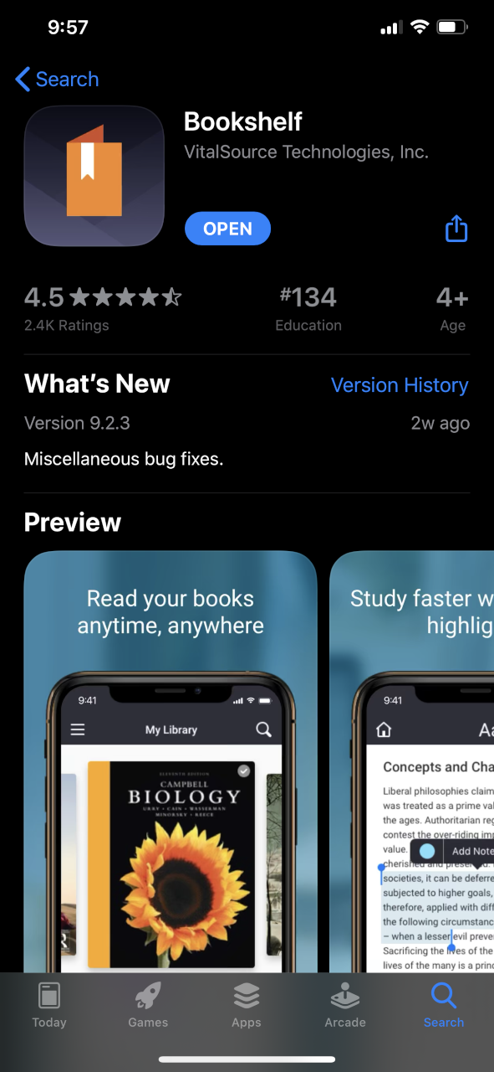

**Website:**

Other Option is to view the book online, but it is harder to navigate on the website compared to then through the app.

1. Website: <https://www.vitalsource.com/en-ca/>
2. Login:
   1. Username: [tajtoor@outlook.com](mailto:tajtoor@outlook.com)
   2. Password: Blackberry2@

Book: Organization Theory & Design Third Canadian Edition