# Remote sensing measurement of urban heat island impact factors

# Introduction

The Urban Heat Island (UHI) refers to the phenomenon that the temperature of urban areas is higher than the temperature of its surrounding area [2–4]. The main reason for this phenomenon is the process of urbanization, as the vegetation is replaced with the built-up area during urban development [5]. This process leads to changes in the physical properties of the land which leads to higher land surface temperatures. For a while now, the subject of the UHI has caught the attention of various researchers around the world (Oke, 1978, 1982; Paterson and Apelt, 1989; Tapper, 1990; Hughes, 2006; Uwadiegwu et al., 2011; Efe and Eyefia, 2014). The extensive recent literature on urban heat island indicates that the artificial increase of temperature in cities is happening because of changes in the built-up environment (Santamouris and Geros, 2006; Erell et al., 2011). This artificial temperature increase affects urban microclimates in different layers of the atmosphere, which include the surface layer (buildings and land surfaces), the canopy layer (below the canopy of trees or in human scale), and the boundary layer (up to approximately 1500 m above the ground surface). These three layers of urban microclimates are tangled in complex climatic systems, while local air circulation in the built environment can moderate the urban heat island effect by mixing the air in each layer with other adjacent layers (Erell et al., 2011).

In small-scale UHI studies, the UHI is mainly characterized by the actual measured air temperature [15–17]. These kinds of studies mainly focused on the temperature difference between the green space and other land types, and the method of characterizing UHI intensity. In addition, some studies add microclimate factors and use the Local Climate Zone (LCZ) factors [3,18] to investigate UHI. These microclimate conditions such as wind speed, wind direction, humidity, solar light intensity, surface reflectance and other localized effects on temperature [19–21]. Those studies showed that the green space cools the air due to the transpiration of the plants, which contributes to low UHI. In addition, local wind speed and wind direction also modify air temperature. The higher the surface albedo, the lower the temperature is found to be [22]. Besides the complexity of local climate and related environmental conditions the measurement of air temperature is limited by the monitoring system, including pieces of equipment, experts, methods and such factors. The accuracy of data collection is always a key factor and it is almost impossible to conduct ideal UHI research on a wide range of space-time scales. These data sources are however very useful in understanding the generalized sources of data studied.

In the studies of Urban Cold Island (UCI) effects and UHI mitigation [23,24], two methods were used to quantify the cooling effect of green space and park areas. These are called Green space Cooling Intensity (GCI) and Park Cooling Intensity (PCI) [25,26]. GCI is defined as the temperature difference between green space and the average temperature of the whole study area. While the PCI is usually determined as the temperature difference between the inside park area and its outside within a 500 m buffer area [27,28]. These two methods are used to describe the cooling effect of green spaces and parks and for this paper we chose PCI. There are two methods of carrying out PCI studies which include: in-situ observations and thermal infrared (TIR) remote sensing (Weng, 2009; Camilloni and Barrucand, 2012). Recently, land surface temperature (LST) retrieved from thermal remote sensing sources has attracted attention among scientists (Voogt and Oke, 2003; Estoque et al., 2017). The availability of high quality TIR images that provide a continuous and simultaneous view of urban city, as well as mature LST retrieval algorithms allow for the characterization of the urban thermal environment using LST (Peng et al., 2011; Rogan et al., 2013; Li et al., 2013). Concerning the investigation of UHI characteristics and changes in large-scale, these studies mainly focus on: (1) The spatial distribution of UHI; (2) the methods of satellite image inversion; (3) the relationship between land use land cover (LULC) and LST [13]. Furthermore, landscape pattern analysis in a regional scale was also proved to be a proper method in UHI research [14].

Moreso, the development of remote sensing has contributed much to the urban thermal environment research. Many researches have been carried out to explore the correlation between urban park features and PCI (Spronken-Smith and Oke, 1998; Potchter et al., 2006; Chen et al., 2012; Chan et al., 2017). Both the park composition and configuration can influence the observed cooling effect intensity. For instance, park size, park perimeter, park shape, percent vegetation and percent water bodies can significantly influence the PCI intensity (Cao et al., 2010; Feyisa et al., 2014).

Urban parks have been chosen as an effective approach to mitigate UHI phenomenon. Consequently, it is imperative for urban designers and urban planners to understand how to design parks to maximize their PCI intensity and mitigate UHI phenomenon. Several researchers have focused on the influence of urban park characteristics on park cool island intensity. Their findings revealed that urban park size correlated positively with PCI intensity (Spronken-Smith and Oke, 1998; Chang et al., 2007; Zhang et al., 2009; Cao et al., 2010). Urban parks of larger sizes had stronger PCI effects than smaller parks. Cao et al. (2010) found that the temperature of urban parks is 1–2◦ C, and sometimes even 5–7◦ C cooler than their urban surroundings. According to Vidrih and Medved (2013), an irregular pattern of cooler areas within generally warmer urban centers is known as Park Cool Island (PCI). The green areas are capable of creating a cooling effect that extends a few hundred metres to the surrounding areas.

In this paper, I selected cloud-free satellite images acquired on July 31, 2019 as base data to focus on the UHI effect characteristics in Dallas. Choosing 209 parks as samples identified by the city of Dallas, I investigated the cooling effect characteristics of the chosen parks. The cooling intensity and park buffer sizes were studied, and the correlation between the park patch metrics and the cooling intensity was explored.

I aimed to:

(1) Analyze the PCI differences among the City’s community and neighborhood parks;

(2) Analyze the park LST and its relation to vegetation, water surface area and built-up surface factors;

(3) Analyze park LST and its relation to park patch indices;

(4) Analyze PCI and its relation to park patch indices and impact factors of park surrounding areas;

(5) Analyze the loss in cooling effect of the parks as distance from them increases.

As a whole, this research was conducted to analyze the relationship between park cooling effect and its related impact factors, to help better understand UHI characteristics in Dallas. The intention of this analysis is to give guidance for stakeholders, as well as to the developers of urban planning strategies to address UHI issues.

# Study Area

*I’d like to mention that Dallas is heavily suburban so there are naturally more trees and green areas just along the highways and fields so they have some impact on the UHI, but even with that, parks are still having an impact on decreasing UHI.*

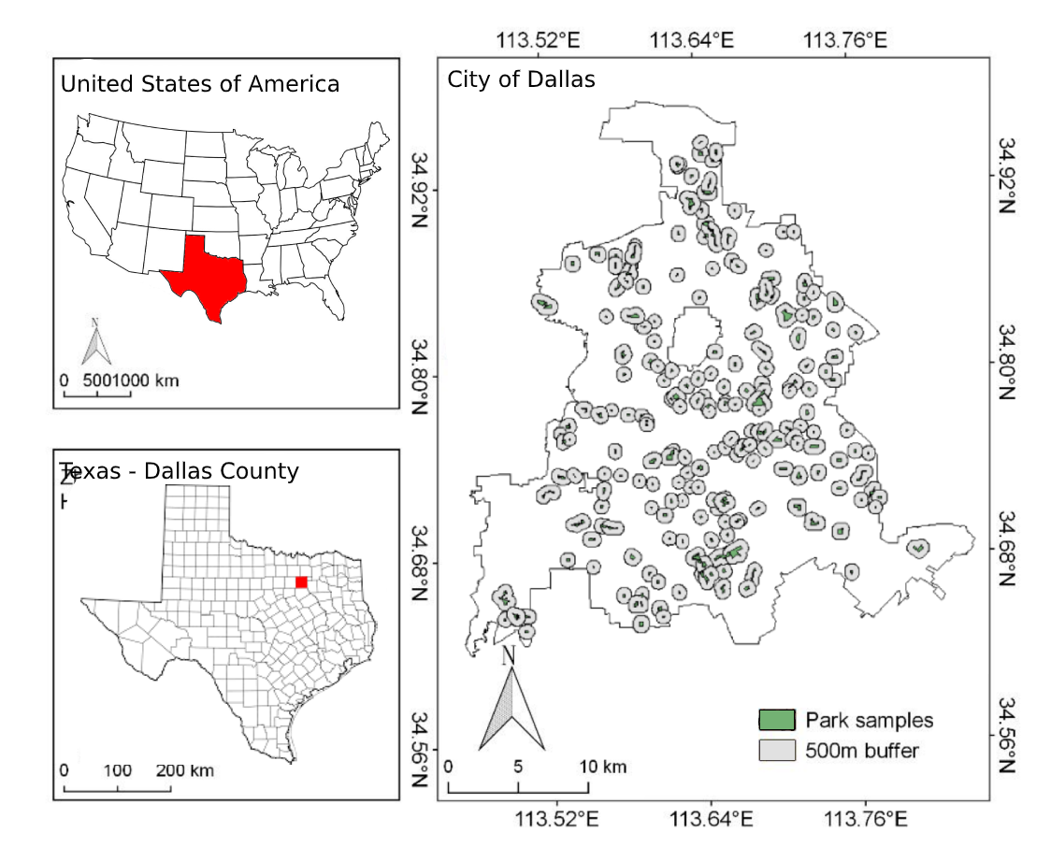

ERROR MAP! NEED TO UPDATE!

# Data Sources and Methods

## Data Used

In this work, Landsat 8 satellite images from USGS were used to extract LST and calculate the vegetation indices. The Landsat 8 image was selected for the date of July 31, 2019 to capture the summer foliage. It is a cloud-free image with a resolution of 30 meters. In conjunction with the satellite image, I’ve also downloaded GIS data directly from the city of Dallas to get more information on the parks in the city. From that park data, I have chosen to analyse the 209 community and neighborhood parks and excluded others such as botanical gardens, zoos, plazas, and others that would be too commercial or built up or only having a single data point.

## LST Calculation

To retrieve the Land Surface Temperature (LST), I made use of the online Landsat Land Surface Temperature application provided by the Remote Sensing Lab under Dr. Nektarios Chrysoulakis. This tool allowed me to easily obtain the LST satellite images for Dallas, Texas, on the same date of July 31, 2019, using Landsat 8 images and NDVI model (Parastatidis, 2017)

## Sample Selection

Based on the park classification provided by the city of Dallas, 209 parks were chosen for the study. The parks are classified into two separate types by the city as seen in figure X.

|  |  |  |  |  |
| --- | --- | --- | --- | --- |
| PARK_TYPE | Count | Percentage | Max size (Km2) | Min size (Km2) |
| Community | 89 | 42.6% | 461.30 | 8.54 |
| Neighborhood | 120 | 57.4% | 291.20 | 3.24 |

## Park Cooling Intensity (PCI)

Park Cooling Intensity (PCI) usually calculates the temperature difference between the inside and outside of the park [28,51,52]. It can be air temperature or land surface temperature. In this study, the PCI (units in C) was defined as the mean LST difference.

$PCI = Tu − Tp$

where Tu is the mean LST of an urban area of the 500m buffer zone outside of the park, and Tp is the mean LST inside the park. The buffer zone includes the area around the park, which contains different land cover types: Buildings, roads, impervious surfaces, trees, and green spaces.

## Descriptors of the Park

In this paper, several indicators were applied to characterize the impact factors on PCI (Table 3). By using the ArcGIS tools, I calculated the fractal dimension index (FDI), perimeter-area ratio (PAR) and landscape shape index (LSI). From previous studies, those three indicators were used as the main patch metrics, and had been widely employed to analyze landscape patterns, both in class level and patch level analysis [33–35]. These initial base studies were successful in demonstrating the characteristics of landscape patterns both in regional and local scale [53]. Here I investigated the relation of these indicators to the park cooling effect in parks of Dallas.

$FDI = \frac{2ln(0.25*Pi)}{lnAi}$

FDI shows how complex a park's shape is. (54)

$PAR = \frac{Pi}{Ai}$

PAR is a simple ratio of the park’s perimeter to area. (54)

$LSI = \frac{0.25*Pi}{\sqrt{Ai}}$

LSI is a standardized measure of the total edge of the park adjusted for the landscape size. (54)

With Pi being the perimeter (in meters) and Ai being the area (in meters squared) in all three.

In addition to the three indicators, I also used three indices to classify the satellite image of the study area (Table 4), which have been successfully proven by other researchers. The three indicators are Normalized Difference Water Index (MNDWI) [55], the Fractional Vegetation Cover (FVC, calculated with NDVI) [56] and the Normalized Difference Built-up Index (NDBI) [57]. These indices can represent the surface coverage condition inside of the park.

$NDVI = \frac{B04 - B03}{B04 + B03}$

Normalized Difference Vegetation Index (NDVI) is used to assess the vegetation density and health of a patch of land [55].

$FVC - \frac{{NDVI}_{i}-{NDVI}_{min}}{{NDVI}_{max}-{NDVI}_{min}}$

The Fractional Vegetation Cover (FVC) is used to show the abundance of vegetation on the ground surface using NDVI values [58]

$MNDWI = \frac{B03 - B11}{B03 + B11}$

Modified Normalized Difference Water Index (MNDWI) is used to find open water areas and areas with large amounts of moisture [59].

$NDBI = \frac{B05 - B04}{B05 + B04}$

Normalized Difference Built-up Index (NDBI) is used to show the level of built-up areas on a patch of land.

## Analysis

Statistical analysis was performed with R. After retrieval of the LST, FVC, MNDWI, NDBI values from the satellite image, ArcMap was used to summarize values of each sample area. Then R was applied to conduct the linear regression analysis to quantify the relationship among LST, FVC, MNDWI, NDBI, and PCI. For the park patch metrics calculation, I used the ArcGIS spatial analysis method to obtain the following parameters of each sample park: area, paratio, shape index and fractal dimension. The same linear regression analysis was made to PCI and LST. Additionally, the related coefficient was also utilized to detect and verify the result.

For the regression analyses, first, I use Pearson correlation analysis to obtain the main significant impact factors, and then analyze the regression relationship between the two factors in a targeted manner to find the optimal curve fitting model. The final presented fitting models in the results section are the best explanation of the relationship between specific factors within the selected sample park.

# Results and Discussions

Following the method in Section 3.2, the LST map based on the 31 July 2019 satellite image was made.

|  |  |  |  |  |  |
| --- | --- | --- | --- | --- | --- |
| **PARK_TYPE** | **count** | **Mean LST** | **Min LST** | **Max LST** | **Average PCI** |
| Community | 89 | 37.53 | 30.77 | 41.78 | 1.37 |
| Neighborhood | 120 | 38.28 | 32.50 | 43.06 | 0.73 |

## Impact of park characteristics and environment on Land Surface Temperatures

First, I analyzed the relation between park LST and the spectral indices inside the park. The results showed that the mean park LST was significantly related to the FVC, the MNDWI, and the NDBI.

Looking at FVC on LST there is evidence that higher FVC values can decrease LST. With an R-square of 0.4919 and a 38.46% success rate in predicting LST. The results were similar, though showing less influence, when looking at MNDWI. The MNDWI regression analysis produced an R-square of 0.2485 and a 25.96% success rate in predicting LST.

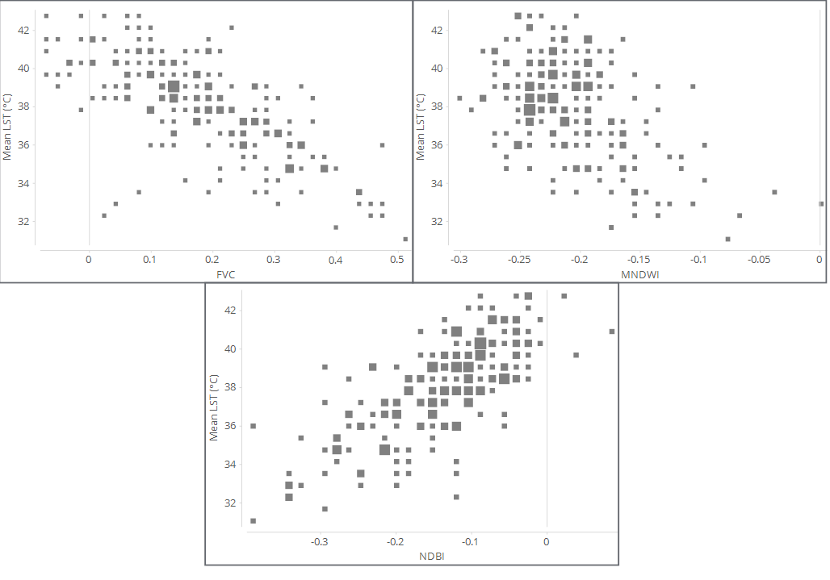

Regressing NDBI on LST produced an R-square of 0.5415 with a 37.5% success rate in predicting LST. While this R-square is larger than that of the FVC on LST regression, it does have a lower success rate of predicting LST.

Secondly, I analyzed the relation between park LST and park characteristics. The result of the analysis shows that patch metrics do have a relationship with LST. The park’s area (in meters square) was compared to LST and showed a negative trend. For the regression of area on LST, I used a sample size of 188 (n = 188) which is the remainder after removing the 10% most outlying observations. This decision was chosen due to the massive gap in park sizes with a median park size being 59km2, a max of 461km2, and a min of 4km2. With 188 cases used in estimation of a total sample size of 209, the regression produced an R-squared of 0.2884 and a 28.37% successful prediction rate of LST. To stay consistent, the Perimeter area ratio, the Shape index, and the Fractal dimension index all also used the same sample size.

The Perimeter area ratio (Paratio) shows a positive correlation with the park LST producing an R-square of 0.06456 and a 20.19% rate of successfully predicting the LST. The shape index and fractal dimension index both showed little to no significant impact on LST. While the shape index did show a slight decrease of LST with increase in index, the results were not significant statistically. This led to the conclusion that the perimeter area ratio plays a more critical role than the other metrics.

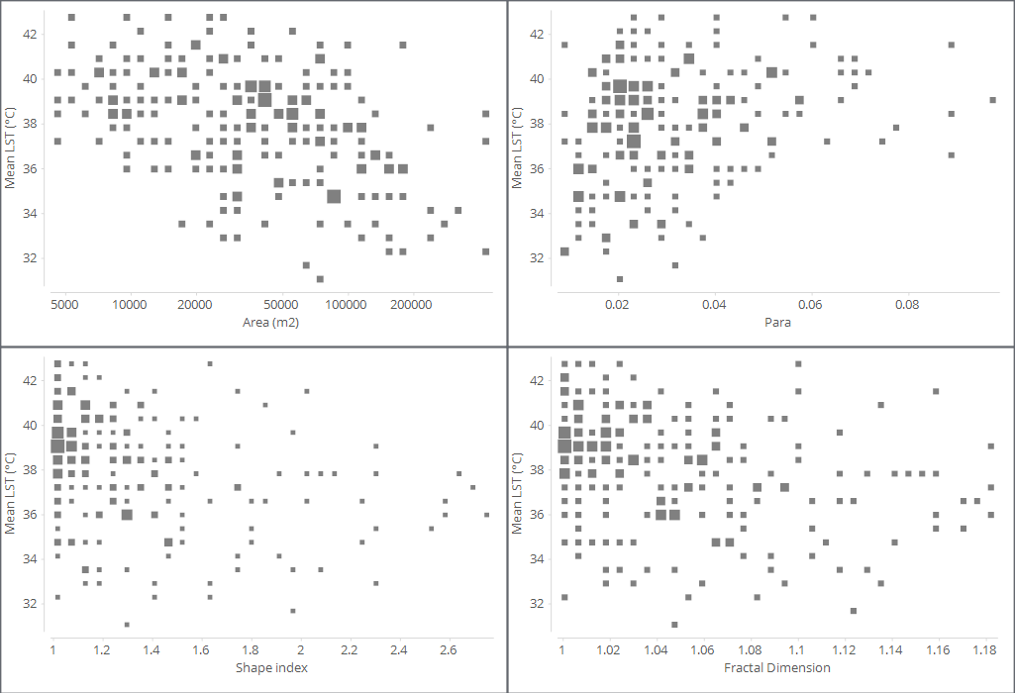

## Impact of park characteristics and environment on Park Cooling Intensity

First, I looked deeper into the relation between PCI and the FVC, MNDWI, and NDBI indices inside the park itself. The results of correlation with PCI are shown below. I found that FVC has a positive effect on PCI: the higher the FVC existing the higher PCI appears. However, the coefficient of determination R-square is only 0.2697. This means that PCI only partly depends on vegetation cover. Figure XX shows that higher MNDWI contributes to higher PCI, this regression analysis R-square is 0.4831. The NDBI also had a strong relationship with PCI, the R-square is 0.4691, which means the impervious surface has a significant influence on PCI. From the park spectral indices results, we can recognize the park vegetation and water percentage play a decisive role in PCI, while the high build-up areas reduces the cooling effect of parks. For each of these metrics, FVC had a 49.28% success rate at predicting the PCI, MNDWI with 43.48%, and NDBI with 51.69%. All three of these did a great job of predicting the data, showing that all three can be valuable in urban planning for UHI mitigation.

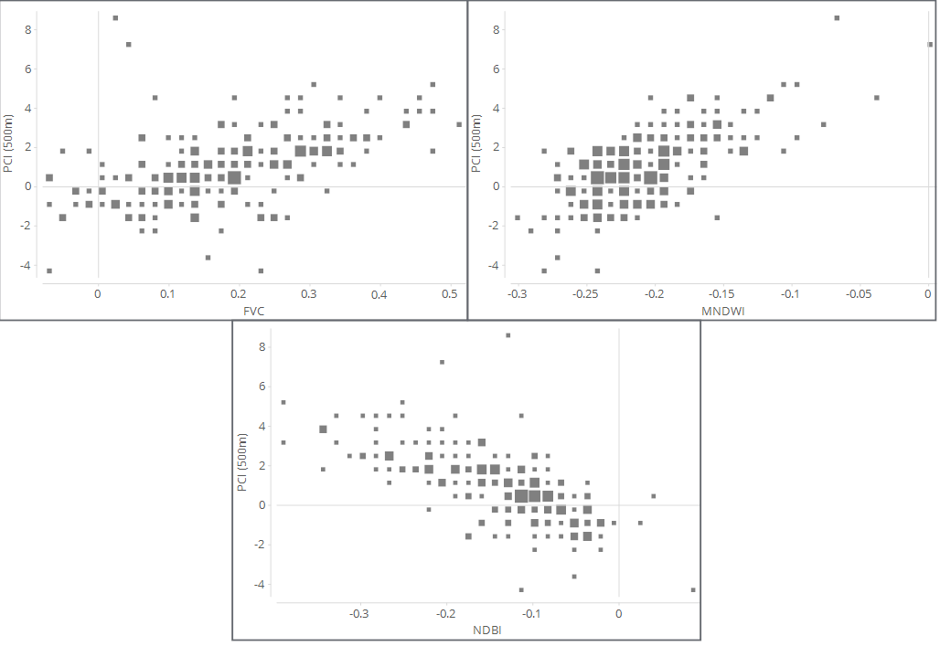

Secondly, I analyzed the relation between PCI and park characteristics. PCI has a complex correlation with park patch metrics (Figure X). Among the four analysis results, the area, fractal dimension, and perimeter area ratio had low R-squares with 0.08959, 0.05515, 0.02556, and 0.06285 respectively.

# 

## Impact Factors of PCI

The cooling effect of the park can be explained from the perspective of thermal balance [39]. I can use the heat transfer theory (Bowen ratio) as an analogy to explain some of the results of this article. The Bowen ratio is the ratio of sensible heat flux to latent heat flux [60]. The surrounding areas are heat sources because the heat capacity of these is significantly smaller than the heat capacity of the parks. In heat conduction, the thermal power (sensible heat flux) absorbed by the parks from the surroundings should be equal to the excess energy resistance by photosynthesis and transpiration (latent heat flux), thus the heat conduction reaches balance. A larger green space means more energy is dissipated which results in more conducted thermal energy. Therefore, parks with large sizes, high vegetation coverage, and high water surface rate have greater energy resistance, which reduces Bowen ratio, and finally, results in higher PCI.

Furthermore, the heat conduction can also explain why parks with high Paratio and fractal dimension have lower PCI. High Paratio and fractal dimension mean that the park boundary is in a large contact surface (complex edges) with the surrounding heat sources, which is conducive to heat conduction and heat exchange. This causes temperature difference decreases, resulting in lower PCI. At the same time, this can also explain the relationship between PCI and surrounding land cover. The ambient temperature also affects the heat transfer. As a whole, to increase the cooling effect of the park, it is recommended to consider the factors of the park itself, improve the resistance to the thermal environment, and increase latent heating, so as to reduce the heat island.

## Impact on land surface temperatures

The results reveal that high FVC and high MNDWI will contribute to low park LST. Those findings are consistent with the results of the previous studies [57,59,61]. This is because the high rate of vegetation cover stores less solar energy and thus solar heat gain. The plants photosynthesis and transpiration absorb the heat during those processes [5]. Those altogether lead to lowering the park LST. As MNDWI mostly represents the water body and the vegetation transpiration, the results seen in the Dallas level study of higher MNDWI leading to lower LST coincides with the findings in another study [62]. A recommendation for planning purposes would be to increase the vegetation and water body ratio to decrease the park LST.

I have used NDBI to analyze the relationship of built-up areas to park LST. The theory states that the reasons behind NDBI increasing LST is that the impervious surfaces that naturally come with built-up areas have high thermal conductivity and low heat capacity [6], which then lead to higher temperature output. As impervious surfaces are an important part of park design, it is important to include them in research over parks and LST.

Despite the practical findings in this article, there are some limitations. First, the data of satellite images have its limitation to interpret the surface thermal environment; because the temperature also relates to the microclimate factors such as wind speed and direction, humidity. It would be great to have more ground level temperature data and greater incorporation of climate into the analysis.

Secondly, the urban structure itself is difficult to model. That being the height, shape, and material of buildings and their impact on the surrounding microclimates. Future research can better add in these variables to better control the model and produce more accurate results that can be more beneficial to planners.

Lastly, in terms of the UHI effect mitigation, the results on park LST are more important for planners than the results of PCI. PCI is related to the factors both inside and outside the park, but the surrounding areas are far more difficult to modify or redesign. It is clear that for planners the better option is to reduce the park LST to increase the cooling effect and mitigate the UHI effect. A future research path can focus on the analysis of parameters (e.g., vegetation types, tree coverage, height of vegetation) within the park. In landscape design, it is necessary to investigate the cooling effects of various green space design examples. Further research can deal with the vegetation cover rate analysis within a green space to optimize design from UHI point of view at local scale.

## PCI values at different buffer zones from the park

While PCI analyses might not be as important as the LST analyses when it comes to park planning, it is important to still analyse the PCI and the features of it. Figure x shows the land surface temperature distribution across various buffer distances from the outer boundaries of the city’s parks. This graph shows that with the 209 parks in the city, the PCI is lowest nearest to the park meaning that temperatures closest to the park are lower and increase as they get further from the park. The results obtained show that urban green spaces are capable of reducing the high surface temperature of the surrounding built-up areas.

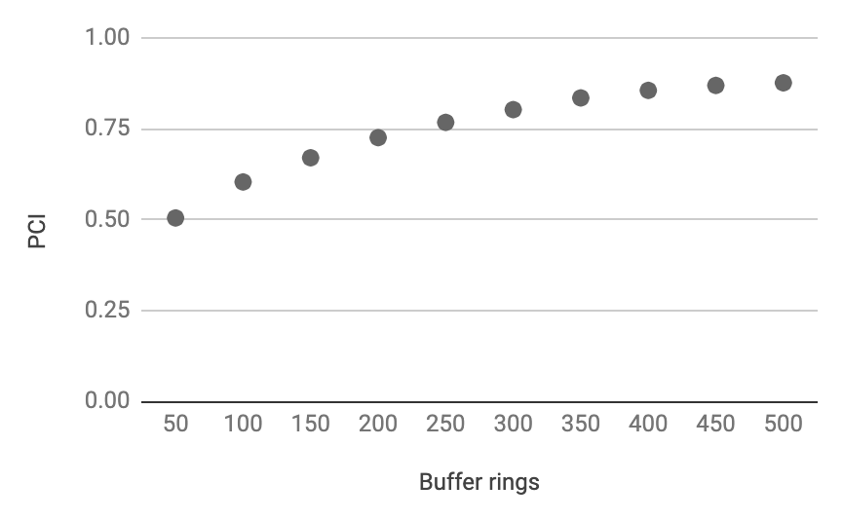

This information is useful because it gives an idea of the diminishing effect on temperatures that parks have. If parks can be planned better to maximize the cooling effect they have on buffers that are further away, then less parks would be necessary. As well, we would be better able to plan park spacing to maximize the benefits.

# Conclusions

The establishment of urban parks is very critical in mitigating UHI in cities. Understanding the correlation between PCI intensity and urban park size and shape is very crucial for urban planners to design green spaces within cities in order to mitigate UHI effects. The findings of this study have proved that urban parks can create PCI effects in Dallas’ microclimate. However, PCI intensity varies across buffer zones from the park outer boundaries. Findings from this study revealed that urban park size and shape were the most important factors for mitigating UHI effect as increase in park size and a decrease in park complexity were effective ways to mitigate UHI phenomenon. Hence, UHI can be mitigated by optimizing urban park size and shape as well as tailoring the spacing between parks when undertaking urban park design and planning. The results of this study may assist urban planners and designers to understand PCI formation and provide useful and practical guidelines for them to design urban parks with stronger cooling effects to mitigate UHI phenomenon especially in suburban cities like Dallas..

## Implications for Urban Planning and Landscape Design

According to the results I can give a reference to urban planning and landscape design in the future. The planner and designer can follow the recommendation:

(1) In urban planning and design: increase the number of park types that have the biggest impact on PCI.

(2) In landscape design and renewal: increase the park size, plan more vegetation and water area in parks, as well as reduce the impervious surface. At the same time, park shapes should be less complex in design with less curving boundaries and less waving edges to lower their fractal dimension index. Of course, in urban planning and design there are many other aspects to be considered, such as existing ecological corridors, road network, residential areas, wind corridors, visual preferences;

(3) Add more parks (green spaces) in the area within high impervious surface ratio, in the central urban area, represented by tall buildings and impervious surfaces of commercial and built-up areas.

(4) Plan park spacing to help spread out the parks cooling affects throughout the city.

References

<https://docs.google.com/spreadsheets/d/1UJ7Pi58hhMbM72BQgQUH9s5d4JvUJ9CPox8eo-zVNe8/edit?usp=sharing>