Titleist Promotion Analysis

Mercedes Moncada

Capella University

Titleist Promotion Analysis

Titleist is one of the leading companies defining the golf sport around the world. The company focuses on the production of sporting equipment ranging from golf clubs to bags and caps. As part of the research, the chosen product among the several products produced by Titleist is the Titleist TS2 Hybrid. Being one of the largest golf equipment companies, Titleist has a proper marketing strategy that has enabled it to be on the leading end in terms of product sales. The company employs a unique promotional approach that puts it in a position where it can be able to make sales worth billions of dollars annually (Titleist, 2020). With the main product being the golf clubs, the Titleist company will be reviewed in a bid to establish its promotional strategy into making it one of the best sellers in sports equipment.

Just like any other highly successful company, Titleist has been on the frontline for marketing their products on different platforms. In this case, the company has been keen to get the attention of their target market by considering all platforms in their adverts. The company at large can be said to have a marketing strategy where it focuses on of creating and communicating its value to its clients (Titleist, 2020). The field in which the company deals in has tight competition from other firms that are likely to displace it from their market position in case they do not become careful with their promotional strategy.

One of the promotional strategies at Titleist is through player sponsorships. The company deals in golf products, and it has known that the best way to reach the target audience could be via sponsoring the players of the sport (Titleist, 2020). For instance, Titleist is famous for sponsoring some of the talented golfers in the world like Justin Thomas, who is ranked fourth in the world of golfers. Player sponsorships allow the company to promote its product through the image of the player in public. A player like Justin Thomas will always be seen on a golf tour in Titleist regalia. Most golf equipment is from the company, which is a strategy to promote the company. When the fans who support the player see that he uses the Titleist product, they are most likely going to buy the Titleist products hence increase the sales of the products (Titleist, 2020). The company has been keen to sponsor upcoming talent in the sport to ensure that the brand of the company remains marketable and reaches the right market. Apart from Justin Thomas, Titleist has been eager to capitalize on sponsoring other professional golfers as it has proven to be one of the best ways to reach their target audience.

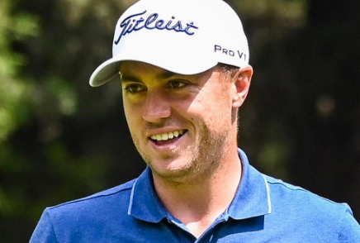

Apart from the player sponsorships, Titleist has been avid to utilize commercial video ads that are run on television. In the commercial, the company is fervent on showcasing some of the products to the general public, with the brand name visible (Titleist, 2019). In one of the video ads that are present on YouTube, the company is enthusiastic to advertise most of its products in a single video ad. For instance, the bags, golf club, caps, and the golf balls are showcased in the ad. The advert could be convincing in such a way that it could convince a person that golf is all about Titleist as they produce most of the things related to the game. The presence of the video ad on YouTube is accompanied by the Titleist YouTube channel, where the company posts a wide range of videos on the channel from time to time (Titleist, 2019). The videos are aimed at promoting the products of the company to the existing users as well as prospective users. One of the video ads where the company communicates with the clients may be found here >><https://www.youtube.com/watch?v=YnVoeDlVGdc&vl=en>

Titleist has also been keen on branding their vehicles with their products; this plays a role in advertising. The cars are highly mobile equipment from which their movement markets the company to the people who can spot the vehicles (Titleist, 2020). The company has several vehicles, including trucks being painted with the details of the company. During golf tours, the vehicles are strategically positioned in areas where they can be seen by the fans and the media that may be covering the sporting event. The more the people are familiarized with the brand name of the company, the more the people are likely to engage in the purchase of the company’s products. Such a promotional strategy targets the fans of the game, which may present themselves physically in the gaming event. Familiarization with the brand name among the public increases the possibility of the customers to choose the Titleist brand over other competing brands in a shop.

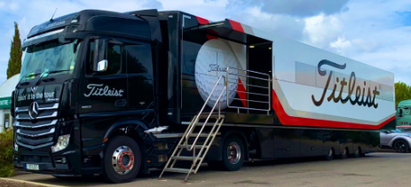

Titleist is one company that tends to have a specific target market. For long, there has been the saying that golf is a sport for the moneyed people; this means that the game is primarily played by wealthy people, especially from the upper class and partly from the middle class. Moreover, golf is not like other sports where the youths are prevalent in sports (Titleist, 2020). Golf is an exceptional sport where the people who excel in it are those between 30 years and 65 years. As a result, Titleist is keen on targeting the people in the specified group as they are the ones who are the primary consumers of the company’s products. Moreover, golf is more famous among men, and Titleist is also more inclined to target them. The promotional strategy of the company is primarily directed to men between 30 to 65 years.

As part of my evaluation of their promotional strategy, I think the company is on the right track. The company has positioned itself in such a way that it can reach the target audience with ease. As a multinational company Titleist is almost on all mass media platforms where it promoted the products from the company (Titleist, 2020). In as much as the company has put up a good advertising campaign, it faces a daunting challenge from other stable competitors like Nike, Callaway, and other companies which also claim a considerable share of the golf market. It will be a good idea if the company increases the quality of their products, which may lead to referrals among product users. The company should also capitalize on the player sponsorships as they are one primary source of increased popularity in the company. Increasing the player sponsorships will enhance the reputation of the firm hence directly increasing the sales. On a more general comment, Titleist can be defined to have mastered the art of communicating to the clients as the company has been able to reach the target audience effectively.

References

Titleist. (2019). "More to Prove" Titleist Pro V1 and Pro V1x. Retrieved from <https://www.youtube.com/watch?v=YnVoeDlVGdc&vl=en>

Titleist. (2020). Justin Thomas. Retrieved from <https://www.titleist.com/tour/2179/justin-thomas>

Titleist. (2020). TS2 hybrid | Hybrid golf club | Titleist. Retrieved from <https://www.titleist.com/golf-clubs/hybrid-golf-clubs/ts2>