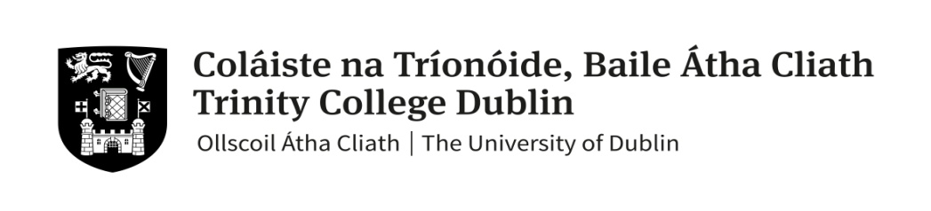

**Faculty of Arts Humanities and Social Sciences**

**Trinity Business School**

### MSc Operations and Supply Chain Management Hilary Term 2020

### Annual Examination

# BU7708 – Global Procurement

##### 6th April – 1st May 2020

# 

# Prof Cacan Kocabasoglu-Hillmer (External Examiner) &

**Dr Sinéad Roden (Lecturer)**

**Instructions to Candidates**:

Open Book Examination

Section A (40%): Candidates must answer **ONE QUESTION**

Section B (60%): Candidates must answer **TWO OF THE FOUR** questions.

Answer each question in a separate answer book.

Due to the open book nature of this examination, there is an expectation that students will (i) cite in more depth and breadth, (ii) have more accuracy in the information and more precision in defining prior assumptions underlying your answers, (iii) have more depth in the analysis, and (iv) be aware that plagiarism will be especially important to avoid: no verbatim texts.

**Materials permitted for this examination**:

Non-programmable calculators are not required for this examination.

**Section A: Compulsory (40%)**

**Answer the following question:**

**Question 1 (40 marks)**

Consider the following four items purchased by a high-volume PC assembler:

1. Keyboard

2. Microsoft Office software

3. Intel Core processor

4. Assembler’s brand decal (label/sticker)

1. Position each product on the Kraljic matrix and justify your positioning. (15 marks)
2. Discuss appropriate sourcing strategies and configurations for each product. (25 marks)

**Section B: Answer any TWO questions (30% each)**

**Question 2 (30 marks)**

1. Critically evaluate the motivations and drawbacks associated with engaging in supplier development. Please provide industry examples where appropriate (20 marks).
2. What specific factors should be considered when seeking to develop a supplier from an emerging economy (10 marks)

**Question 3 (30 marks)**

Fisher (1997) argues that supply chains should be designed and managed differently depending on the demand pattern of the product or service being delivered. Discuss this proposition, referring to examples to illustrate.

**Question 4 (30 marks)**

“Procurement can no longer be considered a tactical, administrative function but should be considered as a source of sustainable competitive advantage”. Discuss the extent to which you agree or disagree with this statement.