MBA7013: Global Strategy and Innovation

Detailed Assessment Brief
Assignment task
Coursework topic
Samsung and the global smartphone market
You are required to carry out an analysis of Samsung in the global smartphone industry. The coursework should be written in a report format, word count of which should not be more than 5000 (excluding reference list)
The report should cover the following themes
1. An analysis of the competitive and international business strategies pursued by Samsung over the years as a competitor in the global smartphone industry
2. An analysis of the innovations that have characterised the global smartphone industry
3. An analysis of the specific innovation strategies adopted by Samsung in the global smartphone industry
4. The impact of the national environment on the international competitiveness of Samsung in the global smartphone industry
5. An analysis of the interrelationships between the business, innovation and internationalization strategies of Samsung in the global smartphone industry
Assessment criteria
For the coursework:
To gain a pass mark you will be expected to attempt the questions asked above and show some relevant knowledge and theory. To gain higher marks we would expect good use of relevant theories, examples and data.
Marks for the individual written assignment will be awarded on the basis of the following criteria with equal weight:
• coverage of all aspects of the assignment questions
• degree to which answer exhibits understanding and knowledge of relevant theories and empirical evidence
• degree to which answer demonstrates consistent and coherent analysis and purposeful structure
• evidence of the use of a variety of sources
• clarity of explanation
• critical analysis
• conclusions that are supported by the discussion
• appropriate citing and referencing of material used
IMPORTANT NOTES:
a.Your written assignment must be in the form of a report. It must not exceed 5000 words (excluding references and tables) and must use double line spacing. You must provide a word count on the first page of your assignment.
b. Your coursework must comply with rules governing academic integrity. You should avoid plagiarism by citing all the papers that you have used within the text and listing them at the end of your work. If you quote what others have said, you should place these within quotation marks and cite the source. You should cite and reference your work in accordance to the guide produced by the Business School. This is available electronically on the library website
c. Your coursework should be based on academic books, articles and studies (e.g. journal articles). Newspaper articles and web links should be avoided particularly when referring to sources for academic theories and concepts. You can use credible newspaper sources for collecting data on the industry and on the firms referred to in the assignment but you should always reference them properly A reading list to help you start work on this assignment is given on the next page. However, you are expected to find additional information on your own. It is not possible to get a good mark on this assignment without doing this.
Recommended reading list
Core Textbook
Custom ebook
Journal Articles
Barney, Jay B. "The resource-based theory of the firm." Organization science 7 (1996): 469-469.
Collins, Christopher J., and Kevin D. Clark. "Strategic human resource practices, top management team social networks, and firm performance: The role of human resource practices in creating organizational competitive advantage." Academy of management Journal 46, no. 6 (2003): 740-751.
Dunning, John H. "The eclectic paradigm of international production: a restatement and some possible extensions." Journal of international business studies (1988): 1-31.
Dyer, Jeffrey H., and Harbir Singh. "The relational view: Cooperative strategy and sources of interorganizational competitive advantage." Academy of management review 23, no. 4 (1998): 660-679.
Elsenhardt, Kathleen M., and Jeffrey A. Martin. "Dynamic capabilities: What are they." Strategic management journal 21, no. 1 (2000): 1105-1121.
Henderson, Rebecca M., and Kim B. Clark. "Architectural innovation: The reconfiguration of existing product technologies and the failure of established firms." Administrative science quarterly (1990): 9-30.
Rugman, Alan M., and Chang Hoon Oh. "Korea's multinationals in a regional world." Journal of World Business 43, no. 1 (2008): 5-15.
Suarez, Fernando F., and James M. Utterback. "Dominant designs and the survival of firms." Strategic management journal 16, no. 6 (1995): 415-430.
Teece, David, and Gary Pisano. "The dynamic capabilities of firms: an introduction." Industrial and corporate change 3, no. 3 (1994): 537-556.
Books
Chesbrough, Henry William. Open innovation: The new imperative for creating and profiting from technology. Harvard Business Press, 2003.
Geroski, Paul A., and P. A. Geroski. Innovation and competitive advantage. No. 159. Gerosky: Organisation for Economic Co-operation and Development, 1995.
(available at this link http://www.oecd.org/regreform/reform/2733164.pdf )
Mintzberg, Henry, Bruce Ahlstrand, and Joseph Lampel. Strategy Safari: A Guided Tour Through The Wilds of Strategic Mangament. Simon and Schuster, 2005.

The main book

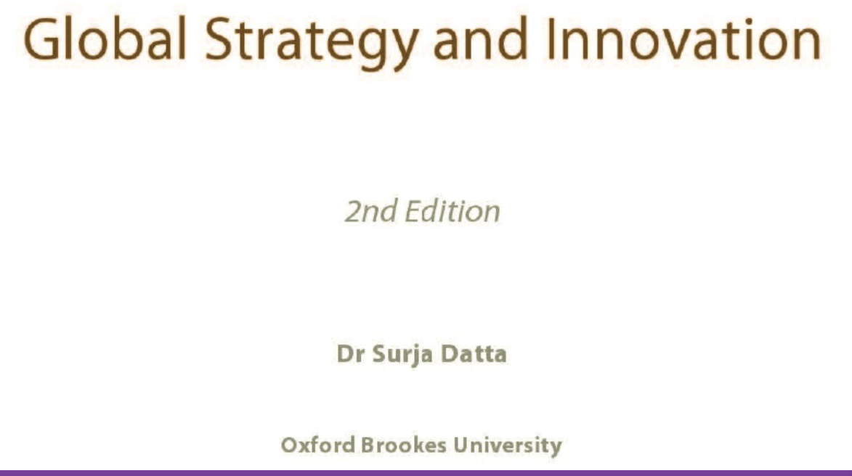

Topics

