ARGUMENTATIVE ESSAY:
``Global Warming In the Long Run``

- GENERAL INFO
-The essay needs to be long 1,500 words between: intro, discussion, and conclusion, divided as follow:
-Body of paper:
Introduction
Literature review
Discussion, divided into two or three subheadings
Conclusion
-Reference list (APA format)
The “Literature review” doesn’t count in 1500 words. It is in addition.
-Length: 250 to 500 words (does not count in the essay’s final word-count)
-Min. 5 academic sources mentioned, but most likely more.
-Remember, the objective is to provide an overview – and tell the story – of how your topic has been researched so far.

Example:

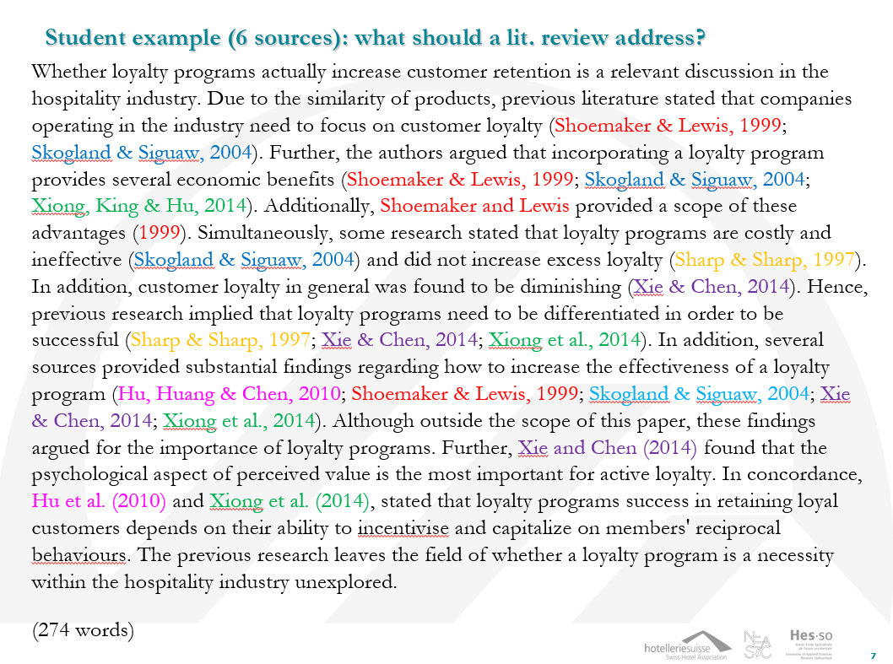
- The whole paper must follow APA format such as:
SOURCES (academic articles and websites)
- Since it is an argumentative essay, you should convince about my position but also present the other side. I will attach my annotated bibliography about the topic in case you would like to take some information from it (only if you want it).

