‘Identify the role of Social Media within a chosen organisation, undertake Social Media analysis and provide a report with recommendations for the client.’

Table of Contents
Part I 2
Introduction 2
Interview 3
Kat Truskolaska – Marketing Executive 3
Part II 4
Analytics and benchmarking 4
Content tactics 5
Layout 6
Recommendation 1 6
Live videos 6
Recommendation 2 7
Story-telling 7
Recommendation 3 7
Crowdsourcing contents and comments. 7
Recommendation 4 8
Google Analytics 8
Recommendation 5 8
Facebook Ads 8
Conclusions 9
Reference 9
Table of figures 11

Part I

Introduction
Investments made on effective Social Media Strategies (Dolan, 2017) have helped companies worldwide to foster brand loyalty, encourage word of mouth (so called e-WOM) (Erkan and Evans, 2016) and to optimise marketing costs (Ismail, 2017 and Russo, 2017).

This report analyses the role that Social Media marketing strategy plays for CinemaLive – UK’s leading event cinema distributor – and provides five recommendations to improve it where necessary. The proposal is based on secondary research findings on best social media best practice and it addresses challenges that the business is facing, pointed out by the client through an interview.

Part II

Analytics and benchmarking

The report will now analyse the Facebook page’s activities, this part covers the time span of three months, from the 10th of October 2017 to the 10th of December 2017. Facebook Insights and third parties’ instruments have been used for the analysis, in order to ensure depth and breadth of the evaluation - vis-à-vis competitors’ behaviours.
CinemaLive has a total of 13,660 likes on Facebook (Facebook, 2017), the number is in constant growth since October 10th (Figure 1). As a matter of fact, it increased at a compound rate of 1.6 % - fluctuating from 13,436 to 13,649 (CinemaLive Insights/Facebook, 2017)

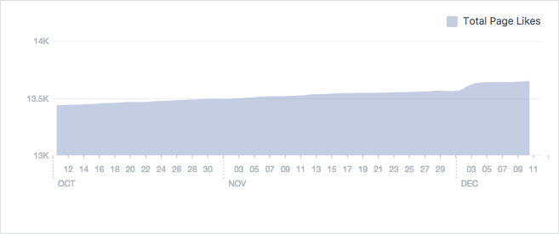
Figure 1 – Followers from 10/10/17 to 10/12/17

CinemaLive Insights/Facebook (2017)

With a number of fans that is considerably higher than their competition’s, and despite the growth emphasised atop, CinemaLive’s engagement rate is mediocre (Klear.com, 2017). Engagement rate refers to the degree of interactions occurred between the brand and the audience (Dessart, 2015) and it is calculated by dividing page’s PTAT number (“people talking about this”) with total likes (likealyzer.com, 2017). As the company gets typically 44 likes and 5 comments per post, their performance here is considered average at best for the industry standards (Figure 2) (klear.com, 2017).
CinemaLive’s most active days are Wednesdays at 14:00 PM on average (Fanpage Karma, 2017). Considering the amount of fans, comments and shares, the engagement level is microscopic, with a registered KPI of 0.0076% (Fanpage Karma, 2017). CinemaLive should consider to increase the amount of content shared on Thursdays and Fridays between 12:00 PM and 3:00 PM as these remain the most effective posting intervals for Facebook (Hootsuite, 2016).

Figure 2 – Audience and engagement
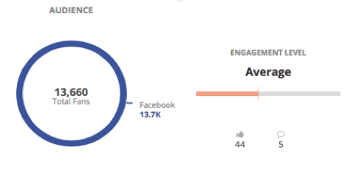
Klear.com (2017)

Below (Figure 3), a benchmarking report on the company’s engagement rate in comparison with its fiercest rivals – Trafalgar Releasing and More2Screen.
The company has maintained a pretty steady but low level of interaction with its fans since October and by the 10th of December, CinemaLive ended third - with 0.3% engagement level, while respectively Trafalgar Releasing and More2Screen registered 2.5% and 12% (Fanpage Karma, 2017).

Figure 3 – Competitors’ engagement levels comparison
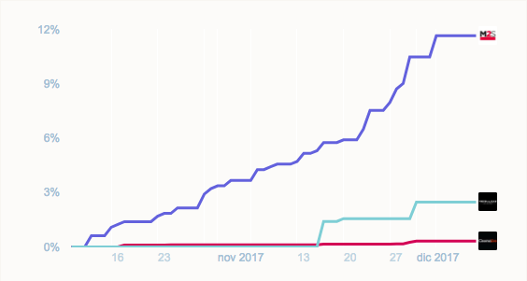
Fanpage Karma (2017)

Content tactics

CinemaLive offers a good variety of content (Fanpage Karma, 2017) often unique, to reward the audience. The tone is consistent with the brand identity and it encourages conversation with questions - a very successful approach on Facebook (Social Bakers, 2017). “Photo posts” are also very well distributed and posted regularly. However, CinemaLive must consider posting some “behind the scenes” pics on Facebook as it does on its Instagram Page (Figure 4), to meet their target audience’s need for authenticity, optimise communication and brand consistency across all platforms (Rosenthal, 2017).

Figure 4 – Instagram behind the scenes
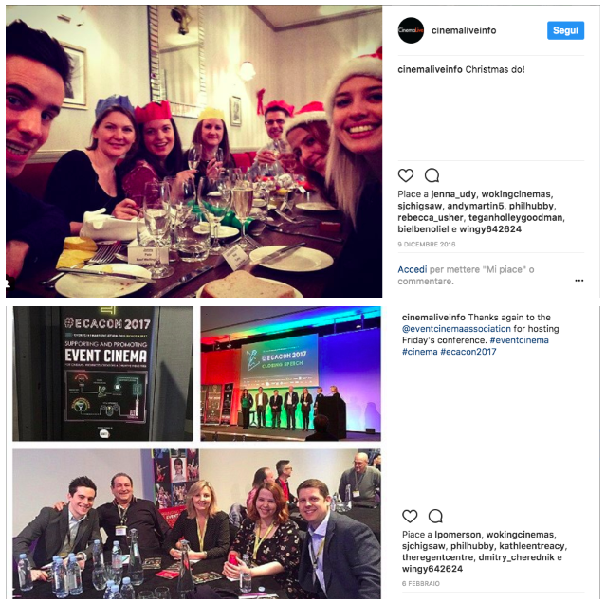
Instagram (2017)

Layout

Over the past three months CinemaLive have changed their cover image just once, this should happen more often as it gives that feeling of an ever changing story. The about section (Figure 5) covers all the essential required fields (likealyzer.com, 2017). There is a link to the official website and an e-mail address for customer enquiries. However, as specified on their official website, the company holds many business’ records such as ‘highest grossing event of all time’ as well as being part of the Event Cinema Association (Cinema Live, 2017) – significant achievements that could be added to the section in order to influence customer’s perception (Schroeder, 2017).

Figure 5 – About section
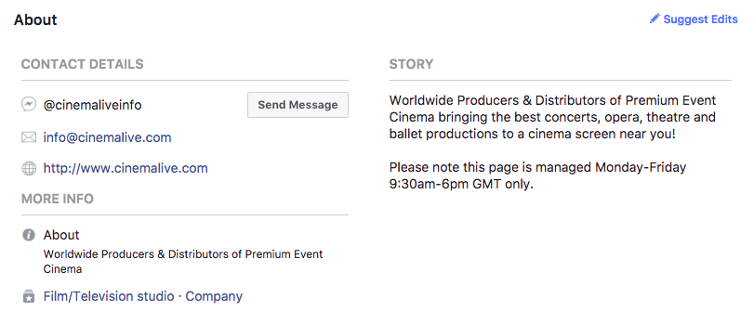
Facebook.com (2017)

The report will now offer five recommendations, aiming at increasing engagement, awareness and driving promotion, as instructed by the client.

Recommendation 1

Live videos
Facebook has just improved the way the news feed looks like in order to make room for live videos and encourage their usage. Coders employed a new algorithm, which makes it much easier for users to find the live broadcasts they would be most interested in (Facebook Live, 2017). Therefore, according to Socialbakers (2017) this feature further enhanced the benefits that Facebook offers to companies thanks to:

- Live interactions: companies’ fans can interact immediately with their favourite brand - this eases up relationship building.

- Massive reach: Loads of brands interviewed reported that the Organic Reach derived by Facebook Live videos is overtaking native ones (Figure 6).

Figure 6 – “Live” compared to Native videos
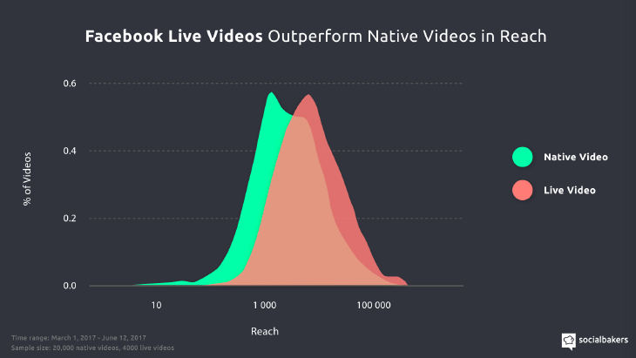
Socialbakers (2017)

CinemaLive should consider increasing the number of Live events broadcast online via Facebook to keep its audience engaged. Streaming special events (like Q&A’s with actors for example) works perfectly with the purpose of live videos and it would act as an effective promotional tool for the company (Shamshoyan, 2017). Furthermore, the company could involve celebrities to have in their live videos for the community to interact with and generate buzz (Cossell, 2017). Not to mention the chances this tool can offer to inform the target demographics about venues, ticket purchases and dates in a timely manner (Ollerton, 2016), showcasing the authenticity of the company culture with behind the scenes videos of a “typical day at the office”.

Recommendation 2

Story-telling
A recent market research conducted by Mintel (2017) affirmed that in order to enhance the social media’s usage effect, brands need to ensure the content provided is always shared. What types of content would a senior be willing to share with his friend? In an absorbing research paper on marketing intelligence and planning, Tafesse (2015), debates about the concept of “brand post novelty” and its significance when developing a brand’s content strategy on Facebook. According to the scholar, the term “novelty” refers to the level of creativity and cleverness of the shared material and the audience perception of it. CinemaLive should implement such content. Stories are thought-provoking and positively affect the consumer’s experience and enjoyment, generating positive reactions and driving engagements, as they allow followers to escape from the ordinary - thanks to uncommon and consistent stimuli generated. Furthermore, customers feel cherished when a company attempts to establish a bond with them. Being appealing on social media does not come uniquely with posting multiple times a day and trying to be pleasing. Especially when the challenge is to catch seniors’ attention, authenticity plays a critical role. As a matter of fact, the concept of “brand persona” recently introduced in social media studies, forces marketers to treat their brands almost as individuals, with specific personality traits and language adopted when delivering the company’s message that needs to mirror those of the targeted age groups (Mintel, 2016). Furthermore, a functional storytelling structure would increase CinemaLive’s “brand affect” - a company’s expertise in stimulating an emotional response on social media (Halaszovich, 2017).
This report suggests that CinemaLive should acquire that “social network personality” with storytelling and focus on clever and smart content to trigger interest from such a difficult age group. Emotional response can be measured by assessing users’ perception of the brand with polls and other user-generated content.

Recommendation 3

Crowdsourcing contents and comments.
User Generated Content (UGC) is seen as a significant method of consumer influence, it works as e-WOM initiator and it has an incredible impact on purchase intention (Kim, 2017). During the interview, one of the marketing goals discussed by the client was the intention of attracting potential content providers to enrich company’s portfolio. This B2B side of the strategy works well on Facebook and it could positively benefit from user-generated content. For example, a review section handled by cinema-goers would possibly boost this ambition’s success. Furthermore, the business’ target market (seniors) is extremely keen on having its voice heard (Forbes, 2017) and by letting them publicly show their thoughts about the products CinemaLive offers, the company could not only encourage participation, but also help in establishing future partnerships with event production firms. More2Screen, one of the client’s competitors, has already adopted this strategy and the page has currently a 0.18% post interaction and a 0.14% engagement rate, compared with respectively 0.098% and 0.0035% of CinemaLive (Fan Page Karma, 2017)

Recommendation 4

Google Analytics
CinemaLive’s Marketing Executive explained that the company’s current challenge is to raise awareness on their less known product portfolio and therefore they use Facebook for promotional purposes. Whichever reason a company is using Social Media networks for, it is possible to measure their effectiveness with the built-in analytical tools that come in bundle. However, Facebook Insights cannot tell if the call-to-action has reached the ultimate goals set by the company. Therefore, the client may want to consider adding Google Analytics to Hootsuite. This tool offers depth and breadth of data and gives specific information on:

- Website traffic driven by the Facebook page

- Call-to-action effectiveness and users’ behaviours on the landing page (are they purchasing, browsing, seeking information or trying to find executives contact’s details?)
Considering that CinemaLive is also seeking new content providers with fresh material through their Facebook page, the company can benefit from an understanding of the Social User Flow, and how to better address links and other marketing collaterals on the official page.
Tonyan (2016), explains that by integrating Google Analytics Campaign’s URL (parameters associated with a specific Social Media Platform) it is possible to differentiate traffic driven by social networks from direct traffic, track it and measure correlated posts’ effectiveness in the Analytics Campaign section.

Recommendation 5

Facebook Ads
Facebook accounts for two-billion people who have joined the platform so far, with a big chunk of them constantly interacting with brands or celebrities (Hootsuite, 2017). As a matter of fact, according to eMarketer (2016), Facebook offers the most profitable opportunities to maximise return of investments – thanks to paid ads.
CinemaLive should increase its advertising spend to make sure their content reaches the target audience productively. This social network allows to select what objective is intended to reach and with what format it is desired to do so (Facebook Ads, 2017). The company could decide whether to attract people interested in live events, arts, concerts or cinema goers – who would be interested in such alternative content.
Specifically, for CinemaLive’s purposes, it is recommended to use video ads as they would potentially intensify Facebook’s added value for the company. According to Hootsuite (2017) over eight billion video ads are viewed on Facebook every day – due to their major appeal over classic posts with caption and links. Kay Jewelers, luxury retailer operating worldwide (Kay.com, 2017) for example, relies on this type of advertising. The company published a series of short clips, presenting their products and the emotional benefits they have on consumers. Each video in itself is a link to their online shop, and the caption is short, catchy and it summarises the promotional objectives (Figure 7).

Figure 7 – Kay Ad snapshots
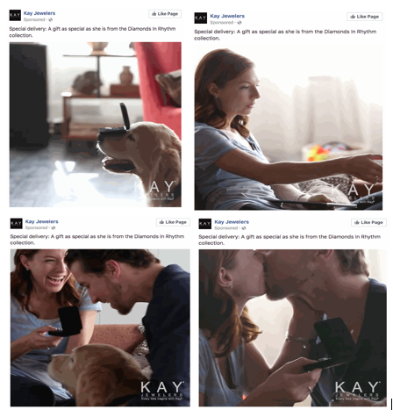
Kay Jewelers/Facebook Page (2017)

There are three reasons why this type of ad works:

- It is all about images and message: by just popping up on my feed, even if the sound is off on my mobile, it already gives me an idea of what the product is, and where the link leads, in the first five seconds.

- Pertinence: CinemaLive could make a few ads this way with shots from operas and concerts instead and it would reach anyone who, in their specific target, has been looking for these types of events.

- Call-to-action is very effective: it is just one click away from getting more information, it definitely encourages likes and the chances of purchasing increase.

Conclusions

This report has conducted a Social Media analysis and identified the role of Social Media within CinemaLive – providing five recommendations to improve the page. Videos and imagery as well as a proactive effort to deploy a well integrated promotional strategy, have proven to be very effective on this network. Social Media is a universe in constant expansion and both embracing new technologies, as well as a clever consistent message, define the success of any ambitious organisation using these tools.

References

Benjamin Rosenthal, Eliane Pereira Zamith Brito, (2017) ‘The brand meaning co-creation process on Facebook’, Marketing Intelligence & Planning, Vol. 35 Issue: 7, pp.923-936, https://doi.org/10.1108/ MIP-09-2016-0171
Carlo Russo, Mariarosaria Simeone, (2017) ‘The growing influence of social and digital media: Impact on consumer choice and market equilibrium’, British Food Journal, Vol. 119 Issue: 8, pp.1766-1780, https://doi.org/10.1108/BFJ-05-2017-0283

Cinemalive.com. (2017). Cinema Live - Producers & Distributors of Premium Event Cinema. [online] Available at: http://cinemalive.com/index.php?p=about/ [Accessed 11 Nov. 2017].

Cossell, H. (2017). Influencers, ads and social media: 2017 in review - We Are Social UK. [online] We Are Social UK. Available at: https://wearesocial.com/uk/blog/2017/12/2017-in-review [Accessed 5 Dec. 2017].

Donyan, J. (2016). Measuring the Success of Your Social Media Presence with Google Analytics. Library Technology Reports. [online] pp.38-42. Available at: http://web.a.ebscohost.com.ezproxy.mdx.ac.uk/ehost/pdfviewer/pdfviewer?vid=1&sid=4959262f-38d1-4c89-b0de-d1f44ceeb001%40sessionmgr4010 [Accessed 14 Dec. 2017].

Emarketer.com. (2017). For Social Media Marketers, Facebook Produces the Best ROI - eMarketer. [online] Available at: https://www.emarketer.com/Article/Social-Media-Marketers-Facebook-Produces-Best-ROI/1013918 [Accessed 14 Dec. 2017].

Erkan, I. and Evans, C. (2016). ‘The influence of eWOM in social media on consumers’ purchase intentions: An extended approach to information adoption.’ Computers in Human Behavior, 61, pp.47-55.

Facebook.com. (2017). About Facebook Ads. [online] Available at: https://www.facebook.com/ads/about [Accessed 14 Dec. 2017].

Facebook.com. (2017). CinemaLive. [online] Available at: https://www.facebook.com/cinemaliveinfo/ [Accessed 14 Dec. 2017].

Facebook.com. (2017). How do I find live videos on Facebook? | Facebook Help Centre | Facebook. [online] Available at: https://www.facebook.com/help/1468879913412530?helpref=uf_permalink [Accessed 12 Dec. 2017].

Facebook/CinemaLive Insights. (2017). CinemaLive Insights | Facebook. [online] Available at: https://www.facebook.com/cinemaliveinfo/insights/?section=navFollowers [Accessed 14 Dec. 2017].

Fan Page Karma (2017). More2Screen analysed: A Facebook Marketing hero? [online] Fanpagekarma.com. Available at: http://www.fanpagekarma.com/facebook/167344178888/more2screen [Accessed 11 Nov. 2017].

Fanpage Karma (2017). CinemaLive analysed: A Facebook Marketing hero? [online] Fanpagekarma.com. Available at: http://www.fanpagekarma.com/facebook/cinemaliveinfo [Accessed 14 Dec. 2017].

Fanpage Karma (2017). Measure and improve fan engagement on Facebook fan pages. [online] Fanpagekarma.com. Available at: http://www.fanpagekarma.com/dashboard?h=ZKP7XWQN0#chartboard [Accessed 14 Dec. 2017].

Forbes.com. (2017). Stellar strategies for marketing to seniors. [online] Available at: https://www.forbes.com/sites/forbescommunicationscouncil/2017/11/09/stellar-strategies-for-marketing-to-seniors/#75b593014e57/ [Accessed 11 Nov. 2017].

Hootsuite Social Media Management. (2016). The Best Time to Post on Facebook, Twitter, and Instagram. [online] Available at: https://blog.hootsuite.com/best-time-to-post-on-facebook-twitter-instagram/

Hootsuite Social Media Management. (2017). How to Advertise on Facebook: The Complete Guide. [online] Available at: https://blog.hootsuite.com/how-to-advertise-on-facebook/ [Accessed 14 Dec. 2017].

Ismail, A. (2017). ‘The influence of perceived social media marketing activities on brand loyalty.’ Asia Pacific Journal of Marketing and Logistics, 29(1), pp.129-144.

Jonathan E. Schroeder, (2017) ‘Corporate branding in perspective: a typology’, European Journal of Marketing, Vol. 51 Issue: 9/10, pp.1522-1529, https://doi.org/10.1108/EJM-07-2017-0450

Kay.com. (2017). Kay - Kay Our Company. [online] Available at: http://www.kay.com/en/kaystore/cms/kay-our-company [Accessed 14 Dec. 2017].

Klear – Smarter Marketing (2017). CinemaLive (@cinemaliveinfo) Facebook Influencer Analysis | Klear.com [online] Available at: https://klear.com/profile2.php?query=cinemaliveinfo&network_type=facebook#/overview [Accessed 14 Dec. 2017].

Laurence Dessart, Cleopatra Veloutsou, Anna Morgan-Thomas, (2015) ‘Consumer engagement in online brand communities: a social media perspective’, Journal of Product & Brand Management, Vol. 24 Issue: 1, pp.28-42,

Likealyzer.com. (2017). Meltwater - Likealyzer. [online] Available at: https://likealyzer.com/report/cinemaliveinfo [Accessed 14 Dec. 2017].

Mintel (2016) “Marketing to Baby Boomers – US – July 2016”. Available at: http://academic.mintel.com.ezproxy.mdx.ac.uk/display/777390/ Accessed on: Monday 6th of November 2017

Mintel (2017) ‘Social and media networks – UK – May 2017’ Available at: http://academic.mintel.com.ezproxy.mdx.ac.uk/display/793285/

Ollerton, T. (2017). How brands can make the most of live streaming - We Are Social UK. [online] We Are Social UK. Available at: https://wearesocial.com/uk/thought-leadership/live-streaming-for-brands [Accessed 5 Dec. 2017].

Rebecca Dolan, Jodie Conduit, John Fahy, Steve Goodman, (2017) ‘Social media: communication strategies, engagement and future research directions’, International Journal of Wine Business Research, Vol. 29 Issue: 1, pp.2-19.

Shamshoyan, A. (2017). SCTV 17 EXPANDS PROGRAMMING TO FACEBOOK LIVE WITH COMREX LIVESHOT. Digital Video - Video Edge - New Bay Media LLC. [online] Available at: http://web.b.ebscohost.com.ezproxy.mdx.ac.uk/ehost/pdfviewer/pdfviewer?vid=1&sid=e31eeba8-4168-49f6-9dc6-5746c0c89ce2%40pdc-v-sessmgr01 [Accessed 1 Dec. 2017].

Socialbakers.com (2017). ‘5 Steps to Creating an Authentic Story Around Your Brand.’ [online] Available at: https://www.socialbakers.com/blog/2706-5-steps-to-creating-an-authentic-story-around-your-brand [Accessed 9 Nov. 2017].

Socialbakers.com. (2017). Facebook Live: What Can Brands Learn? [online] Available at: https://www.socialbakers.com/blog/2715-facebook-live-what-can-brands-learn [Accessed 14 Dec. 2017].

Tilo Halaszovich, Jacques Nel, (2017) ‘Customer–brand engagement and Facebook fan-page “Like”-intention’, Journal of Product & Brand Management, Vol. 26 Issue: 2, pp.120-134, https://doi.org/10.1108/JPBM-02-2016-1102

Wang, Z. and Kim, H. (2017). Can Social Media Marketing Improve Customer Relationship Capabilities and Firm Performance? Dynamic Capability Perspective. Journal of Interactive Marketing, [online] 39, pp.15-26. Available at: https://ac-els-cdn-com.ezproxy.mdx.ac.uk/S109499681730018X/1-s2.0-S109499681730018X-main.pdf?_tid=63b4cc26-c6cc-11e7-9f3a-00000aacb35d&acdnat=1510396861_7cc98d38cbf66701cf9684749f7848e8 [Accessed 11 Nov. 2017].

Wondwesen Tafesse, (2015) ‘Content strategies and audience response on Facebook brand pages’, Marketing Intelligence & Planning, Vol. 33 Issue: 6, pp.927-943, https://doi.org/10.1108/ MIP-07-2014-0135

Table of figures

Figure 1 “Total page followers as of today” - Retrieved from:
https://www.facebook.com/cinemaliveinfo/insights/?section=navFollowers [Accessed 12 Dec. 2017].

Figure 2 “Engagement level and audience” – Retrieved from: https://klear.com/profile2.php?query=cinemaliveinfo&network_type=facebook#/overview [Accessed 11 Dec. 2017]

Figure 3 “Engagement” – Retrieved from: http://www.fanpagekarma.com/dashboard?h=ZKP7XWQN0#chartboard [Accessed 12 Dec. 2017].

Figure 4 Instagram post. Page: cinemaliveinfo. (Published 6th February 2016). ‘Thanks again to the @eventcinemaassociation for hosting…’ [Instagram post] Retrieved from: https://www.instagram.com/p/BQLm89QgWG_/?taken-by=cinemaliveinfo [Accessed 11th Dec 2017]

Instagram post. Page: cinemaliveinfo (Published 9th Dec 2016). ‘Christmas do.’ [Instagram post] Retrieved from: https://www.instagram.com/p/BRtNVOIjLby/?taken-by=cinemaliveinfo [Accessed 11th Dec 2017}

Figure 5 “CinemaLive Info About Page” – Retrieved from:
https://www.facebook.com/pg/cinemaliveinfo/about/?ref=page_internal [Accessed 12th Dec 2017]

Figure 6 “Facebook Live videos outperform Native Videos in reach” – Retrieved from: https://www.socialbakers.com/blog/2715-facebook-live-what-can-brands-learn [Accessed 11th Dec 2017]

Figure 7 Facebook post. Page: KayJewelers. (Published 2nd February) ‘Stop in or shop online during our Guest Appreciation Event…’ [Facebook commercial] Available at: https://www.facebook.com/KayJewelers/videos/1298152800220976/ [Accessed: 14th Dec 2017]

